Development of Web-Based Anonymous Feedback System for CCIS Students Using Sentiment Analysis and Algorithmic Concern Ranking

Submitted by:
Queypo, Ckhiel Joshua G.
Mariano Marcos State University
College of Computing and Information Sciences

CMPSC 146: Software Engineering

October 5, 2026
TABLE OF CONTENTS
CHAPTER 1 INTRODUCTION 8
1.1 Background of the Project 8
1.2 Statement of the Problem and Project Gap 9
1.3 Objectives of the Project 11
1.3.1 Main Objective 11
1.3.2 Specific Objectives 11
1.4 Scope and Limitations of the Project 12
1.5 Significance of the Project 13
CHAPTER 2 REVIEW OF RELATED LITERATURE 14
2.1 Review of Related Literature and Systems 14
2.1.1 Student Feedback and Institutional Improvement 14
2.1.2 Identity Protection Privacy and Anonymity 14
2.1.3 Sentiment Analysis in Educational Feedback 15
2.1.4 Philippine Applications and Multilingual Feedback 15
2.1.5 Pretrained Language Models and Structured Analysis 16
2.1.6 Concern Topics Confidence and Prioritization 17
2.1.7 Dashboards Reporting and Human Review 17
2.1.8 Comparison of Related Systems and Synthesis 18
2.2 Conceptual Framework 19
CHAPTER 3 METHODOLOGY 21
3.1 Project and Research Design 21
3.2 Method and Approach 22
3.2.1 Setting Stakeholders and Preliminary Requirements Questionnaire 22
3.2.2 Agile Data Science 2.0 Development Process 25
3.2.3 Application Architecture and Role Permissions 27
3.2.4 Data Model and Feedback Lifecycle 30
3.2.5 Submission Safeguards and Analysis Procedure 31
3.2.6 Concern Ranking Procedure 33
3.2.7 Proposed Evaluation Participants and Data 34
3.2.8 Functional Testing and Quality Evaluation 35
3.2.9 Proposed Usability and Analysis Measures 37
3.2.10 Ethical Procedures and Data Management 38
3.3 Machine Learning Integration and Evaluation 39
3.3.1 Data Acquisition 39
3.3.2 Preprocessing and Data Cleaning 40
3.3.3 Feature Extraction Using the Pretrained Model 40
3.3.4 Model Configuration and Performance Evaluation 40
3.3.5 Utilization of the Model 41
REFERENCES 42
APPENDIX A FISHBONE DIAGRAM 47
APPENDIX B GANTT CHART 50
APPENDIX C USE CASE DIAGRAM 55
APPENDIX D USE CASE DESCRIPTIONS 57
APPENDIX E ACTIVITY DIAGRAMS 92
APPENDIX F CLASS DIAGRAMS 114
APPENDIX G COMPONENT DIAGRAM 121
APPENDIX H PACKAGE DIAGRAM 123
APPENDIX I DEPLOYMENT DIAGRAMS LOCAL AND ONLINE 125
LIST OF FIGURES
Figure 1 ResBack conceptual framework 20
Figure 2 Agile Data Science 2.0 stages adapted to ResBack 27
Figure 3 Local development architecture 28
Figure 4 Roles and use case overview 29
Figure 5 Core data relationships 30
Figure 6 Feedback processing and failure paths 32
Figure 7 ResBack fishbone diagram 47
Figure 8 ResBack Gantt chart using Agile Data Science 2.0 51
Figure 9 ResBack UML use case diagram 56
Figure 10 Activity diagram for register an account 94
Figure 11 Activity diagram for log in 95
Figure 12 Activity diagram for submit feedback 96
Figure 13 Activity diagram for view my feedback history 99
Figure 14 Activity diagram for view dashboard and ranked concerns 100
Figure 15 Activity diagram for manage accounts 103
Figure 16 Activity diagram for analyze feedback 106
Figure 17 Activity diagram for export feedback to Excel 109
Figure 18 Activity diagram for generate a PDF analytics report 110
Figure 19 Activity diagram for delete feedback 111
Figure 20 Activity diagram for edit my profile 112
Figure 21 Activity diagram for log out 113
Figure 22 Class diagram for core domain model 115
Figure 23 Class diagram for authentication accounts and profiles 116
Figure 24 Class diagram for feedback submission and protection 117
Figure 25 Class diagram for sentiment analysis and concern ranking 118
Figure 26 Class diagram for dashboard and report generation 119
Figure 27 Class diagram for account access middleware 120
Figure 28 ResBack UML component diagram 122
Figure 29 ResBack UML package diagram 124
Figure 30 ResBack UML local deployment diagram 126
Figure 31 Proposed online deployment diagram 127
LIST OF TABLES
Table 1 Comparison of related feedback systems 18
Table 2 Requirements and implementation traceability 22
Table 3 Preliminary questionnaire descriptive areas 24
Table 4 Proposed evaluation measures and records 36
Table 5 UC-01 Create Account 58
Table 6 UC-02 Login 60
Table 7 UC-03 Submit Feedback 62
Table 8 UC-04 Screen Feedback 64
Table 9 UC-05 Edit Own Profile 66
Table 10 UC-06 Analyze Accepted Feedback 68
Table 11 UC-07 View My Feedback 70
Table 12 UC-08 View Dashboard 72
Table 13 UC-09 Filter Feedback 74
Table 14 UC-10 Download PDF Report 76
Table 15 UC-11 Export Feedback 78
Table 16 UC-12 Delete Feedback 80
Table 17 UC-13 View / Search Account 82
Table 18 UC-14 Delete Another Account 84
Table 19 UC-15 Change Account Role 86
Table 20 UC-16 Deactivate / Reactivate Account 88
Table 21 UC-17 Logout 90
ACKNOWLEDGMENT
I thank the Lord for giving me the capability to do this research project. I also thank Mr. Noel S. Rafanan, my professor in CMPSC 146 Software Engineering for the assistance he rendered in the development of the project and its documentation.
The following are the development background and evaluation of ResBack for the College of Computing and Information Sciences of Mariano Marcos State University. There were twenty-five students who already answered a pre-questionnaire using Google Forms. The stakeholder validation and evaluation of the system will be done once the necessary permission is given.

CHAPTER 1 INTRODUCTION

1.1 Background of the Project
Student feedback allows the institution to gauge their experiences of the teaching process, the academic facilities and other services provided, as well as the facilities themselves. Feedback in written form will reveal issues which may be hard to identify through scoring. Richardson [1] explains the importance of the feedback tool in evaluating teaching and the effectiveness of the program. Shah et al. [2] note the need for institutions to use feedback obtained.
For the College of Computing and Information Sciences (CCIS), Mariano Marcos State University, ResBack's objective is to arrange the comments for authorized examination without compromising the anonymity of the submitter. Initially, twenty-five participants were surveyed using a Google Forms survey from September 24 to 29, 2026. All twenty-three respondents agreed or strongly agreed that they would feel more comfortable giving feedback if they could remain anonymous, and all twenty-five of them linked anonymity to truthfulness [3].
ResBack requires an account that privately links submission information with its owners for personal history and abuse protection purposes. The dashboard and feedback report for faculty lack any information about the identity of the submitter. As such, anonymity in this project is synonymous with identity suppression in the review process. However, the link through accounts stays in the database, while comments could reveal identities.
The sentiment analysis categorizes the sentiments of the comments as positive, neutral, and negative sentiments.
The reviews of the studies by Kastrati et al. [4], Dalipi et al. [5], and Shaik et al. [6] reveal that the sentiment analysis has been applied to the field of education and it is faced with challenges like context interpretation, negation detection, opinion contradiction, and language diversity. In the Philippines, sentiment analysis has been conducted through the analysis of the English and Filipino comments [7], academic service analytics [8], and multilingual faculty evaluation [9].
ResBack is an amalgamation of submitting concerns via a web-browser and pre-trained Gemma inference via the Google Gemini API. The system checks for the validity of the results generated by the model, language normalization and concerns categories, as well as the provision of summaries and report downloads. The concerns are ranked based on a programmed formula which takes into consideration the negative volume, negative ratio, certainty of the model’s output, and the recency of the concerns. This project does not use model training on any language dataset.
The project combines identity protection, multi-language analysis, topic classification, concern prioritization, and role-based reporting for CCIS. It helps authorized users analyze the feedback received. Investigation, disciplinary action, and concern resolution are still the responsibility of the organization.

1.2 Statement of the Problem and Project Gap
The key issue that arises is how to gather CCIS feedback, preserve anonymity in the submission interface for the submitter, and assist the designated person in finding recurring problems. For this, there needs to be consistent labeling of sentiments and languages used, as well as summaries of topics.
Previous works have shown analytics for student feedback [7][8]. ResBack fills a gap in local integration through the use of English, Tagalog, Ilocano, and bilingual processing together with submission of data using private accounts and a ranked rule. This will be evaluated for CCIS.
The study addresses the following questions.
1. How is a web-based system able to create a feedback mechanism for authenticated CCIS users but exclude the identities of the submitters on the faculty dashboards and feedback reports?
2. How is a pretrained language model able to classify feedback into positive, neutral, or negative and provide analysis results that are valid and actionable?
3. How is the system able to identify and categorize English, Tagalog, Ilocano, and mixed language feedback types?
4. How can submissions be categorized in terms of concern topics so that repetitive concerns can be analyzed together?
5. How can a ranking rule be developed based on negative volume, negative ratio, confidence, and recency but without making the score seem like urgency?
6. How can filtered dashboards, Excel files, and PDF reports help facilitate review by faculty and administration?
7. What evaluation criteria will be used in order to ensure functionality, analysis quality, usability, privacy and ranking behavior?

1.3 Objectives of the Project

1.3.1 Main Objective
To design and evaluate ResBack, a web-based feedback application on CCIS that ensures the anonymity of the sender while including pre-trained sentiment analysis, multilingual categorization, topic clustering, and explicit concerns prioritization in the interface for evaluation.

1.3.2 Specific Objectives
1. Describe the CCIS implementation's feedback, access, privacy, and reporting standards and verify them with the appropriate stakeholders.
2. Offer registration, login, private feedback submission, and feedback history by user with access controls from the server side.
3. Include pretrained Gemma inference and verify its results for sentiment, confidence, keywords, language, and topic.
4. Standardize the English, Tagalog, Ilocano, Taglish, Iloclish, Taglocano, Trilingual, and Other Language categories.
5. Categorize the feedback by standardized concern names and compute the weighted ranking with the number of supporting evidence samples and selected examples.
6. Include dashboards with filtering options based on date and language and generate Excel and PDF reports without identifying the submitter.
7. Evaluate the application through functional and failure-path testing, independent feedback annotations, ranking verification, and stakeholder usability study.
8. Iteratively refine the application through Agile Data Science 2.0 and develop the respective design documents, test cases, and operating instructions.

1.4 Scope and Limitations of the Project
This web application is used by CCIS students, faculty, administrative staff members, and a privileged super administrator. The users can provide their feedback and check their history. The faculty members and administrative users can use the analytics and reports facility, while the administrative users handle the user accounts and remove feedback. The mobile application is out of the scope of this project.
The feedback is allowed up to 10–2,000 characters only in the active CCIS category. The controls available are duplicate detection over a 24-hour period, a maximum of five submission per account in ten minutes, and a rejectable dictionary. The rejected submission stays saved, is exempted from model evaluation, and does not appear in faculty analytics/reporting. This does not validate any complaint.
Analysis covers overall sentiment, model-reported confidence, up to five keywords, concern topics, detected languages, and language confidence. Topics include internet access, classrooms, facilities, cleanliness, teaching, schedules, enrollment, the library, safety, equipment, administration, and other concerns. A submission may receive several topics, so topic counts can exceed submission counts.
The languages to be covered by the system include English, Tagalog, Ilocano, and any combination of these languages. Accuracy will depend on the language, sarcasm, regional variations, spelling, and sentiment. Every individual comment gets a single sentiment score regardless of the number of topics being discussed. Pretrained Gemma will be used.
Development relies on Laravel, PHP, XAMPP Database Server for the local environment, browsers and Google APIs. The model needs to have internet connection for analysis as well as access to API. Delay may happen during synchronous analysis when the API is slow. Failure of the analysis does not give any sentiment label.
Concern Ranking reflect the filtered information but not the severity of the issue itself. It is necessary to examine the weighting system along with the thirty-day recency half-life.
Emergency response, automation of problem-solving process, and the appeals process are out of scope for now.

1.5 Significance of the Project
For students, using ResBack include having a common medium through which feedback can be provided, having their identity protected in the reviewing interface, and access to their submission history. Local language and multilingual support is intended to facilitate participation.
For faculty and administrators, Sentiment summaries, topic groupings, filters, and example content may help identify patterns. Reports can be downloaded for review and discussion, while comment access will ensure that the context is retained.
For CCIS and the university, the project provides documented access rules, system diagrams, and evaluation procedures that can inform future expansion. Any improvement in institutional responsiveness will depend on how personnel use and act on the feedback.
Researchers can build on the documented model integration, safeguards, and ranking through language-specific evaluation and sensitivity analysis.

CHAPTER 2 REVIEW OF RELATED LITERATURE

2.1 Review of Related Literature and Systems
This chapter reviews student feedback, privacy, sentiment analysis, multilingual processing, concern ranking, and dashboards. It relates findings from these areas to ResBack’s design and compares similar educational systems.

2.1.1 Student Feedback and Institutional Improvement
Feedback tools for the purposes of teaching, satisfaction with the program, and quality perception are discussed by Richardson [1], along with constraints of interpretation and application. The feedback approaches in Australia and Scotland are examined by Shah et al. [2].
ResBack supports this process through grouped topics and reports. The current application does not record a complete case-resolution dialogue or notify students of every administrative action. Closing the feedback loop remains an institutional responsibility and a possible system extension.

2.1.2 Identity Protection Privacy and Anonymity
The concepts of consent, de-identification, surveillance, and interpretation of student data are addressed by Slade and Prinsloo [10]. Privacy as a factor is linked to transparency, trust, and accountability by Pardo and Siemens [11]. Such principles would be conducive to implementing separate access controls on accounts and feedback reports.
In their study of university peer assessment, Fraile et al. [12] state that 73.6% of students favored anonymity, although this preference did not always enhance perception measurement and identifiable discussion was still useful. The above finding can help to address the issue of user preferences; it cannot be automatically applied to CCIS feedback.
ResBack keeps identities hidden from faculty views and exports but maintains private user connections. It is important for users to be aware of this situation and have access to data at the back end. As per the implementation rules of the Philippine Data Privacy Act, transparency, legitimate purpose, and proportionality are highlighted [13].

2.1.3 Sentiment Analysis in Educational Feedback
Pang, Lee, and Vaithyanathan [14] provide an example of sentiment classification based on movie reviews, forming a base for sentiment-based text organization. The application of the technique in multilingual educational feedback analysis needs to be evaluated specifically.
Kastrati et al. [4] survey 92 papers on NLP and deep learning in student feedback. The paper of Dalipi et al. [5] focuses on sentiment analysis in MOOCs, while Shaik et al. [6] talk about different analytical levels, negation, and polarity. In their turn, Grimalt-Álvaro and Usart [15] pinpoint some limitations in the use of sentiment analysis tools in education.
In their analysis of lexicon-based and machine learning systems for student feedback Dervenis, Kanakis and Fitsilis [16], offer evidence that comparisons should be conducted on a similar task. The ResBack method will be evaluated against independently generated labels, and an alternative model/lexicon used as a benchmark.

2.1.4 Philippine Applications and Multilingual Feedback
Balahadia et al. [7] analyze English and Filipino teacher-evaluation comments and display sentiment results graphically. Justo [8] applies sentiment analytics to academic services among computer studies students at Laguna State Polytechnic University. These applications support ResBack’s coverage of teaching and broader CCIS services.
Bonifacio et al. [9] introduce ClasSentiments, which uses English, Tagalog, and Bisaya texts for evaluating teaching quality at a Philippine State University. The labeling of the comments, visualization of the data and human oversight make for an extremely similar functional comparison. Their models and evaluation results cannot be compared to those of ResBack’s Gemma.
Bautista [17] mentions Tagalog-English code-switching as a linguistic tool, while Herrera, Aich, and Parde [18] present TweetTaglish for analyzing this language context. The two references mentioned above accept multilingual input, though neither gives a CCIS sentiment corpus or classifies Ilocano.
Samanta et al. [19] study sentiment detection in code-mixed text, whereas Conneau et al. [20] show multilingual representation learning using XLM-R. These studies lead us to perform experiments in different languages and mixed languages. ResBack will test language identification and sentiment classification independently.

2.1.5 Pretrained Language Models and Structured Analysis
The Gemma [21] and Gemma 4 [22] technical reports describe the pretrained model families and their benchmark performance. They establish model provenance but do not measure accuracy on CCIS feedback.
Kuzmanova et al. [23] use Gemini in feedback provided by students at the university level, which involves linguistic variability, slang, and sentiment. The work done by Nguyen et al. [24] includes EduPulse, which is used for feedback in Vietnam that involves sentiment, categorization, suggestion detection, and summarization.
Requests made by ResBack require structured JSON and validation of field values prior to storage. This is done to ensure usable data format but human readable labels are necessary for meaning assessment.

2.1.6 Concern Topics Confidence and Prioritization
Pontiki et al. [25], there is a difference between identifying aspects and finding sentiments towards the aspects. ResBack provides topic labels to multi-topics reviews but only provides one single sentiment label, which makes it less effective than aspect based sentiment analysis.
Guo et al. [26], neural-network confidence does not necessarily equate to the accuracy of the predictions made by neural networks. Calibration results provided by the researchers cannot be used as proof of the validity of Gemma’s calculated confidence figures.
ResBack’s weighting system for its ranking (40 percent negative volume, 25 percent negative ratio, 20 percent confidence, and 15 percent recency) is a project heuristic. Their appropriateness will be evaluated by means of controlled cases, faculty evaluations, and sensitivity testing.

2.1.7 Dashboards Reporting and Human Review
Schwendimann et al. [27] discuss educational dashboards and information visualization. Kaliisa et al. [28] cover the design of teacher-oriented dashboards, stakeholder participation, privacy, and evaluation. Masiello et al. [29] summarize the existing body of work on dashboards and their limitations.
These studies deal mostly with information about learning activities, while ResBack deals with the feedback that has been submitted. The design principle which is applicable here is helping users to answer real-life review questions. This principle is implemented by ResBack through date filtering, language filtering, comments, and export.

2.1.8 Comparison of Related Systems and Synthesis
Table 1 compares the reported features, methods, and language coverage of related systems. Unreported features are not assumed to be absent.
Table 1 Comparison of related feedback systems
Related system | Setting and capability | Connection and distinction
Balahadia et al. [7] | Comments on English and Filipino teacher evaluations; opinion extraction. | Facilitates feedback categorization. ResBack incorporates identity protection based on accounts and ranking of topics.
Justo [8] | Academic services of LSPU; Sentiment analysis and Data Analytics. | Service feedback analysis support. CCIS language capabilities and ranking need local assessment.
Bonifacio et al. [9] | Evaluation process of multilingual faculty using transformer model. | Close Philippine comparison. The published work cannot be directly applied to ResBack.
Kuzmanova et al. [23] | Analysis of LLM-based feedback by students through Gemini. | Facilitates LLM Analysis Studies. ResBack enables validation of structured results and deals with failed queries.
Nguyen et al. [24] | Vietnamese educational feedback; LLM-assisted opinion mining. | Facilitates practical integration. Specific language and deployment environments require individual testing.
Dervenis et al. [16] | Comparison of student feedback sentiment analysis techniques. | Supports measuring model suitability rather than assuming one method performs best.
ResBack project | Feedback from CCIS; Gemma's conclusion, topic summary, report, and weighted ranking. | Initial questionnaire completed; models and task-oriented systems yet to be evaluated.

The literature supports a central feedback channel, privacy controls, automated analysis evaluation, multilingual topic categorization, and clear reports. The ResBack system incorporates all these elements for CCIS and suggests evaluation of these for this environment.

2.2 Conceptual Framework
The theoretical framework takes the input-process-output format but is human-aided. The inputs consist of comments, timestamps, accounts, and access policies. The process entails validation, screening, pretrained inference, label standardization, aggregation, ranking, and reporting. The outputs consist of classified feedback, topics summary, ranked concerns, dashboards, and downloaded reports.
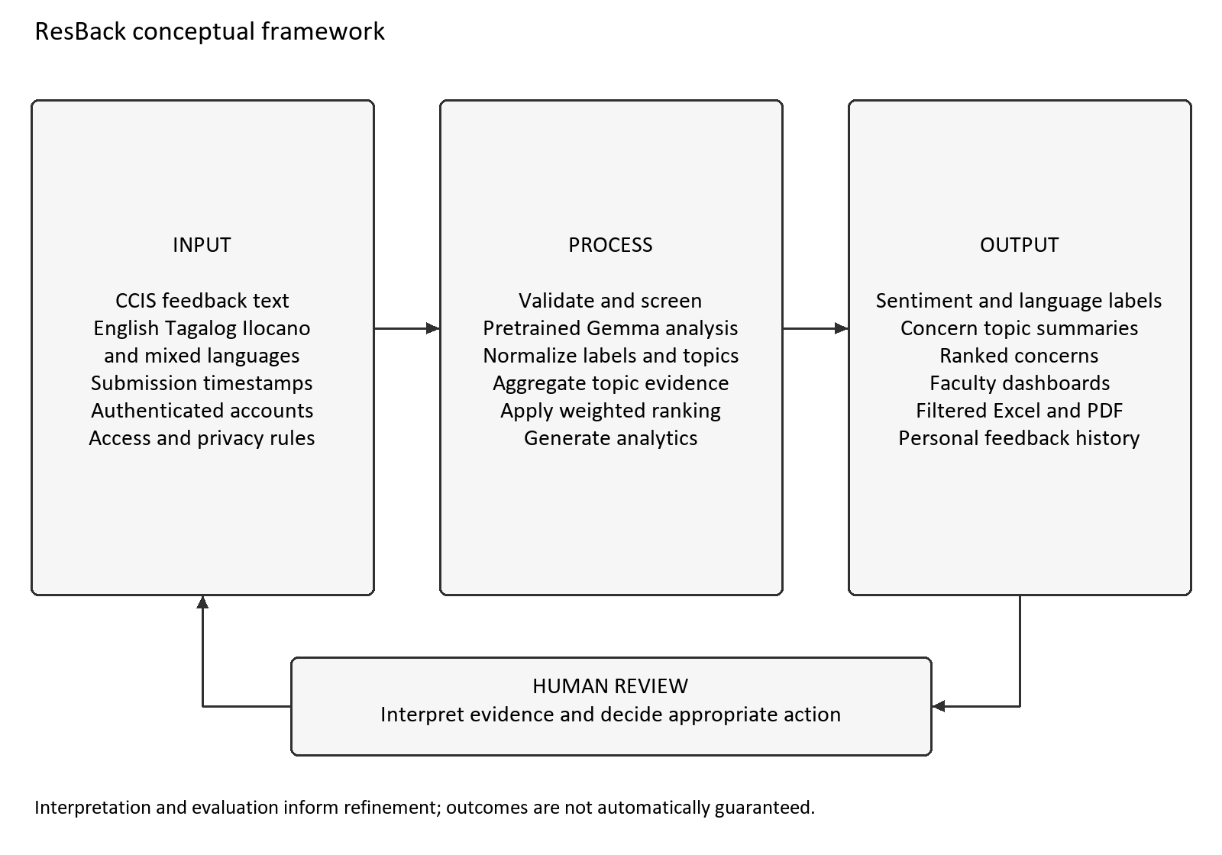
Figure 1 ResBack conceptual framework
Figure 1 shows that comments provide analytical content, timestamps provide recency scores, topic tags allow aggregation, and access policies control usage. The screening comes before inference and validation of the model’s responses. There are privacy controls across the entire process.
Authorizations are required for reviewing the summaries along with comments. The feedback received from evaluation is used for changing interfaces, prompts, safety measures, and ranking criteria. The return arrow stands for human intervention along with system improvement and not for concern resolution through automation.

CHAPTER 3 METHODOLOGY

3.1 Project and Research Design
The project is following the software engineering development methodology approach to develop and test the Resback for CCIS. The development process includes requirement gathering, implementation, functional testing, and evaluation of analysis quality and usability. Requirement gathering from students through the initial questionnaire has been done. Model evaluation and usability testing by stakeholders have been suggested, and these activities have been defined in this chapter.
Agile Data Science 2.0 as outlined by Jurney [30] involves the process of iterations using Records, Charts, Reports, Recommendations, and Actions. In the case of Resback, these phases are connected to data gathering, visualization, report downloads, prioritizing concerns and human approval. Findings from the testing and review phase may call for modifications in previous phases. The process has been customized according to the current Laravel application without the need to use all the technologies that have been utilized in the book.
Resback incorporates a trained machine learning model using the Google Gemini API and implements programmed rules for input filtering, language and topic normalization, and concern prioritization. The research team does not train or fine-tune Gemma. Evaluation will thus include testing the trained model against CCIS feedback, checking that the calculation is correct, and watching participants perform tasks with the system. Questionnaire ratings of anticipated utility do not guarantee the validity or usability of the model.

3.2 Method and Approach

3.2.1 Setting Stakeholders and Preliminary Requirements Questionnaire
This research project will take place in CCIS in Mariano Marcos State University. The students can give feedbacks as well as check their submission records. The faculty members have access to give feedbacks and access to see their authorized reports and analytics. The Admin and Super Admin can view the analytics, manage the account based on their authority and delete the feedback.
The first Google Forms survey consists of consent questions, profile questions, 25 statements on a five-point Likert Scale of agreement, and five open-ended questions [3]. The dataset collected data for 25 volunteer students between September 24th and 29th, 2026: 17 from the Computer Science department and 8 from Information Technology. They all chose the age group of 18 to 25 years old. There are no faculty or administration in the dataset.
Table 2 links the project requirements to implementation areas and verification activities. These links will support traceability when features, prompts, or analytical rules are revised.
Table 2 Requirements and implementation traceability
ID | Requirement | Implementation or verification focus
R1 | Authenticated private submission and history. | Account controls, FeedbackController, ownership checks.
R2 | Suppress submitter identity in review outputs. | Dashboard and export field review; privacy task questions.
R3 | Accept only active CCIS feedback categories. | StoreFeedbackRequest; category access tests.
R4 | Screen abuse and limit repeated submissions. | FeedbackSubmissionGuard and FeedbackAutoRejectService.
R5 | Validate sentiment and multilingual analysis. | SentimentService and LanguageCategoryService; annotated corpus.
R6 | Normalize topics and calculate concern ranking. | ConcernTopicService and ConcernRankingService; arithmetic and sensitivity tests.
R7 | Provide filtered dashboards and matching reports. | DashboardController, Excel and PDF controllers; record reconciliation.
R8 | Restrict administrative and account actions. | Role middleware and account authorization; hierarchy tests.
R9 | Expose analysis status and retain failed submissions. | Pending, analyzed, failed, and rejected lifecycle tests.
R10 | Support repeatable evaluation and maintenance. | Test records, diagrams, modular services, and documented configuration.

The 25 students provided 625 ratings across the 25 agreement statements. Each item mean is the sum of its ratings divided by 25. Table 3 reports the unweighted mean of the five item means within each questionnaire area. These descriptive results summarize this preliminary sample and do not constitute a usability or model-performance score.
Table 3 Preliminary questionnaire descriptive areas
Descriptive area | Items | Mean rating from 1 to 5
Perceived value of feedback | 1–5 | 4.39
Anonymity and expression | 6–10 | 4.62
Sentiment categorization | 11–15 | 4.23
Concern ranking | 16–20 | 4.18
Willingness and perceived usefulness | 21–25 | 4.27

Anonymity has the highest area mean, at 4.62 on the five-point scale. The source summary records 23 of the 25 respondents, or 92 percent, as more comfortable providing feedback through this approach; the corresponding item mean is 4.68. The item about anonymity supporting honest expression has a mean of 4.64. An item mean alone does not establish that every respondent selected an agreement response.
The open-ended answers obtained from the questionnaire were thematically analyzed in relation to safety in expression, institution-related aspects, seriousness of the issue, students involved, accessibility, and progress updates. One participant was concerned with irrelevant submission and jokes. Blank answers and those with no substantial information were ignored in the thematic analysis. This is based on observations made from the questionnaires and not from interviews.
These results indicate that there is an identity protection system, personal feedback experience, summary information, and submission security measures. There is a need for resolution tracking, which highlights the limitation since the application tracks the submission and analysis but it doesn’t track the resolution process entirely. The survey questionnaire lacks measurement of classification accuracy, validation of the ranking weights, and number of affected students.
Faculty and administrator interviews and walkthroughs that are planned will focus on access needs, language needs, understanding of the dashboard, and review processes. Recruitment, permission, and consent will be tracked. The preliminary survey sample will be noted as separate from the usability sample, even though some individuals participate in both efforts.

3.2.2 Agile Data Science 2.0 Development Process
The Records phase sets up accounts, feedback, categories, analysis findings, and ranks with explicit ownership, validation, status, and timestamps. The deliverables will be the data model, migration scripts, access control details, and sample records. Feedback and its analysis are stored separately such that a submission may still be retrievable even if external analysis fails.
Sentiment distributions, language classifications, trends, and concern summaries will be displayed at the Charts stage based on the data available in the records. Verification will involve matching the data totals in the display against the controlled data, as well as the manner in which the pending, failed, and missing analysis are indicated.
The Reports phase entails combining feedback tables, Excel export, and PDF analysis report through the use of identical supported filters. Tests will be done to see how the chosen records, statuses, and totals correlate with the controlled data. The review output should not include any rejected submissions and identification accounts, but only the feedback information.
Recommendations is a phase in which the feedback is organized according to concerns and in which the weighted ranking process described in Section 3.2.6 takes place. Count data, negative ratios, reported confidence by the models, recency of the complaint, and examples are made explicit in the justification for the ranking. The weights and low evidence markers will be evaluated using controlled studies, faculty reviews, and sensitivity analyses.
Under the Actions stage, the task allows authorized persons to investigate issues and determine what actions should be taken by the institution. The research team will take into consideration evaluation results when improving the documents, questions, interfaces, and ranking criteria. The refinement process will not involve automated issue solving. A new version of the Gantt chart, which includes all the same dates and development tasks, is in Appendix B.
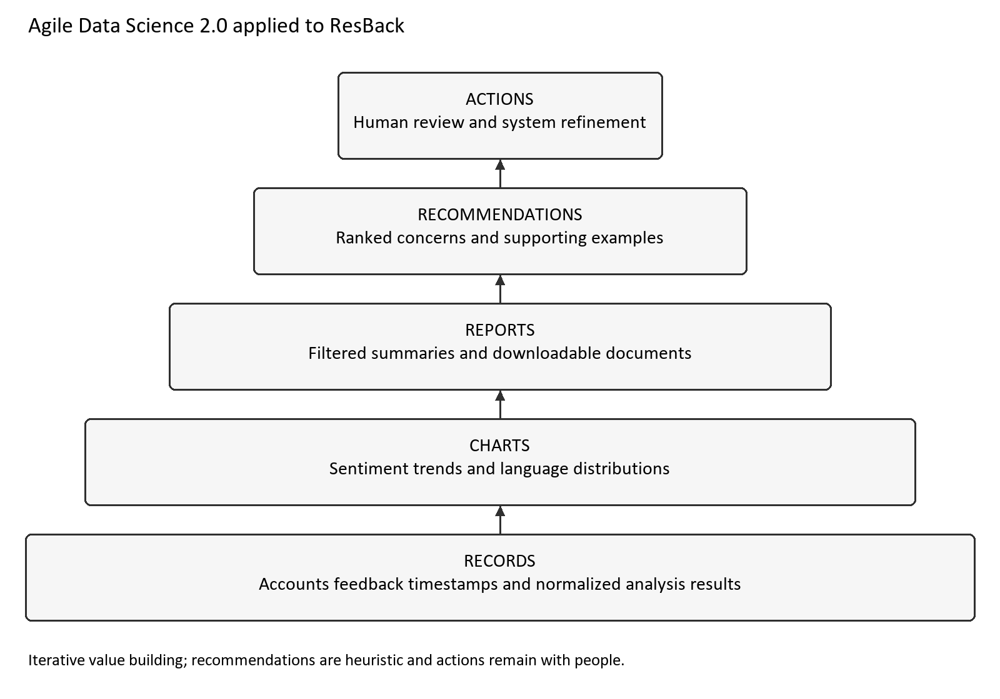
Figure 2 Agile Data Science 2.0 stages adapted to ResBack

3.2.3 Application Architecture and Role Permissions
The ResBack framework relies on Laravel routing, controllers, services, Eloquent model, and Blade views. Authentication, validation, and authorization define access to restricted operations. The controllers manage the submission and reports, whereas the services perform the screening, analysis, normalization, and ranking. Chart.js is used for charts, PhpSpreadsheet for generating Excel files, and Dompdf for PDF reports.
The figure below illustrates the architecture of the local development that is being done using PHP with Laravel framework, MySQL or MariaDB from XAMPP, local application files and the Google Gemini API over HTTPS protocol. The second figure below (figure 31 in appendix I) is the proposed design of the online deployment to be done using Docker on Render with Supabase PostgreSQL and Supabase Storage for profile pictures. This system still needs database compatibility tests and integration to be called deployment.
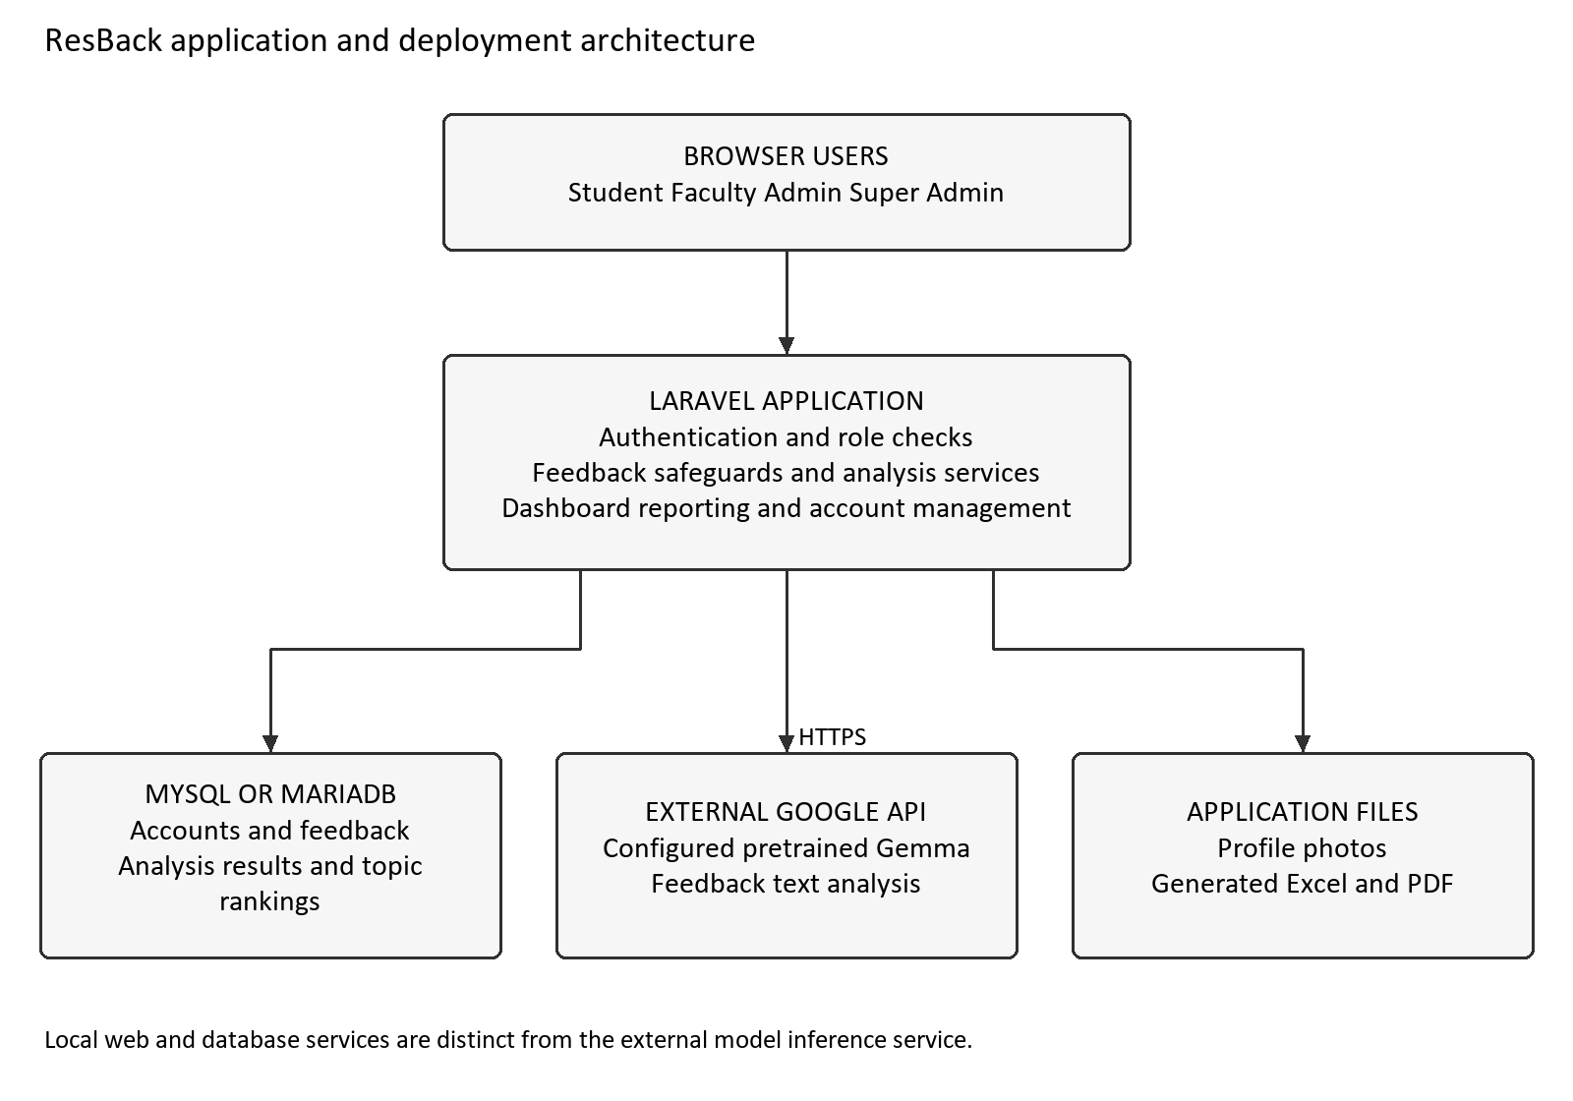
Figure 3 Local development architecture
Figure 28, which is located in Appendix G, has segmented the application into categories such as Web Presentation, Identity and Accounts, Feedback Management, Sentiment Analysis, Concern Ranking, and Dashboard & Reporting. All these are segments that logically fall into one Laravel application.
Component Diagram utilizes provided and required interfaces for service contracts and delegation connectors to connect application boundaries to inner components. External inference is provided by the Google Gemini API. Dompdf and PhpSpreadsheet work inside the application, while the profile-photo implementation currently works using the Laravel public filesystem. Application records and the database-backed session and cache records are kept in relational storage. Accepted feedback is processed synchronously, while rejected feedback is not used for external inference.
Student users are allowed to provide feedback, see only their feedback history, and make changes to their profile. The faculty users are able to submit feedback, as well as access dashboards and reports. The admins and super-admins can view reports and analytics, manage accounts in accordance with their role hierarchy, and delete feedback, but are not able to submit feedback.
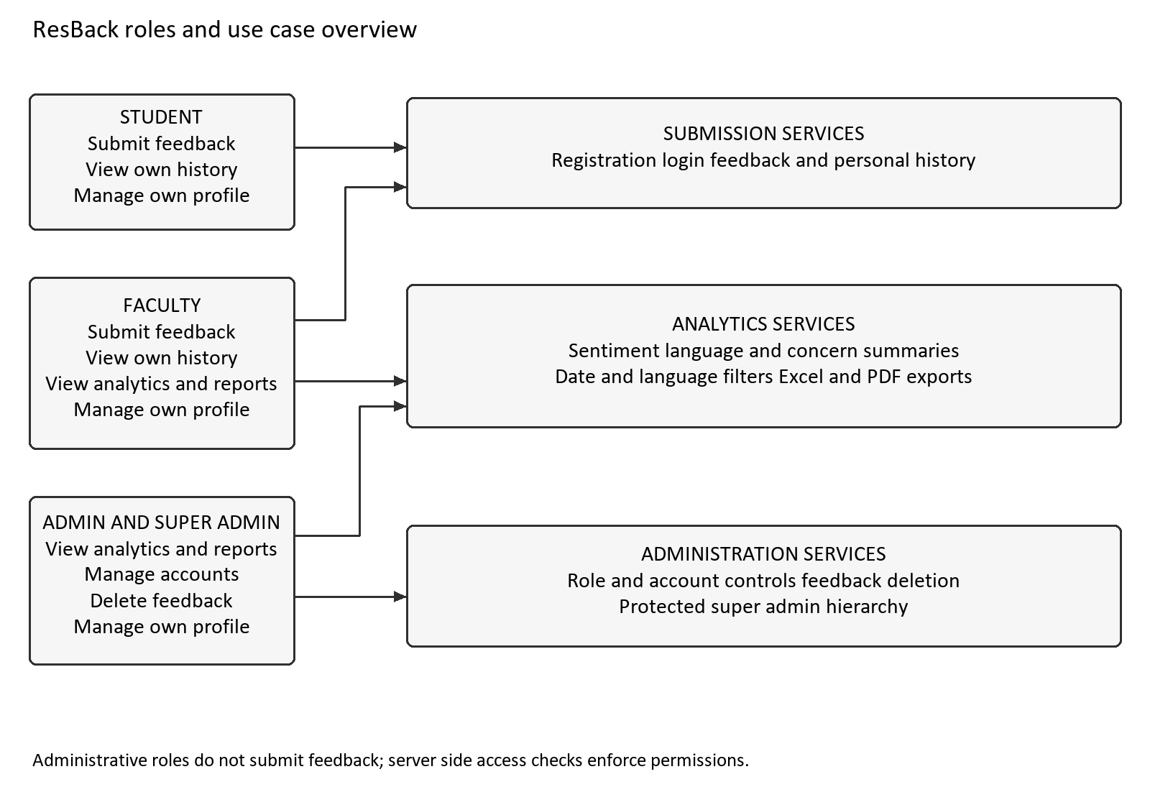
Figure 4 Roles and use case overview
These appendices have been presented in the prescribed order. Appendix A: Fishbone Diagram, Appendix B: Gantt Chart, Appendix C: Use Case Diagram, Appendix D: Use Case Description, Appendix E: Activity Diagrams, Appendix F: Class Diagrams, Appendix G: Component Diagram, Appendix H: Package Diagram, and Appendix I: Deployment Diagrams (Local & Online). The use case diagram consists of 17 use cases, along with their 17 descriptions. There are 12 activity diagrams and 6 class diagrams describing the application.

3.2.4 Data Model and Feedback Lifecycle
The fundamental entities are the following: User, Category, Feedback, Sentiment Result, and Concern Ranking. A user can be associated with more than one instance of feedback; moreover, each instance of feedback is linked with a category. The successful analysis leads to the creation or updating of the associated sentiment result. A category can have many instances of topic rankings.
Feedback log contains the original content, private owner, hashed network address, processing status, and time stamps. Analysis log contains sentiment, confidence of model, keywords, normalized topic names, language details, and the response of provider. Ranking log contains numbers and scores for all categories and topics. In the current ranking model, keyword field contains the normalized topic name.
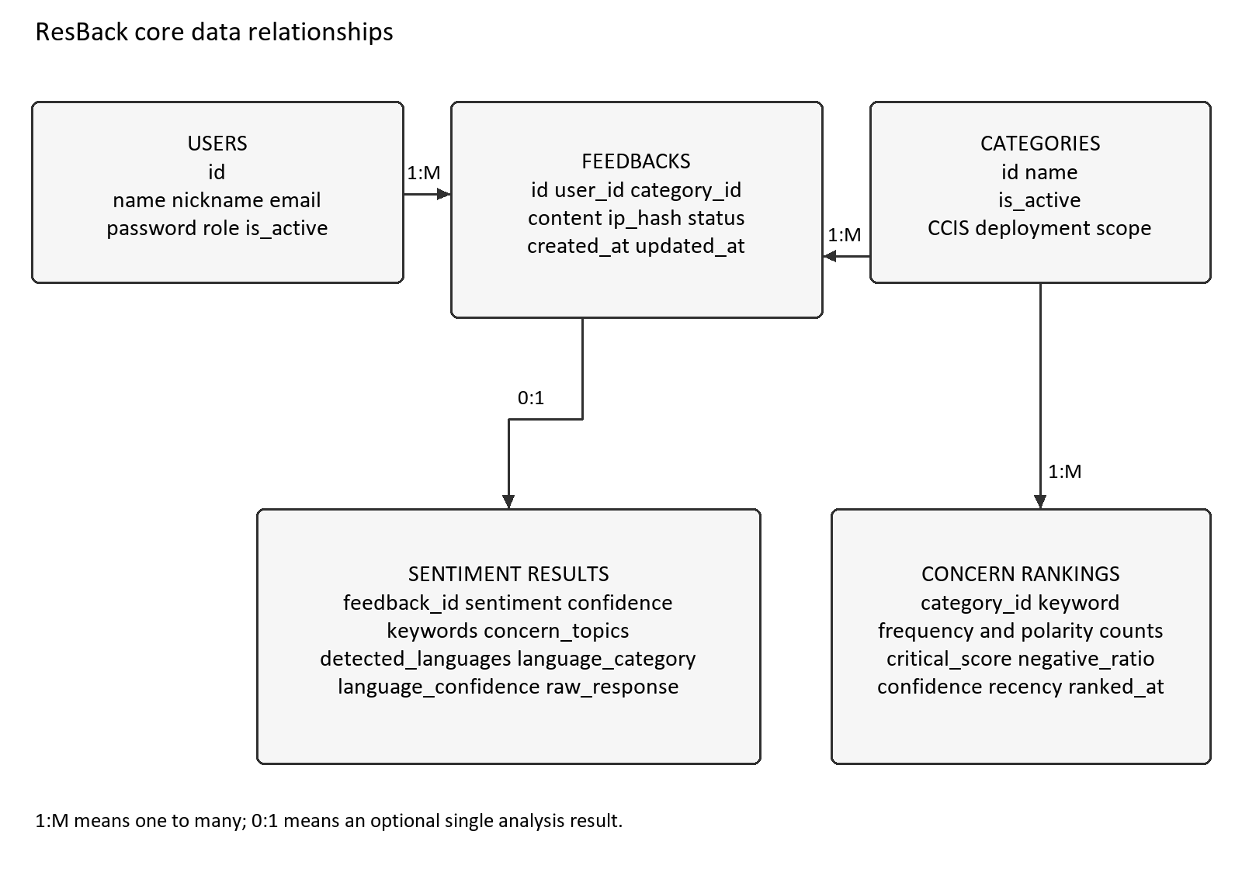
Figure 5 Core data relationships
There are four different statuses for the feedback life cycle. Pending refers to the saved submission that requires analysis. Analyzed refers to the submission that has a stored usable result. Failed refers to the saved submission whose analysis is not capable of producing a usable result. Rejected refers to the submission that is filtered based on the configured screening rules, without any inference or inclusion in analytics.

3.2.5 Submission Safeguards and Analysis Procedure
The server will accept only those comments which belong to the active CCIS category and contain 10-2000 characters. The duplicate check will be based on the same user and the same category for the last 24 hours, ignoring case and whitespace differences. There is a different rate-limited restriction for the user: saving 5 comments in 10 minutes.
The configured prohibited content dictionary filters validated feedback prior to inference. If there is a match, the submission will be stored as a rejected submission; if not, the submission will be stored as a pending submission. The text of the feedback remains intact, while a hash of the network address is maintained. Both accepted and rejected submissions are included in the submission limits.
The feedback sent by SentimentService includes the following elements – sentiment, confidence, keywords, topics, languages, and language_confidence – and is provided in the JSON format. The prompt asks the model to treat the feedback data as content rather than instructions to be executed. The response parser skips the thought segments, parses the JSON received, verifies the usable sentiment, confidence, keywords, and language information, and ensures that the confidence numbers are within the range between zero and one.
LanguagesCategoryService translates detected languages into English, Tagalog, Ilocano, Taglish, Iloclish, Taglocano, Trilingual, or Other Language. ConcernsTopicService translates concern titles into topics that are supported and resorts to using keywords and feedback body as evidence when required. Usable translation is recorded, feedback is analyzed, and category ranking is updated. Failure to provide configuration, loss of connection, API failure, or unprocessable analysis results makes the saved feedback failed.
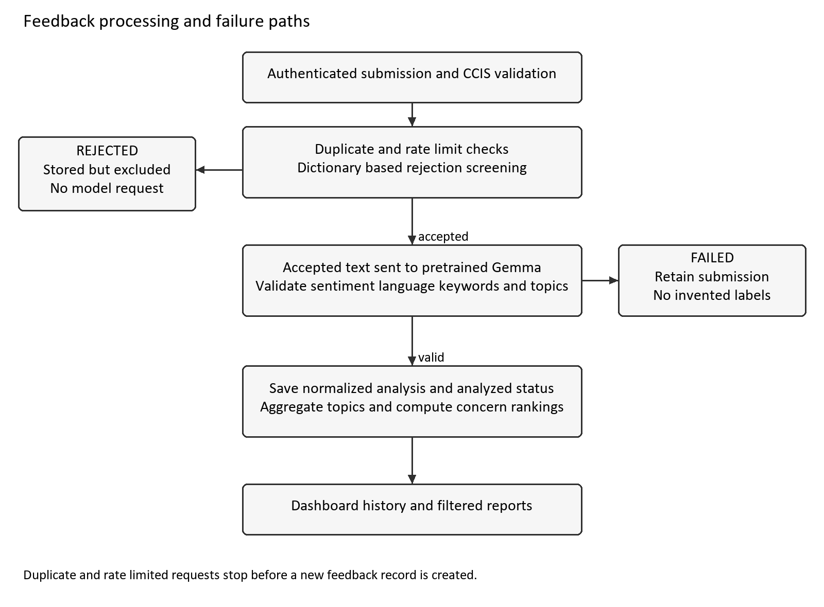
Figure 6 Feedback processing and failure paths
The default identifier for the repository default model is gemma-4-26b-a4b-it. The specific deployment can override the default identifier. The parameters currently in use for the request include a temperature of 0.1 and a maximum output length of 256 tokens. For the evaluation process, the following details will be logged: the actual model that was used, version of prompt, request parameters, date of evaluation, and identified failures.

3.2.6 Concern Ranking Procedure
ConcernRankingService groups stored analysis results by normalized topic within the selected category, date, and language scope. It counts sentiments and calculates four factors for each topic. A comment assigned to several topics contributes its single overall sentiment to every assigned topic. This is topic grouping with comment-level sentiment; it is not a separate sentiment prediction for each aspect.
Let n be a topic’s negative count, t its total analyzed count, and nmax the largest negative count among the selected topics, with a minimum of one. The volume factor is V = ln(1 + n) / ln(1 + nmax), with V = 0 when n = 0. The negative ratio is R = n / t. The confidence factor C is the mean model-reported confidence of negative comments. The recency factor T is their mean exp(−ln(2) × age in days / 30), using non-negative ages relative to the calculation time. If there are no negative comments, C and T are zero.
Concern score S = 100 x (0.40V + 0.25R + 0.20C + 0.15T), to one decimal place. Normalization of logarithmic volume lessens the impact of very high values, and the ratio represents the proportion of negative comments. Recency factor of each comment decreases by half within 30 days. Weights and half-life are heuristic assumptions of this project and need to be evaluated. Confidence in model is not a probability of right classification [26].
For instance, scores for V = 1.00, R = 0.75, C = 0.80, and T = 0.50 yield 82.3. This is a demonstrative computation. The score for a topic having no negative comments equals zero. The existing low-evidence flagging is established when the number of comments on a topic is less than three irrespective of the polarity of these comments. Scores are ranked in descending order, and in case of a tie, negative comment count and topic name break the tie.
Volume normalization depends on the largest negative count in the selected dataset. A topic score may therefore change when filters or other topic counts change, even if that topic’s own records are unchanged. Verification will fix the calculation time and selected scope for reproducibility. Sensitivity analysis will compare alternative weights and recency half-lives, including a calculation without the confidence factor.

3.2.7 Proposed Evaluation Participants and Data
This is the usability sample that has been developed using purposive sampling which involves 30 CCIS students, five faculty members, and two administrators provided there is consent and availability. The student selection process shall involve variation among the year of study, browser usage, and language used. The reviewers’ task shall involve some responsibilities associated with the tasks being tested.
This proposed corpus of frozen evaluations comprises 210 comments without any identifiers, wherein there are ten comments for each of the three sentiment classes in each of the seven language categories. The language categories considered are English, Tagalog, Ilocano, Taglish, Iloclish, Taglocano, and Trilingual. The other cases will be analyzed with respect to Other Language, ambiguous contents, screening matches, and service failures.
Comments may be contributed with consent or authored as explicitly identified test scenarios by contributors competent in the relevant languages. Source type will be recorded, duplicates removed, and unnecessary identifiers removed before external processing. Natural and authored cases will be reported separately where sample size permits. Prompt-development examples will be separate from the 210 evaluation comments; the evaluation set will be frozen before the final prompt is assessed.
The annotation will be carried out independently by two annotators who possess the required language skills. Guidelines will include definitions for positive sentiment, neutral sentiment, negative sentiment, mixed sentiment, loanwords, and multiple topics. The agreement will be noted before any disagreements are resolved to create the reference labels. The guidelines and resolution process will make the evaluation method replicable.

3.2.8 Functional Testing and Quality Evaluation
Function tests will include authentication, ownership, role-based authorization, input validations, submission protections, analysis pass/fail status, normalization, filters, account management, deletion, and export tests. The current unit tests using PHPUnit will serve as the basis of the implementation. Each evaluation performed will document the environment, expected and actual results, failures, fixes, and re-tests. Successful test cases will be documented only if the run was conducted.
The chosen product quality factors will be structured according to ISO/IEC 25010:2023 [31]. Functional suitability, performance efficiency, reliability, security, compatibility, and maintainability will be studied. Interoperability will be studied through compatibility due to API and exportability. Maintainability testing will test modular service architecture, traceability, and reproducible testing. Usability will be analyzed using role-based task analysis and SUS. This selection of factors does not represent certification or a comprehensive evaluation of all factors of the standard.
End-to-end testing will make use of test-only accounts and test database. Calls to external models will be mocked for deterministic tests on the application and tested separately using inference requests. Failure modes can be in the absence of configuration, timeout on connections, failure response, malformed JSON, and incorrect labels. Testing for export will validate chosen records and their total amounts without the identifying fields of the accounts and rejected feedback.
Performance statistics will include the submission latency, the dashboard latency, the export time, failure percentage of analysis, size of the dataset, environment and API condition. Latency distribution will be computed through repeated submissions, and not just through one measurement. The external inference time will be tracked separately from local processing where possible, as synchronous requests influence overall submission time.
Table 4 Proposed evaluation measures and records
Area | Proposed measure | Evidence to record
Functional behavior | Expected outcomes for permissions, safeguards, filters, and exports. | Case results, failures, fixes, and retests.
Sentiment analysis | Accuracy, class precision and recall, macro-F1. | Confusion matrix; labels; ambiguous and failed attempts.
Language and topics | Language accuracy; topic micro- and macro-F1. | Category counts, missed or extra labels, annotator agreement.
Concern ranking | Arithmetic checks, rank agreement, leading-concern agreement, sensitivity. | Controlled data; independent faculty rankings and comments.
Usability | Task completion, errors, assistance, time, and SUS. | Role-specific observations; scores and achieved sample.
Performance and reliability | Latency distributions, export duration, failure rate. | Environment, dataset size, API conditions, repeated runs.
Security and privacy | Ownership, role, export identity, and data handling checks. | Access test results; disclosures; approved data procedures.

3.2.9 Proposed Usability and Analysis Measures
Usability tasks will be carried out according to role permissions. Students will submit feedback, check result status, and find their history. Faculty will filter analytics, review support cases, and create reports. Administrators will conduct permissible user and feedback tasks using test data. Results of task performance, error rates, help needed, and task duration will be recorded before the completion of the ten-question System Usability Scale (SUS) [32].
SUS uses ten items rated on a five-point response scale. For odd-numbered items, the contribution is the response minus one. For even-numbered items, the contribution is five minus the response. The ten contributions are summed and multiplied by 2.5 to produce a score from zero to 100. This score is a usability index, not a percentage of completed tasks.
Evaluation of sentiment classification performance will rely on comparison between predictions and human-adjudicated reference labels via accuracy, class-based precision and recall, macro-F1, and confusion matrix analysis. Accuracy of language category classification will be computed both globally and for each category. Topic assignment performance will rely on micro-F1 and macro-F1 as well as specific instances of misses and false positives. Non-responsive submissions and failed request cases will be tracked separately along with valid response coverage.
The controlled record will validate the mathematics involved in ranking, tiebreakers, dates, filtering, and low evidence indicators. The faculty reviewers will consider the identical anonymous evidence independently prior to seeing the system ranking. The comparison will focus on the agreement in rank and leading problems, with both the rank statistic and tiebreaker method decided prior to evaluation. Disagreement will not be considered evidence that either ranking is right.
The acceptance criteria shall be determined in advance of the evaluation through discussion with the stakeholders. Ownership and role checks should succeed, exports should correspond to the chosen scope, and processing errors need to stay visible. Error reports, sample limitations, and coverage attained shall be part of model and usability reports. A benchmark appropriate for the subset of the language under test can be evaluated using the same set of reference data; its language coverage and configuration shall be described before comparison.

3.2.10 Ethical Procedures and Data Management
Participation is voluntary and dependent on institutional approval. Information sheets will describe the aim of the research, tasks to be performed, information collection and usage, withdrawal rules, and model processing by third parties. Participation or non-participation will not influence grades or regular access to accounts. Proposed research procedures and preliminary questionnaire will be clearly marked in research documentation.
Research testing shall make use of test accounts, limited identifiers, limited research file access, and approved retention/deletion periods. Sensitive allegations will not be used as testing material. Identity masking on the dashboard is not able to protect identity from being exposed through free-text input nor is it able to remove the ownership of the application. Data privacy shall be assessed by the institution based on the Data Privacy Act Principles [13].

3.3 Machine Learning Integration and Evaluation
The following diagram depicts the machine learning pipeline linking the Gemma integration implementation to the processes of data collection, data pre-processing, feature extraction, model evaluation, and model usage. Further details about safety measures, data requirements, and evaluation metrics can be found in Sections 3.2.5-3.2.9. The project leverages an external pre-trained model [21][22] whose experiments will not train any model parameters.

3.3.1 Data Acquisition
The input for the operational use case comes in the form of feedback provided by authentic Student and Faculty users along with details such as category and timestamp. The application maintains a private ownership link, but does not include identification fields related to account in the review output. The research data will include the individually documented consented/authored evaluation comments mentioned in Section 3.2.7.

3.3.2 Preprocessing and Data Cleaning
The application preprocessing ensures that the category and text size are validated, performs duplicate checks on normalized text, limits submissions, and checks configured prohibited keywords. The original text that is accepted goes through the model without undergoing stemming, stop-word removal, and TF-IDF processing. Preparation for the research will remove any unnecessary identifiers and duplicates, as well as language and references tags. Sentiment in wording will be maintained even during the process of cleaning.

3.3.3 Feature Extraction Using the Pretrained Model
Gemma utilizes representations obtained during pre-training. ResBack does not use any internal embeddings or manually create a feature vector. It receives sentiment, self-reported confidence, keywords, concern topics, and language data. Validation and normalization processes turn them into analytic features that will be filtered, aggregated, and ranked. The ranking criteria are defined by the programmer using the previously saved results and timestamps.

3.3.4 Model Configuration and Performance Evaluation
The same parameters will be used for each experiment, including the model, prompt, parameters, and evaluation samples. Two annotators will determine reference labels individually. Metrics from Section 3.2.9 will include sentiment accuracy, precision, recall, and macro-F1; language accuracy; and topic micro-F1 and macro-F1. Output will include counts of samples, coverage, failure, and examples. The separate prompt development dataset will prevent evaluation leakage. Loss and epochs will not be part of the implementation.

3.3.5 Utilization of the Model
Validated feedback is subjected to synchronous inference, verification, normalization, result persistence, and ranking restoration. Dashboard and reporting tools show the chosen records for review by designated reviewers. The rejected records will not go through inference while the unsuccessful analysis will maintain their visibility. Reviewers study the actual comments and the related evidences before taking action in the institution.

REFERENCES
[1] J. T. E. Richardson, “Instruments for Obtaining Student Feedback: A Review of the Literature,” Assessment & Evaluation in Higher Education, vol. 30, no. 4, pp. 387–415, 2005. [Online]. Available: https://www.tandfonline.com/doi/abs/10.1080/02602930500099193
[2] M. Shah, M. Cheng, and R. Fitzgerald, “Closing the Loop on Student Feedback: The Case of Australian and Scottish Universities,” Higher Education, vol. 74, pp. 115–129, 2017. [Online]. Available: https://shura.shu.ac.uk/30828/
[3] C. J. G. Queypo, “ResBack preliminary requirements questionnaire responses,” Unpublished Google Forms response dataset, 25 student records, September 24–29, 2026. [Online]. Available: https://docs.google.com/spreadsheets/d/148lKjRJ4cuUbL5wjAZgBJGqB2NjcOWQOqkyIDnTaSZw/edit
[4] Z. Kastrati, F. Dalipi, A. S. Imran, K. P. Nuci, and M. A. Wani, “Sentiment Analysis of Students’ Feedback with NLP and Deep Learning: A Systematic Mapping Study,” Applied Sciences, vol. 11, no. 9, article 3986, 2021. [Online]. Available: https://www.mdpi.com/2076-3417/11/9/3986
[5] F. Dalipi, K. Zdravkova, and F. Ahlgren, “Sentiment Analysis of Students’ Feedback in MOOCs: A Systematic Literature Review,” Frontiers in Artificial Intelligence, vol. 4, article 728708, 2021. [Online]. Available: https://www.frontiersin.org/journals/artificial-intelligence/articles/10.3389/frai.2021.728708/full
[6] T. Shaik, X. Tao, C. Dann, H. Xie, Y. Li, and L. Galligan, “Sentiment Analysis and Opinion Mining on Educational Data: A Survey,” Natural Language Processing Journal, vol. 2, article 100003, 2023. [Online]. Available: https://www.sciencedirect.com/science/article/pii/S2949719122000036
[7] F. F. Balahadia, M. C. G. Fernando, and I. C. Juanatas, “Teacher’s Performance Evaluation Tool Using Opinion Mining with Sentiment Analysis,” 2016 IEEE Region 10 Symposium (TENSYMP), pp. 95–98, 2016. [Online]. Available: https://paraverse.feutech.edu.ph/repository/article/10.1109/TENCONSpring.2016.7519384
[8] R. C. Justo, “Academic-Related Services of Laguna State Polytechnic University with Sentiment Analysis and Data Analytics Using Multinomial Naïve Bayes Algorithm,” UE Research Journal, vol. 26, no. 1, 2024. [Online]. Available: https://www.ejournals.ph/article.php?id=33695
[9] K. L. Bonifacio, J. Estrada, M. M. Talandron-Felipe, G. Ayunar, F. Bascones Jr., N. J. Casildo, and J. Marcelo, “Automated Multilingual Sentiment Analysis of Student Comments in Faculty Evaluations using Transformer-Based AI,” Proceedings of the 33rd International Conference on Computers in Education, 2025. [Online]. Available: https://library.apsce.net/index.php/ICCE/article/view/6051
[10] S. Slade, and P. Prinsloo, “Learning Analytics: Ethical Issues and Dilemmas,” American Behavioral Scientist, vol. 57, no. 10, pp. 1510–1529, 2013. [Online]. Available: https://journals.sagepub.com/doi/10.1177/0002764213479366
[11] A. Pardo, and G. Siemens, “Ethical and Privacy Principles for Learning Analytics,” British Journal of Educational Technology, vol. 45, no. 3, pp. 438–450, 2014. [Online]. Available: https://bera-journals.onlinelibrary.wiley.com/doi/abs/10.1111/bjet.12152
[12] J. Fraile, M. Monguillot, C. González-Arévalo, P. Lehane, and E. Panadero, “Investigating Anonymity in Formative and Summative Peer Assessment: Effects on University Students’ Social-Affective Factors, Perceptions and Preference,” Studies in Educational Evaluation, vol. 83, article 101410, 2024. [Online]. Available: https://www.sciencedirect.com/science/article/pii/S0191491X24000890
[13] National Privacy Commission, “Implementing Rules and Regulations of Republic Act No 10173 known as the Data Privacy Act of 2012,” Philippines, 2016. [Online]. Available: https://privacy.gov.ph/implementing-rules-regulations-data-privacy-act-2012/
[14] B. Pang, L. Lee, and S. Vaithyanathan, “Thumbs Up? Sentiment Classification Using Machine Learning Techniques,” Proceedings of EMNLP 2002, pp. 79–86, 2002. [Online]. Available: https://aclanthology.org/W02-1011/
[15] C. Grimalt-Álvaro, and M. Usart, “Sentiment Analysis for Formative Assessment in Higher Education: A Systematic Literature Review,” Journal of Computing in Higher Education, vol. 36, pp. 647–682, 2024. [Online]. Available: https://link.springer.com/article/10.1007/s12528-023-09370-5
[16] C. Dervenis, G. Kanakis, and P. Fitsilis, “Sentiment analysis of student feedback: A comparative study employing lexicon and machine learning techniques,” Studies in Educational Evaluation, vol. 83, article 101406, 2024. [Online]. Available: https://doi.org/10.1016/j.stueduc.2024.101406
[17] M. L. S. Bautista, “Tagalog-English Code Switching as a Mode of Discourse,” Asia Pacific Education Review, vol. 5, pp. 226–233, 2004. [Online]. Available: https://link.springer.com/article/10.1007/BF03024960
[18] M. Herrera, A. Aich, and N. Parde, “TweetTaglish: A Dataset for Investigating Tagalog-English Code-Switching,” Proceedings of LREC 2022, pp. 2090–2097, 2022. [Online]. Available: https://aclanthology.org/2022.lrec-1.225/
[19] B. Samanta, N. Ganguly, and S. Chakrabarti, “Improved Sentiment Detection via Label Transfer from Monolingual to Synthetic Code-Switched Text,” Proceedings of ACL 2019, pp. 3528–3537, 2019. [Online]. Available: https://aclanthology.org/P19-1343/
[20] A. Conneau, K. Khandelwal, N. Goyal, V. Chaudhary, G. Wenzek, F. Guzmán, et al., “Unsupervised Cross-Lingual Representation Learning at Scale,” Proceedings of ACL 2020, pp. 8440–8451, 2020. [Online]. Available: https://aclanthology.org/2020.acl-main.747/
[21] Gemma Team et al., “Gemma: Open Models Based on Gemini Research and Technology,” Technical report, arXiv:2403.08295, 2024. [Online]. Available: https://arxiv.org/abs/2403.08295
[22] Gemma Team et al., “Gemma 4 Technical Report,” Technical report, arXiv:2607.02770, 2026. [Online]. Available: https://arxiv.org/abs/2607.02770
[23] J. Kuzmanova, K. Zdravkova, and I. Chorbev, “Integrating Large Language Models for Comprehensive Study and Sentiment Analysis of Student Feedback,” Proceedings of RANLP 2025, pp. 604–613, 2025. [Online]. Available: https://aclanthology.org/2025.ranlp-1.71/
[24] X. P. Nguyen, X. P. Nguyen, V. T. Nguyen, V. T. Dang, and N. L.-T. Nguyen, “EduPulse: A Practical LLM-Enhanced Opinion Mining System for Vietnamese Student Feedback in Educational Platforms,” Proceedings of EACL 2026 Industry Track, pp. 338–365, 2026. [Online]. Available: https://aclanthology.org/2026.eacl-industry.25/
[25] M. Pontiki, D. Galanis, J. Pavlopoulos, H. Papageorgiou, I. Androutsopoulos, and S. Manandhar, “SemEval-2014 Task 4: Aspect Based Sentiment Analysis,” Proceedings of SemEval 2014, pp. 27–35, 2014. [Online]. Available: https://aclanthology.org/S14-2004/
[26] C. Guo, G. Pleiss, Y. Sun, and K. Q. Weinberger, “On Calibration of Modern Neural Networks,” Proceedings of ICML 2017, PMLR, vol. 70, pp. 1321–1330, 2017. [Online]. Available: https://proceedings.mlr.press/v70/guo17a.html
[27] B. A. Schwendimann, M. J. Rodriguez-Triana, A. Vozniuk, L. P. Prieto, M. S. Boroujeni, A. Holzer, et al., “Perceiving Learning at a Glance: A Systematic Literature Review of Learning Dashboard Research,” IEEE Transactions on Learning Technologies, vol. 10, no. 1, pp. 30–41, 2017. [Online]. Available: https://eric.ed.gov/?id=EJ1141028
[28] R. Kaliisa, I. Jivet, and P. Prinsloo, “A Checklist to Guide the Planning, Designing, Implementation, and Evaluation of Learning Analytics Dashboards,” International Journal of Educational Technology in Higher Education, vol. 20, article 28, 2023. [Online]. Available: https://link.springer.com/article/10.1186/s41239-023-00394-6
[29] I. Masiello, Z. A. Mohseni, F. Palma, S. Nordmark, H. Augustsson, and R. Rundquist, “A Current Overview of the Use of Learning Analytics Dashboards,” Education Sciences, vol. 14, no. 1, article 82, 2024. [Online]. Available: https://www.mdpi.com/2227-7102/14/1/82
[30] R. Jurney, “Agile Data Science 2.0 Building Full Stack Data Analytics Applications with Spark,” O’Reilly Media, 2017. [Online]. Available: https://www.oreilly.com/library/view/agile-data-science/9781491960103/
[31] International Organization for Standardization, “ISO/IEC 25010:2023 Systems and software engineering Systems and software Quality Requirements and Evaluation SQuaRE Product quality model,” International standard, 2023. [Online]. Available: https://www.iso.org/standard/78176.html
[32] J. Brooke, “SUS A quick and dirty usability scale,” In Usability Evaluation in Industry, P. W. Jordan, B. Thomas, B. A. Weerdmeester, and I. L. McClelland, Eds., Taylor & Francis, 1996. [Online]. Available: https://hci-studies.org/methods-and-measures/downloads/SUS_Brooke1996.pdf

APPENDIX A FISHBONE DIAGRAM
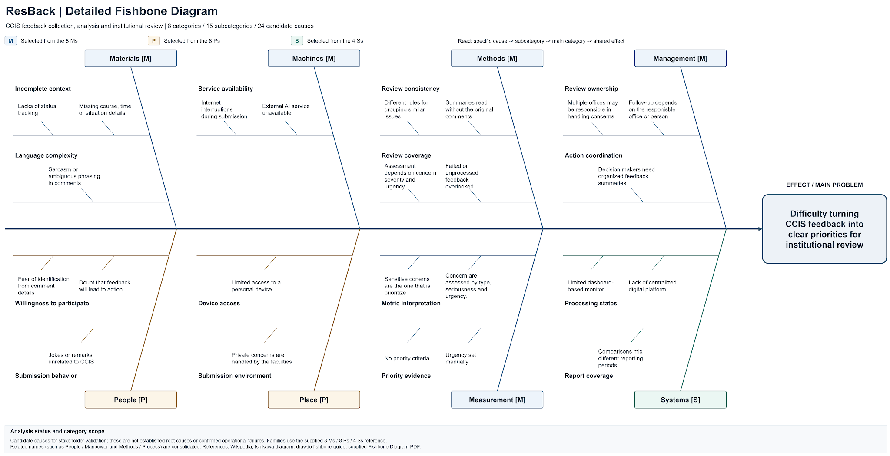
Figure 7 ResBack fishbone diagram
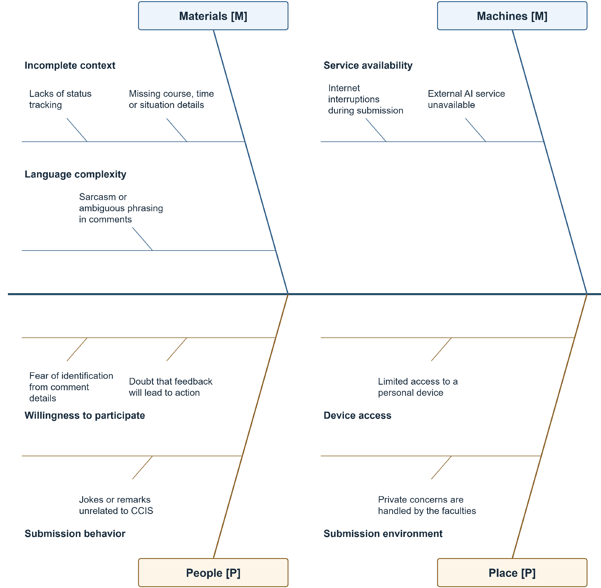
Figure 7 ResBack fishbone diagram enlarged continuation panel 1 of 2
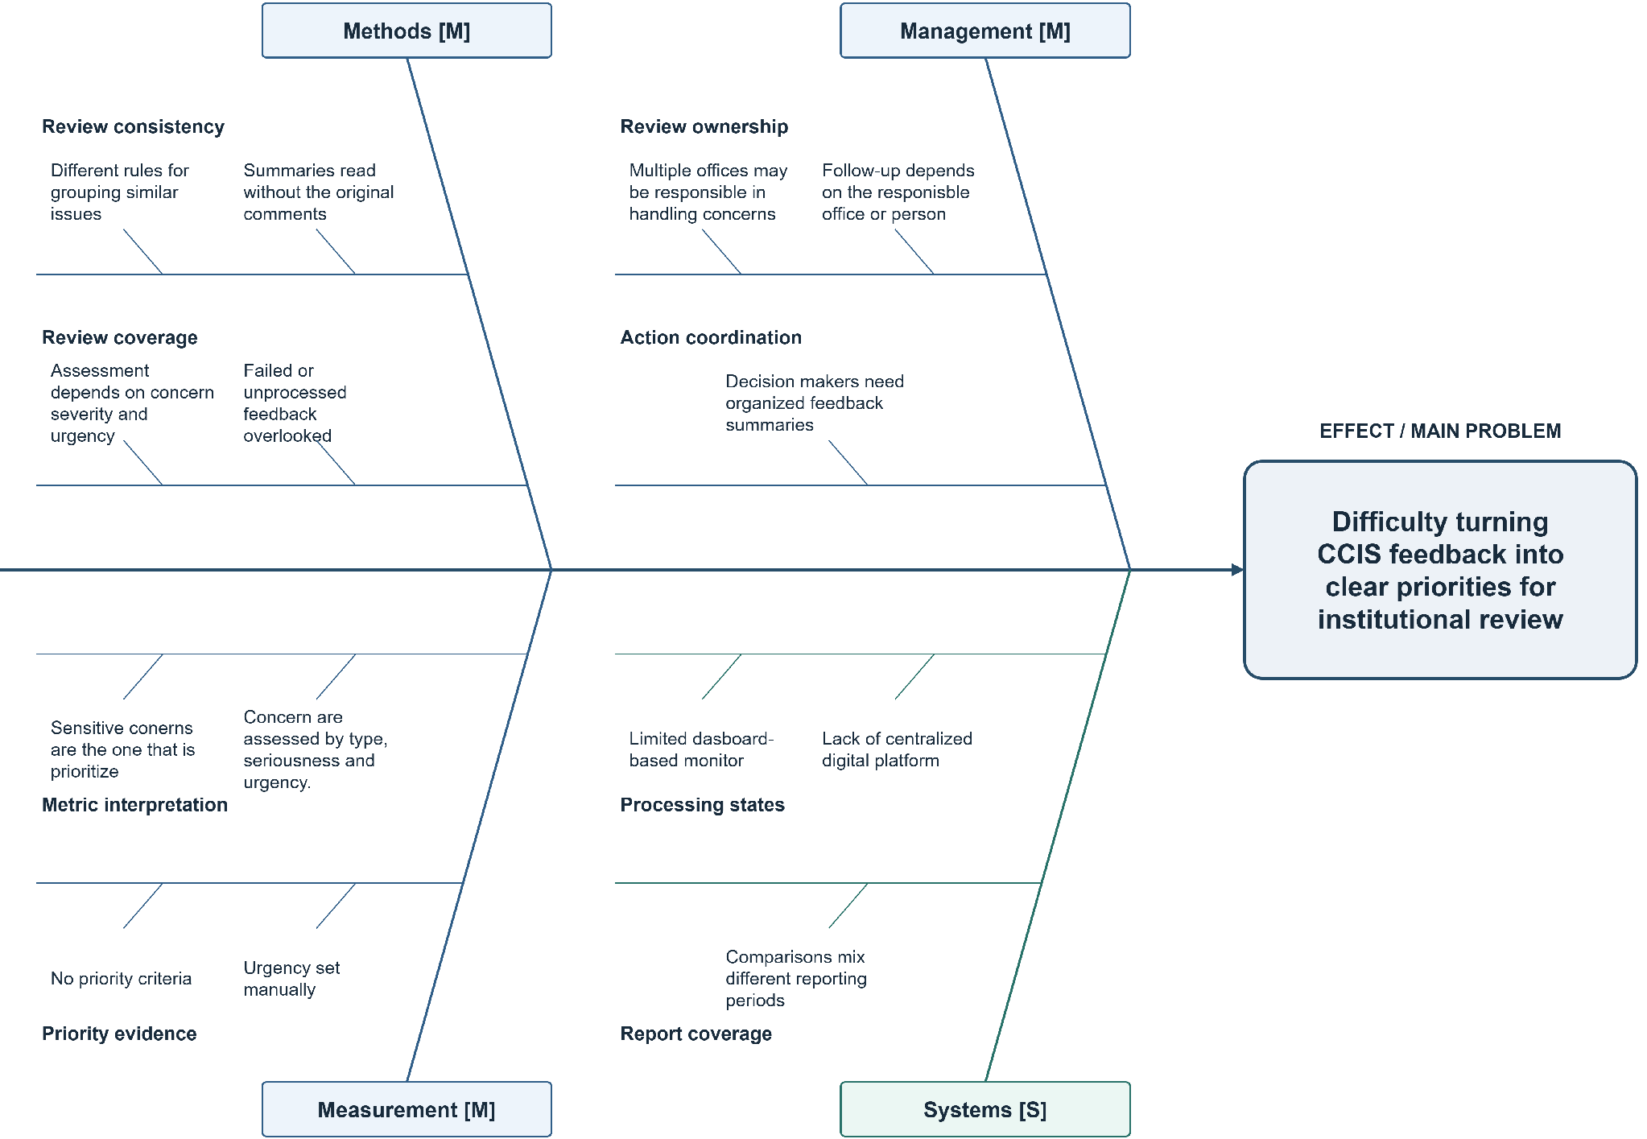
Figure 7 ResBack fishbone diagram enlarged continuation panel 2 of 2

APPENDIX B GANTT CHART
Figure 8 below shows the ResBack project schedule modified for use in Agile Data Science 2.0 framework. This project schedule contains all the task dates and the assigned team members from August 3 to October 31, 2026. The preparation stage assists in the completion of the following five stages of data value: Records, Charts, Reports, Recommendations, and Actions.
All task progress notations are made For confirmation. Bars for scheduling show planned task times and not actual completion. The chart uses the normal formatting of the template. Expanded continuation boxes list the tasks so that task descriptions can be aligned with their timeline and deliverables.
Week 1 is from August 3-9. All subsequent weeks start on a Monday; Week 5 starts on August 31, Week 9 starts on September 28, and Week 13 runs from October 26-31. The final partial week is included so that the end of all tasks can be shown until October 31.

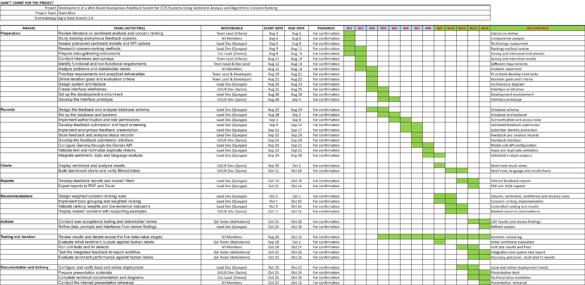
Figure 8 ResBack Gantt chart using Agile Data Science 2.0
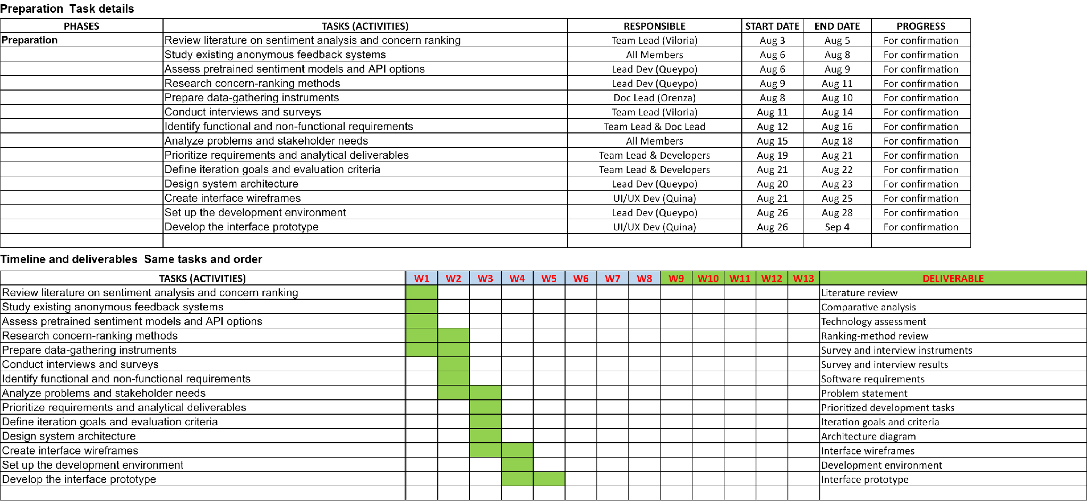
Figure 8 ResBack Gantt chart enlarged continuation panel 1 of 3
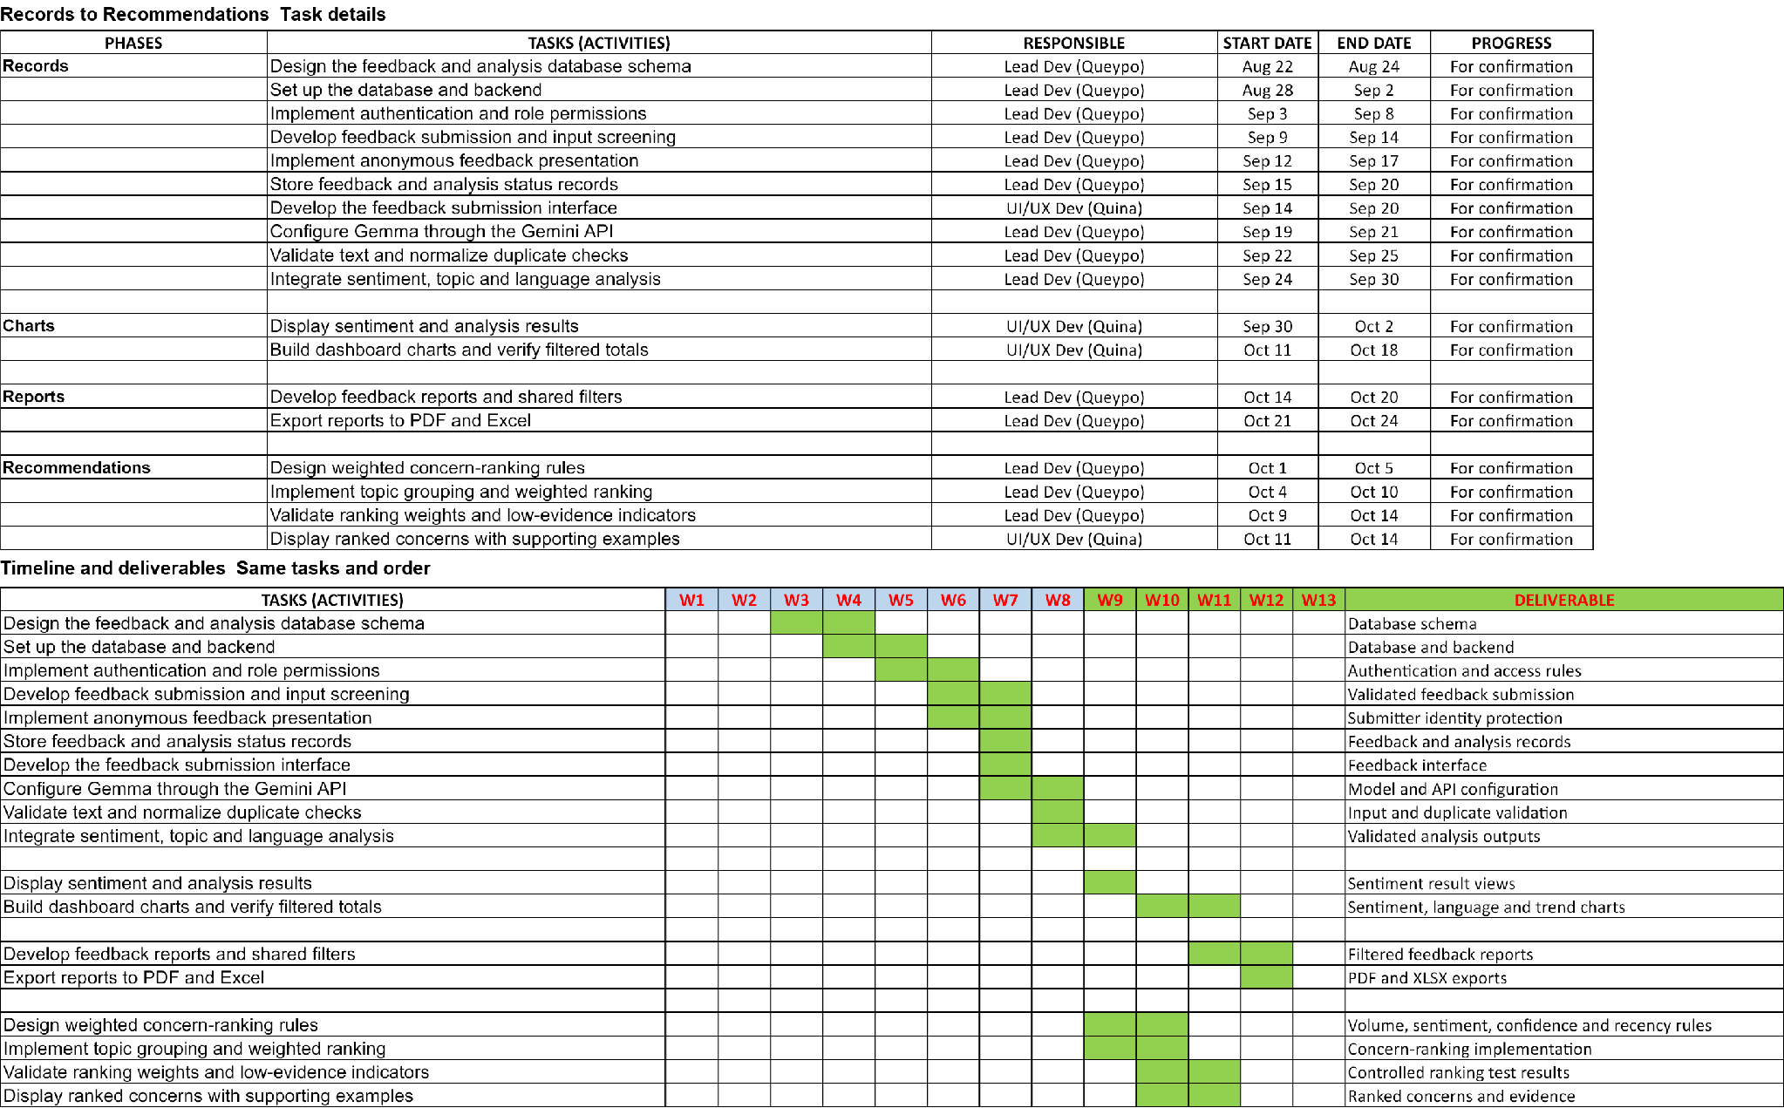
Figure 8 ResBack Gantt chart enlarged continuation panel 2 of 3
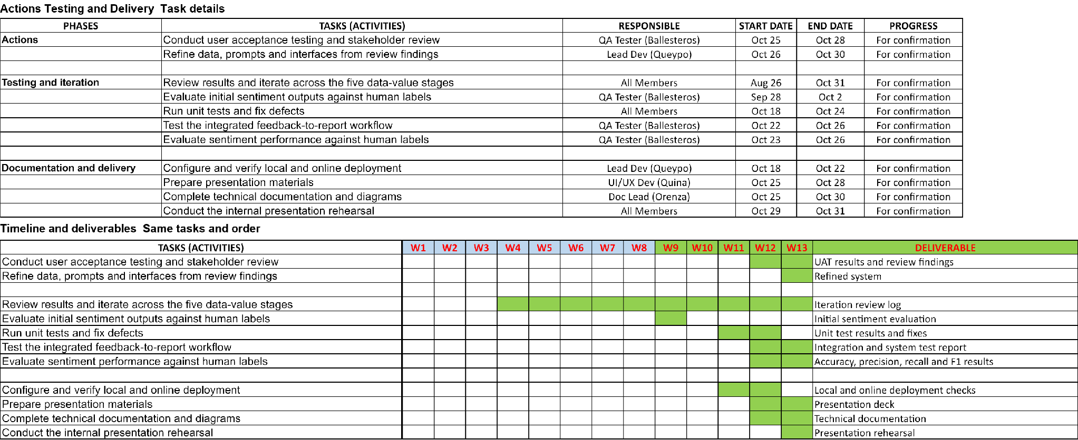
Figure 8 ResBack Gantt chart enlarged continuation panel 3 of 3

APPENDIX C USE CASE DIAGRAM
Figure 9 shows the 17 ResBack use cases and their actor associations, including Google Gemini API as the external supporting actor for accepted-feedback analysis. Student, Faculty, Admin, and Super Admin permissions are represented within the system boundary. Super Admin inherits administrative capabilities, while feedback screening and accepted-feedback analysis are associated with submission.
Appendix D provides the corresponding use case descriptions. Figure numbers identify each diagram’s position in this paper; labels within the source diagram sheets remain unchanged.
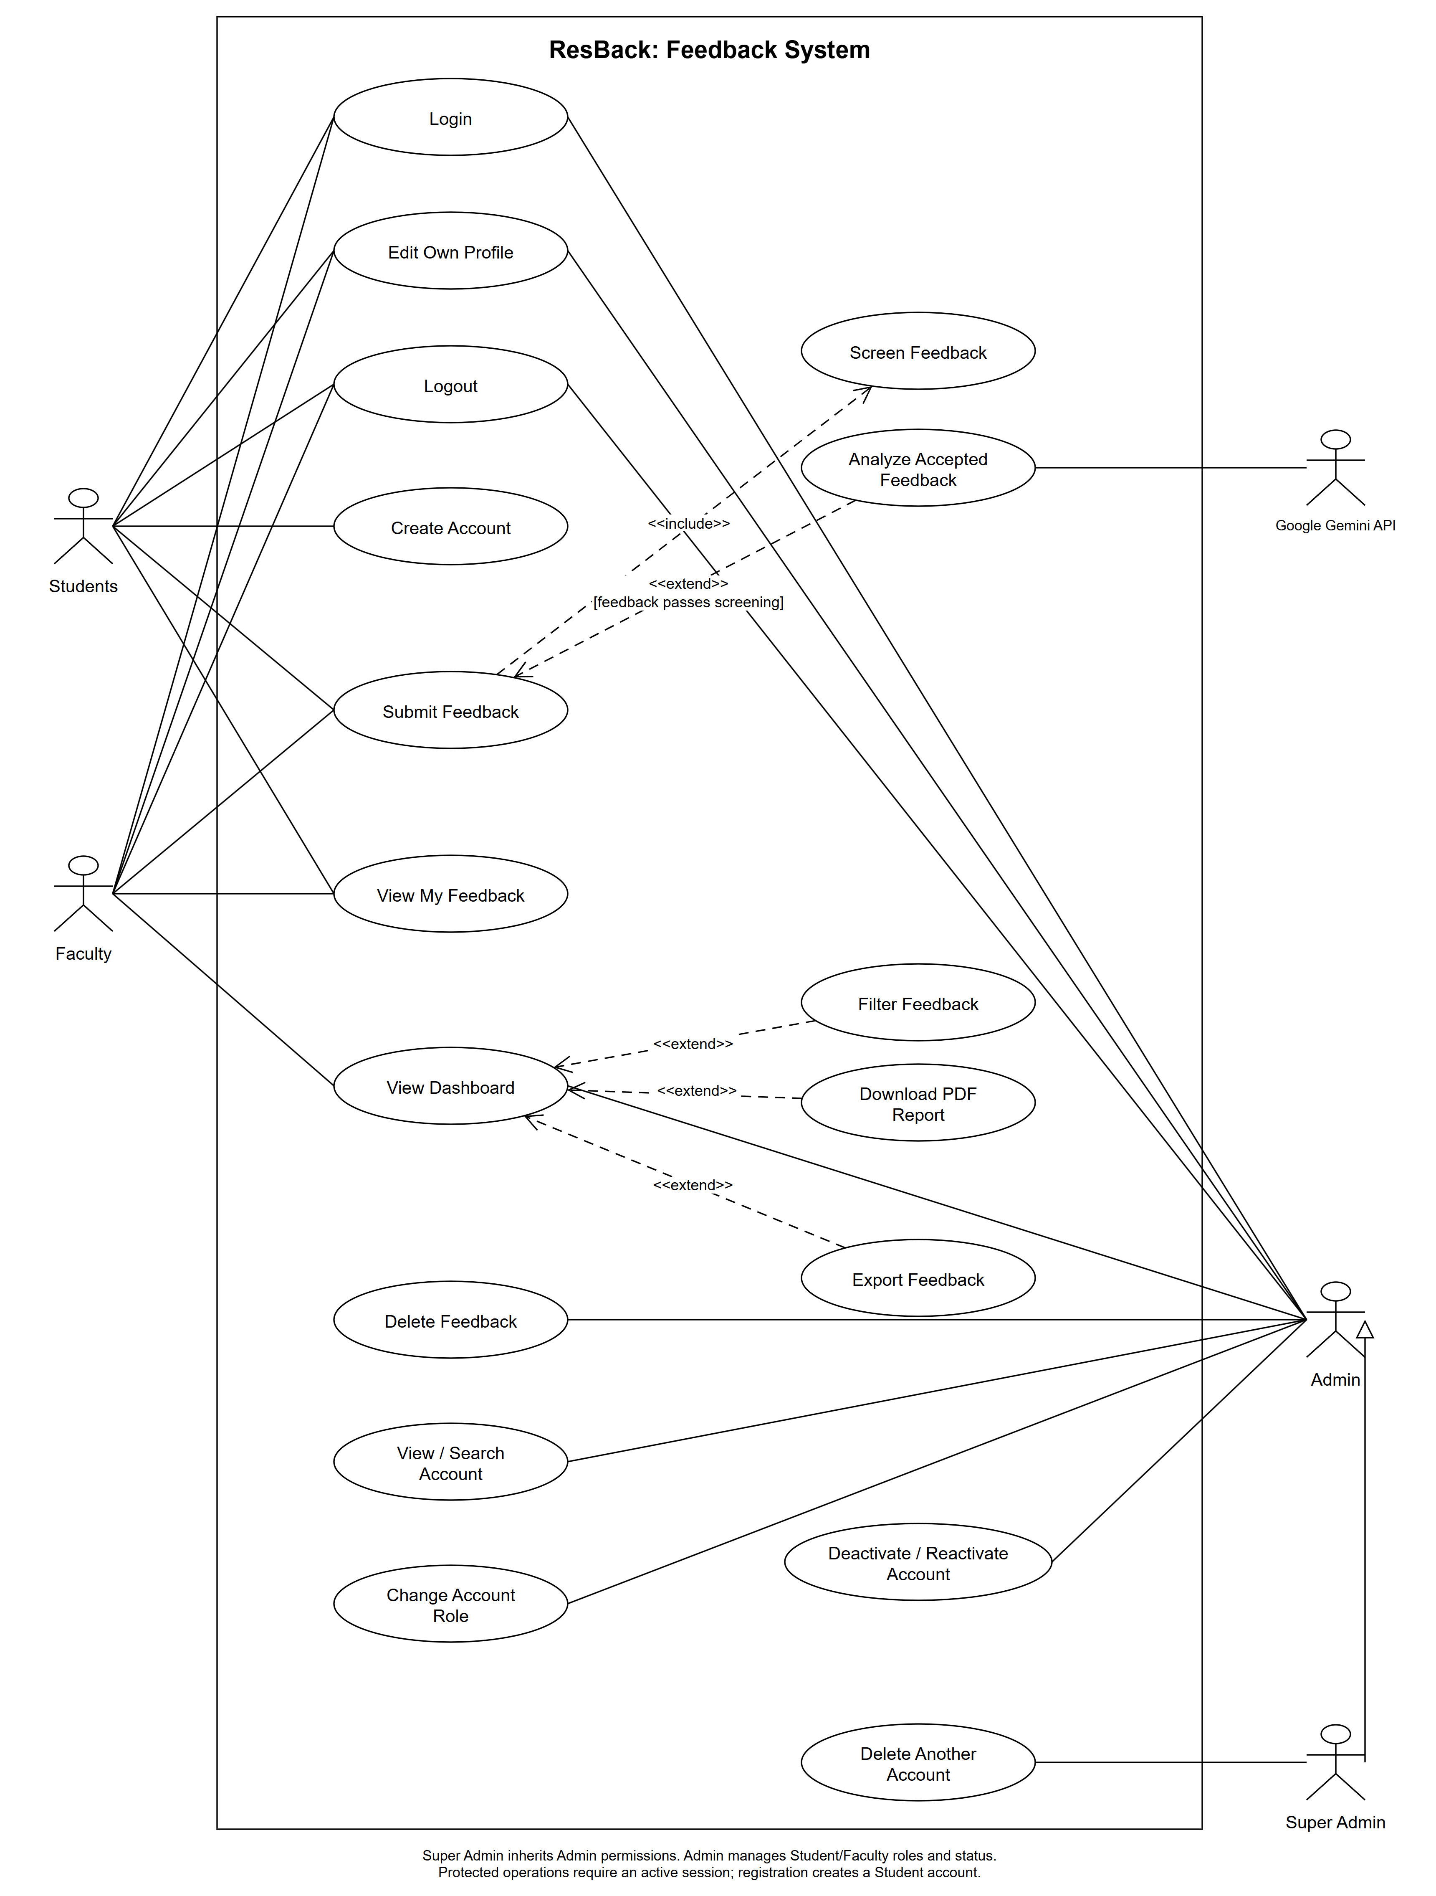
Figure 9 ResBack UML use case diagram

APPENDIX D USE CASE DESCRIPTIONS
The following 17 descriptions correspond to the use cases in Figure 9. Each table identifies the actors, preconditions, trigger, main steps, alternate and exception flows, postconditions, and non-functional requirements. The tables retain the previously prepared Lab 5 description format.
UC-01 Create Account
UC-02 Login
UC-03 Submit Feedback
UC-04 Screen Feedback
UC-05 Edit Own Profile
UC-06 Analyze Accepted Feedback
UC-07 View My Feedback
UC-08 View Dashboard
UC-09 Filter Feedback
UC-10 Download PDF Report
UC-11 Export Feedback
UC-12 Delete Feedback
UC-13 View / Search Account
UC-14 Delete Another Account
UC-15 Change Account Role
UC-16 Deactivate / Reactivate Account
UC-17 Logout
Table 5 UC-01 Create Account
Use Case Name | Create Account
Use Case ID | UC-01
Use Case Description | Allows a new Student to register an account and access the feedback submission form.
Primary Actor | Student registering a new account
Secondary Actor | None
Precondition | The Student is not signed in and can access the registration page.
Postcondition | A Student account is saved and an authenticated session opens the feedback form.
Normal Flow (Main Flow) | User Action | System Response
Normal Flow (Main Flow) | 1. Selects Create Account. | 2. Displays the registration form.
Normal Flow (Main Flow) | 3. Enters a nickname, email, password and password confirmation; submits the form. | 4. Validates the required fields, uniqueness and password confirmation.
Normal Flow (Main Flow) | 5. None | 6. Saves the account with the Student role and a hashed password.
Normal Flow (Main Flow) | 7. None | 8. Starts an authenticated session and displays the feedback form.
Alternate Flow | 1a. A Student who already has an account selects Login (UC-02) instead of registering again.
Exception Flow | 4a. Invalid or duplicate details prevent account creation. The system identifies the fields to correct. A storage failure prevents successful registration.
Non-Functional Requirements | Passwords must be hashed. Validation must not reveal stored passwords. The authenticated session must be regenerated.

Table 6 UC-02 Login
Use Case Name | Login
Use Case ID | UC-02
Use Case Description | Allows an existing user to access ResBack according to the account role.
Primary Actor | Student, Faculty, Admin or Super Admin
Secondary Actor | None
Precondition | The user has an active account and is not currently signed in.
Postcondition | The user is authenticated and reaches the feedback form or dashboard allowed for the role.
Normal Flow (Main Flow) | User Action | System Response
Normal Flow (Main Flow) | 1. Opens Login. | 2. Displays the email and password fields.
Normal Flow (Main Flow) | 3. Enters the registered email and password; selects Login. | 4. Validates the input, verifies the credentials and checks that the account is active.
Normal Flow (Main Flow) | 5. None | 6. Starts an authenticated session and regenerates the session identifier.
Normal Flow (Main Flow) | 7. None | 8. Opens the Student feedback form or the Faculty, Admin or Super Admin dashboard according to the account role.
Alternate Flow | 1a. A Student without an account selects Create Account (UC-01). Successful registration signs the Student in automatically.
Exception Flow | 4a. Incorrect credentials or an inactive account prevents login. Missing or invalid fields return validation errors.
Non-Functional Requirements | Password entry must be masked. Authentication errors must not expose stored credentials. Sessions must be protected from fixation.

Table 7 UC-03 Submit Feedback
Use Case Name | Submit Feedback
Use Case ID | UC-03
Use Case Description | Allows a Student or Faculty member to submit confidential CCIS feedback for screening and, when accepted, automatic analysis.
Primary Actor | Student or Faculty
Secondary Actor | None
Precondition | The submitter is signed in with an active Student or Faculty account and can access the active CCIS feedback category. Admin and Super Admin cannot submit feedback.
Postcondition | The feedback is saved with its screening and analysis result. The submitter receives the submission result.
Normal Flow (Main Flow) | User Action | System Response
Normal Flow (Main Flow) | 1. Opens Submit Feedback. | 2. Displays the CCIS feedback form.
Normal Flow (Main Flow) | 3. Enters feedback and selects Submit. | 4. Validates the content, category, duplicate submission and submission limit.
Normal Flow (Main Flow) | 5. None | 6. Performs Screen Feedback (UC-04) and saves accepted feedback as pending.
Normal Flow (Main Flow) | 7. None | 8. Performs Analyze Accepted Feedback (UC-06) and displays the stored status and available analysis.
Alternate Flow | 6a. If screening detects prohibited content, the system saves the feedback as rejected, displays the rejection result and skips UC-06.
Exception Flow | 4a. Invalid content/category, duplicate feedback or exceeding the submission limit prevents saving. 8a. Analysis failure leaves the saved feedback marked failed.
Non-Functional Requirements | Feedback history must remain private to its owner. The result must distinguish an unsaved submission from a saved record whose analysis failed.

Table 8 UC-04 Screen Feedback
Use Case Name | Screen Feedback
Use Case ID | UC-04
Use Case Description | Checks submitted feedback against configured prohibited-content rules before analysis.
Primary Actor | Student or Faculty through Submit Feedback (UC-03)
Secondary Actor | None
Precondition | Feedback has passed submission validation and duplicate and submission-limit checks.
Postcondition | The screening decision is returned to Submit Feedback; rejected content is excluded from AI analysis.
Normal Flow (Main Flow) | User Action | System Response
Normal Flow (Main Flow) | 1. None | 2. Receives the validated feedback text from Submit Feedback (UC-03).
Normal Flow (Main Flow) | 3. None | 4. Normalizes the text and configured blocked terms and their variants.
Normal Flow (Main Flow) | 5. None | 6. Checks the normalized text for prohibited matches.
Normal Flow (Main Flow) | 7. None | 8. Returns an accepted decision to UC-03 when no prohibited match is found; UC-03 saves the feedback as pending and continues to UC-06.
Alternate Flow | 6a. A prohibited match returns a rejected decision to UC-03. The system saves the record as rejected, displays the rejection result and skips UC-06.
Exception Flow | 4a/6a. A screening error prevents successful completion; the system must not report the submission as successfully analyzed.
Non-Functional Requirements | Screening must apply the configured rules consistently. It must preserve the original feedback text and keep rejected content out of dashboard reports.

Table 9 UC-05 Edit Own Profile
Use Case Name | Edit Own Profile
Use Case ID | UC-05
Use Case Description | Allows a signed-in user to update the user's own nickname and optional profile photo.
Primary Actor | Student, Faculty, Admin or Super Admin
Secondary Actor | None
Precondition | The user is signed in with an active account.
Postcondition | Valid profile changes are saved and a confirmation is displayed.
Normal Flow (Main Flow) | User Action | System Response
Normal Flow (Main Flow) | 1. Opens the profile page. | 2. Displays the current nickname and profile photo.
Normal Flow (Main Flow) | 3. Changes the nickname or selects a new photo; selects Save. | 4. Validates nickname uniqueness and the permitted photo type and size.
Normal Flow (Main Flow) | 5. None | 6. Stores or removes the profile photo as requested and updates only the signed-in user's profile.
Normal Flow (Main Flow) | 7. None | 8. Displays the updated profile and a confirmation message.
Alternate Flow | 3a. The user chooses to remove the existing photo before selecting Save. The user may leave the page without saving; existing details remain.
Exception Flow | 4a. A duplicate/invalid nickname or an invalid photo prevents the update. 6a. A photo-storage failure prevents successful completion.
Non-Functional Requirements | Users must only edit their own profiles. Nicknames protect real-name privacy. Photo uploads must be validated before storage.

Table 10 UC-06 Analyze Accepted Feedback
Use Case Name | Analyze Accepted Feedback
Use Case ID | UC-06
Use Case Description | Classifies accepted feedback by sentiment, language and concern topics using Gemma through the Gemini API.
Primary Actor | Student or Faculty through Submit Feedback (UC-03)
Secondary Actor | Google Gemini API (hosted Gemma inference service)
Precondition | Screen Feedback (UC-04) accepted the content; the feedback is saved as pending and the analysis service is configured.
Postcondition | A valid analysis result is saved, the feedback is marked analyzed and its category concern rankings are rebuilt.
Normal Flow (Main Flow) | User Action | System Response
Normal Flow (Main Flow) | 1. None | 2. Starts analysis for the accepted feedback record saved as pending by UC-03.
Normal Flow (Main Flow) | 3. None | 4. Sends the feedback to the Gemini API with the required classification instructions.
Normal Flow (Main Flow) | 5. None | 6. Receives and validates the returned sentiment, confidence, keywords, topics and language data.
Normal Flow (Main Flow) | 7. None | 8. Saves the result, marks the feedback analyzed and rebuilds the concern rankings; returns control to UC-03 to display the result.
Alternate Flow | 4a. A temporary request failure may trigger a retry before the final result is determined.
Exception Flow | 4a/6a. Missing configuration, connection failure, API error or unusable output marks the saved feedback failed; it does not create a successful analysis result.
Non-Functional Requirements | API credentials must remain confidential and transport must use TLS. Returned data must be validated. A service failure must preserve the submitted record.

Table 11 UC-07 View My Feedback
Use Case Name | View My Feedback
Use Case ID | UC-07
Use Case Description | Allows a submitter to review only the feedback records belonging to the signed-in account.
Primary Actor | Student or Faculty
Secondary Actor | None
Precondition | The Student or Faculty member is signed in with an active account. Feedback history is restricted to the account owner.
Postcondition | The user sees the personal feedback history with processing status and available analysis.
Normal Flow (Main Flow) | User Action | System Response
Normal Flow (Main Flow) | 1. Selects View My Feedback. | 2. Checks that the signed-in user is permitted to access personal feedback history.
Normal Flow (Main Flow) | 3. None | 4. Retrieves only the user's feedback records with their categories and available analysis, newest first.
Normal Flow (Main Flow) | 5. None | 6. Displays the personal feedback history, processing statuses and available analysis in a paginated list.
Normal Flow (Main Flow) | 7. Selects the next or previous history page when available. | 8. Displays the requested page of the same user's records.
Alternate Flow | 4a. If the user has no submissions, the system displays an empty history. 6a. Records without analysis show their current status.
Exception Flow | 1a. An expired session requires Login (UC-02). A retrieval failure prevents the history from being displayed.
Non-Functional Requirements | History queries must enforce ownership. Pagination must not expose another user's records. Status labels must distinguish rejected, pending, failed and analyzed feedback.

Table 12 UC-08 View Dashboard
Use Case Name | View Dashboard
Use Case ID | UC-08
Use Case Description | Allows authorized users to review CCIS feedback summaries, sentiment and language distributions, trends and ranked concerns.
Primary Actor | Faculty, Admin or Super Admin
Secondary Actor | None
Precondition | The user is signed in with an active account and a role permitted to access the dashboard.
Postcondition | The dashboard displays the available reportable feedback and analytics for the current scope.
Normal Flow (Main Flow) | User Action | System Response
Normal Flow (Main Flow) | 1. Opens View Dashboard. | 2. Checks dashboard access and retrieves reportable CCIS feedback.
Normal Flow (Main Flow) | 3. None | 4. Calculates feedback counts, sentiment and language distributions and trends.
Normal Flow (Main Flow) | 5. None | 6. Builds the leading concern rankings and retrieves the paginated feedback list.
Normal Flow (Main Flow) | 7. None | 8. Displays the dashboard summaries, charts, concerns and feedback, with Filter Feedback (UC-09), Download PDF Report (UC-10) and Export Feedback (UC-11).
Alternate Flow | 2a. With no reportable records, the dashboard shows zero totals and an empty list. After step 8, the user may activate UC-09, UC-10 or UC-11.
Exception Flow | 1a. A Student or other unauthorized user is denied dashboard access. Invalid scope values or a retrieval failure prevent the requested view.
Non-Functional Requirements | Access must be role controlled. Rejected feedback must be excluded from reports. Dashboard records must not disclose submitters' email addresses or real names.

Table 13 UC-09 Filter Feedback
Use Case Name | Filter Feedback
Use Case ID | UC-09
Use Case Description | Narrows dashboard feedback and analytics by supported language and date-range criteria.
Primary Actor | Faculty, Admin or Super Admin
Secondary Actor | None
Precondition | View Dashboard (UC-08) is open and the user has dashboard permission.
Postcondition | Dashboard records and analytics reflect the selected valid filter criteria.
Normal Flow (Main Flow) | User Action | System Response
Normal Flow (Main Flow) | 1. Opens the dashboard filter controls. | 2. Displays supported language and date-range options for CCIS.
Normal Flow (Main Flow) | 3. Selects the desired criteria and applies the filters. | 4. Validates the selected criteria.
Normal Flow (Main Flow) | 5. None | 6. Retrieves matching reportable feedback and recalculates analytics for the selected scope.
Normal Flow (Main Flow) | 7. None | 8. Displays the filtered feedback and analytics; retains the scope for PDF and spreadsheet downloads.
Alternate Flow | 3a. The user clears optional filters to restore the default CCIS view. 6a. No matching records produces an empty result.
Exception Flow | 4a. Unsupported language/category values or invalid date ranges prevent applying the requested filter. A retrieval failure prevents refreshed results.
Non-Functional Requirements | The same criteria must be applied consistently to records, analytics and downloads. Filter use must not bypass access restrictions.

Table 14 UC-10 Download PDF Report
Use Case Name | Download PDF Report
Use Case ID | UC-10
Use Case Description | Produces a downloadable PDF containing CCIS feedback summaries, concern rankings and reportable feedback for the selected scope.
Primary Actor | Faculty, Admin or Super Admin
Secondary Actor | None
Precondition | The user has dashboard permission and the requested language and date filters are valid.
Postcondition | A PDF report is generated and returned for download.
Normal Flow (Main Flow) | User Action | System Response
Normal Flow (Main Flow) | 1. Selects Download PDF Report for the current dashboard scope. | 2. Checks access and validates the requested language and date filters.
Normal Flow (Main Flow) | 3. None | 4. Retrieves matching reportable CCIS feedback and calculates summaries and concern rankings.
Normal Flow (Main Flow) | 5. None | 6. Renders the PDF report with the selected scope and page numbering.
Normal Flow (Main Flow) | 7. None | 8. Returns the PDF for download with a descriptive filename.
Alternate Flow | 1a. With no optional filters, the report uses the default CCIS scope. 4a. With no matching feedback, the report contains the available zero/empty summaries.
Exception Flow | 2a. Invalid filters or unauthorized access prevents download. 4a/6a. A retrieval or PDF-generation failure prevents a completed report.
Non-Functional Requirements | The PDF must be readable with consistent pagination. It must reflect the selected scope, exclude rejected feedback and avoid submitters' identifying account data.

Table 15 UC-11 Export Feedback
Use Case Name | Export Feedback
Use Case ID | UC-11
Use Case Description | Exports matching reportable CCIS feedback and available analysis to an Excel spreadsheet.
Primary Actor | Faculty, Admin or Super Admin
Secondary Actor | None
Precondition | The user has dashboard permission and the requested filters are valid.
Postcondition | An XLSX spreadsheet is generated and returned for download.
Normal Flow (Main Flow) | User Action | System Response
Normal Flow (Main Flow) | 1. Selects Export Feedback for the current dashboard scope. | 2. Checks access and validates the requested language and date filters.
Normal Flow (Main Flow) | 3. None | 4. Retrieves matching reportable CCIS feedback and available analysis.
Normal Flow (Main Flow) | 5. None | 6. Writes feedback, dates, statuses and analysis into an XLSX spreadsheet with column headings and formatted values.
Normal Flow (Main Flow) | 7. None | 8. Returns the XLSX file for download with a descriptive filename.
Alternate Flow | 1a. With no optional filters, the export uses the default CCIS scope. 4a. No matching feedback produces a spreadsheet containing the column headings.
Exception Flow | 2a. Invalid filters or unauthorized access prevents export. 4a/6a. A retrieval or spreadsheet-generation failure prevents a completed download.
Non-Functional Requirements | The export must preserve the selected scope and exclude rejected feedback and identifying account fields. Feedback text must be written as text rather than executable spreadsheet formulas.

Table 16 UC-12 Delete Feedback
Use Case Name | Delete Feedback
Use Case ID | UC-12
Use Case Description | Allows an administrator to permanently remove a selected feedback record and its associated analysis.
Primary Actor | Admin or Super Admin
Secondary Actor | None
Precondition | The administrator is signed in with an active account and the selected feedback exists.
Postcondition | The feedback and associated analysis are removed; the dashboard displays a deletion confirmation.
Normal Flow (Main Flow) | User Action | System Response
Normal Flow (Main Flow) | 1. Locates a feedback record on the dashboard. | 2. Displays the record and the permitted delete control.
Normal Flow (Main Flow) | 3. Selects Delete Feedback. | 4. Presents the deletion confirmation.
Normal Flow (Main Flow) | 5. Confirms deletion. | 6. Checks administrator permission and permanently deletes the record and associated analysis.
Normal Flow (Main Flow) | 7. None | 8. Displays confirmation and the remaining feedback records.
Alternate Flow | 5a. The administrator cancels confirmation; the feedback remains unchanged.
Exception Flow | 6a. A Faculty or Student user cannot delete feedback. A missing record or database failure prevents successful deletion.
Non-Functional Requirements | Deletion must enforce administrator authorization and request protection. Confirmation must make the permanent effect clear. Associated analysis must not remain orphaned.

Table 17 UC-13 View / Search Account
Use Case Name | View / Search Account
Use Case ID | UC-13
Use Case Description | Allows an administrator to view registered accounts and search them by nickname.
Primary Actor | Admin or Super Admin
Secondary Actor | None
Precondition | The administrator is signed in with an active account and has account-management access.
Postcondition | The account list or nickname search results are displayed.
Normal Flow (Main Flow) | User Action | System Response
Normal Flow (Main Flow) | 1. Opens View / Search Account. | 2. Displays accounts with nickname, role, status and registration date.
Normal Flow (Main Flow) | 3. Enters a nickname or part of a nickname and submits the search. | 4. Validates the search text.
Normal Flow (Main Flow) | 5. None | 6. Retrieves accounts matching the nickname search.
Normal Flow (Main Flow) | 7. None | 8. Displays the paginated results while retaining the search criteria.
Alternate Flow | 3a. An empty search displays the full paginated list. 6a. No matching nickname displays an empty result. After step 8, the administrator may select another result page or an authorized account action (UC-14, UC-15 or UC-16).
Exception Flow | 1a. An unauthorized user is denied access. Invalid search input or a retrieval failure prevents the requested result.
Non-Functional Requirements | Account lists must use nicknames and omit email addresses and real names. Search must enforce administrator access and validate input.

Table 18 UC-14 Delete Another Account
Use Case Name | Delete Another Account
Use Case ID | UC-14
Use Case Description | Allows a Super Admin to permanently delete an account other than the currently signed-in account.
Primary Actor | Super Admin
Secondary Actor | None
Precondition | The Super Admin is signed in with an active account; the target account exists and belongs to another user.
Postcondition | The target account is deleted and the updated account list shows a confirmation.
Normal Flow (Main Flow) | User Action | System Response
Normal Flow (Main Flow) | 1. Finds the target using View / Search Account (UC-13). | 2. Displays the account and its permitted delete control.
Normal Flow (Main Flow) | 3. Selects Delete Another Account. | 4. Presents confirmation identifying the target by nickname.
Normal Flow (Main Flow) | 5. Confirms the deletion. | 6. Verifies Super Admin permission and checks that the target is not the signed-in account.
Normal Flow (Main Flow) | 7. None | 8. Deletes the target account and displays the updated account list with a success message.
Alternate Flow | 5a. The Super Admin cancels confirmation; the target account remains unchanged.
Exception Flow | 6a. A regular Admin or any other role cannot delete accounts. Self-deletion is blocked. A missing target or database failure prevents successful completion.
Non-Functional Requirements | Super Admin authorization and request protection must be enforced. Confirmation must make permanent deletion clear without exposing email addresses or real names.

Table 19 UC-15 Change Account Role
Use Case Name | Change Account Role
Use Case ID | UC-15
Use Case Description | Allows an administrator to assign a permitted role to another registered account.
Primary Actor | Admin or Super Admin
Secondary Actor | None
Precondition | The administrator is signed in with an active account and has opened View / Search Account (UC-13). The target account exists and is not the signed-in account.
Postcondition | The permitted role is saved for the target account and a confirmation is displayed.
Normal Flow (Main Flow) | User Action | System Response
Normal Flow (Main Flow) | 1. Opens View / Search Account (UC-13). | 2. Displays account nicknames, current roles, statuses and permitted role controls.
Normal Flow (Main Flow) | 3. Selects another account, chooses a permitted role and selects Save. | 4. Checks administrator authority and blocks self-role changes. Admin may manage only Student/Faculty targets; Super Admin may also manage administrator targets.
Normal Flow (Main Flow) | 5. None | 6. Validates the selected role. Admin may assign Student or Faculty; Super Admin may also assign Admin or Super Admin.
Normal Flow (Main Flow) | 7. None | 8. Updates the target account role and displays confirmation.
Alternate Flow | 3a. The administrator leaves the page without saving; the current role remains unchanged.
Exception Flow | 4a. Self-role changes or unauthorized management of an administrator account are blocked. 6a. An invalid or disallowed role prevents the update. A missing target or database failure prevents successful completion.
Non-Functional Requirements | Authorization must be enforced on the server. Requests must be protected against forgery. Account controls must identify users by nickname and protect the signed-in account.

Table 20 UC-16 Deactivate / Reactivate Account
Use Case Name | Deactivate / Reactivate Account
Use Case ID | UC-16
Use Case Description | Allows an administrator to deactivate or reactivate another account within the administrator's authority.
Primary Actor | Admin or Super Admin
Secondary Actor | None
Precondition | The administrator is signed in with an active account and has opened View / Search Account (UC-13). The target account exists and is not the signed-in account.
Postcondition | The target account status is changed and a confirmation is displayed. Deactivated accounts cannot log in or access operations that require an active account.
Normal Flow (Main Flow) | User Action | System Response
Normal Flow (Main Flow) | 1. Opens View / Search Account (UC-13). | 2. Displays account nicknames, roles, statuses and permitted status controls.
Normal Flow (Main Flow) | 3. Selects Deactivate for an active target or Reactivate for an inactive target. | 4. Checks administrator authority and blocks changes to the signed-in account. Admin may manage only Student/Faculty targets; Super Admin may also manage administrator targets.
Normal Flow (Main Flow) | 5. None | 6. Changes the target's active status to the opposite state and saves it.
Normal Flow (Main Flow) | 7. None | 8. Displays the updated status and a confirmation message.
Alternate Flow | 3a. For an inactive account, Reactivate restores active status. For an active account, Deactivate removes active status.
Exception Flow | 4a. Changing the signed-in account's status or unauthorized management of an administrator account is blocked. A missing target or database failure prevents successful completion.
Non-Functional Requirements | Status updates must enforce role restrictions and request protection. Active-account checks must prevent a deactivated user from accessing protected operations.

Table 21 UC-17 Logout
Use Case Name | Logout
Use Case ID | UC-17
Use Case Description | Allows a signed-in actor to end the current authenticated session.
Primary Actor | Student, Faculty, Admin or Super Admin
Secondary Actor | None
Precondition | The actor has an authenticated session.
Postcondition | The actor is signed out, the session is invalidated and the Login page is displayed.
Normal Flow (Main Flow) | User Action | System Response
Normal Flow (Main Flow) | 1. Selects Logout. | 2. Ends authentication for the current session.
Normal Flow (Main Flow) | 3. None | 4. Invalidates the session and clears its stored data.
Normal Flow (Main Flow) | 5. None | 6. Regenerates the request-protection token.
Normal Flow (Main Flow) | 7. None | 8. Redirects the actor to Login (UC-02).
Alternate Flow | 1a. If the session has already expired, access to the authenticated logout route redirects the actor to Login.
Exception Flow | 2a. An invalid request-protection token prevents the logout request from being processed; the actor must reload the page and submit a valid request.
Non-Functional Requirements | Logout must use a protected POST request. Invalidated sessions must not authorize further access to authenticated pages.

APPENDIX E ACTIVITY DIAGRAMS
Figures 10–21 show the twelve ResBack activities. Swimlanes separate user and system responsibilities. Every activity has one final endpoint; additional exits in the corrected diagrams loop back to an action. Larger workflows include continuation panels for readability.
Figure 10. Registration validates account details, handles duplicate values, creates an active Student account, and starts an authenticated session.
Figure 11. Login checks credentials and account status before routing the user according to role. Extra endings return to an action through a loop.
Figure 12. Submission covers confirmation, validation, duplicate and rate checks, screening, storage, and accepted or rejected results.
Figure 13. Personal feedback history displays the signed-in user’s submissions, processing status, and pagination.
Figure 14. Dashboard review validates date and language filters, retrieves matching feedback, summarizes sentiment, and ranks concerns.
Figure 15. Account management covers search, protected-account checks, role and status changes, and permitted account deletion. Disallowed or canceled actions return to the relevant action.
Figure 16. Analysis performs synchronous Gemma inference, validates the response, normalizes language and concern topics, stores results, and rebuilds rankings. Failed analysis remains visible as a failed status.
Figure 17. Excel export applies the selected filters and downloads feedback without submitter identities or rejected submissions.
Figure 18. PDF reporting uses the same filters and presents summaries and supporting feedback, including an empty state when appropriate.
Figure 19. Feedback deletion checks permission and the selected record. Cancellation preserves the record and returns to the previous action.
Figure 20. Profile editing validates the nickname and photo, handles photo replacement or removal, and saves permitted changes.
Figure 21. Logout invalidates the authenticated session, refreshes the CSRF token, and redirects the user.
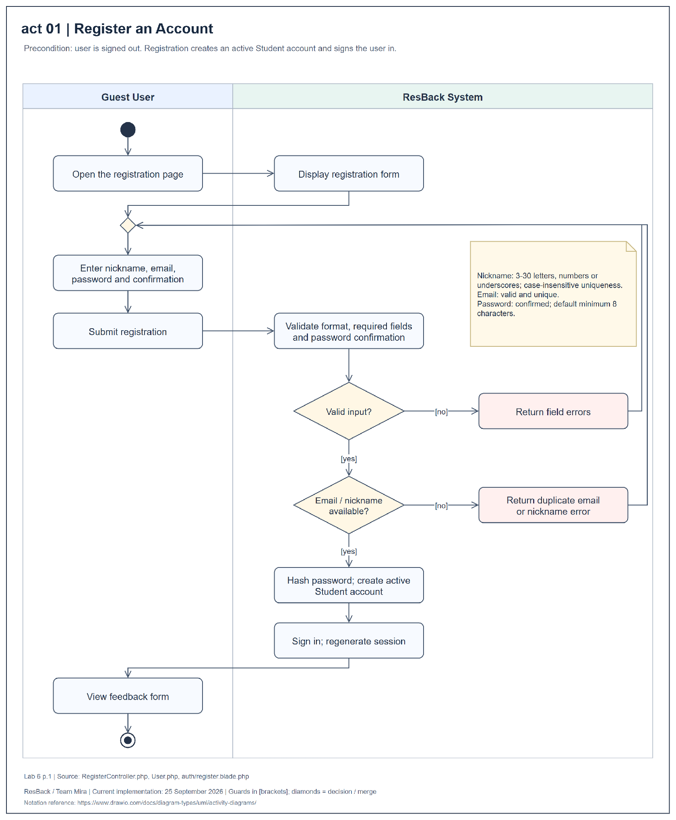
Figure 10 Activity diagram for register an account
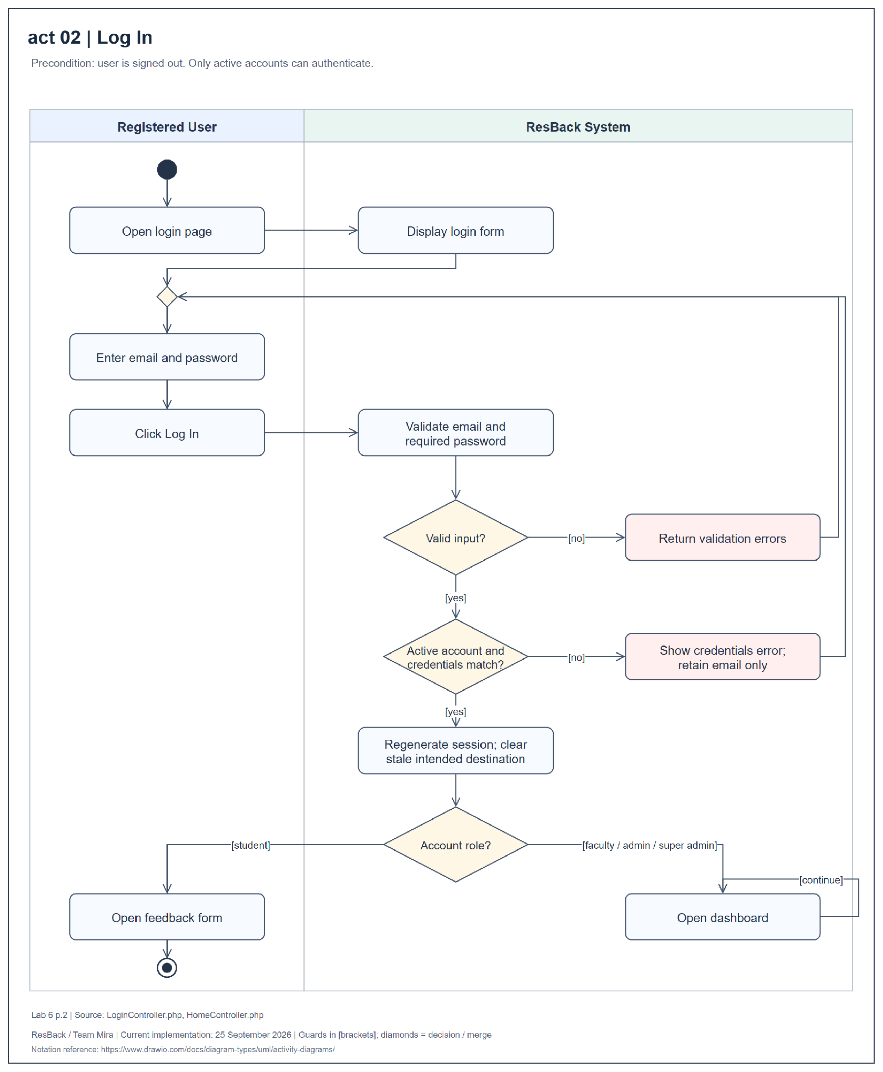
Figure 11 Activity diagram for log in
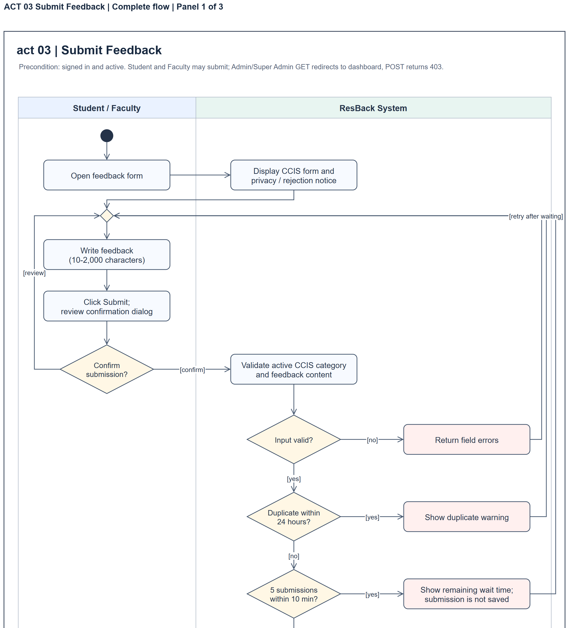
Figure 12 Activity diagram for submit feedback complete flow panel 1 of 3
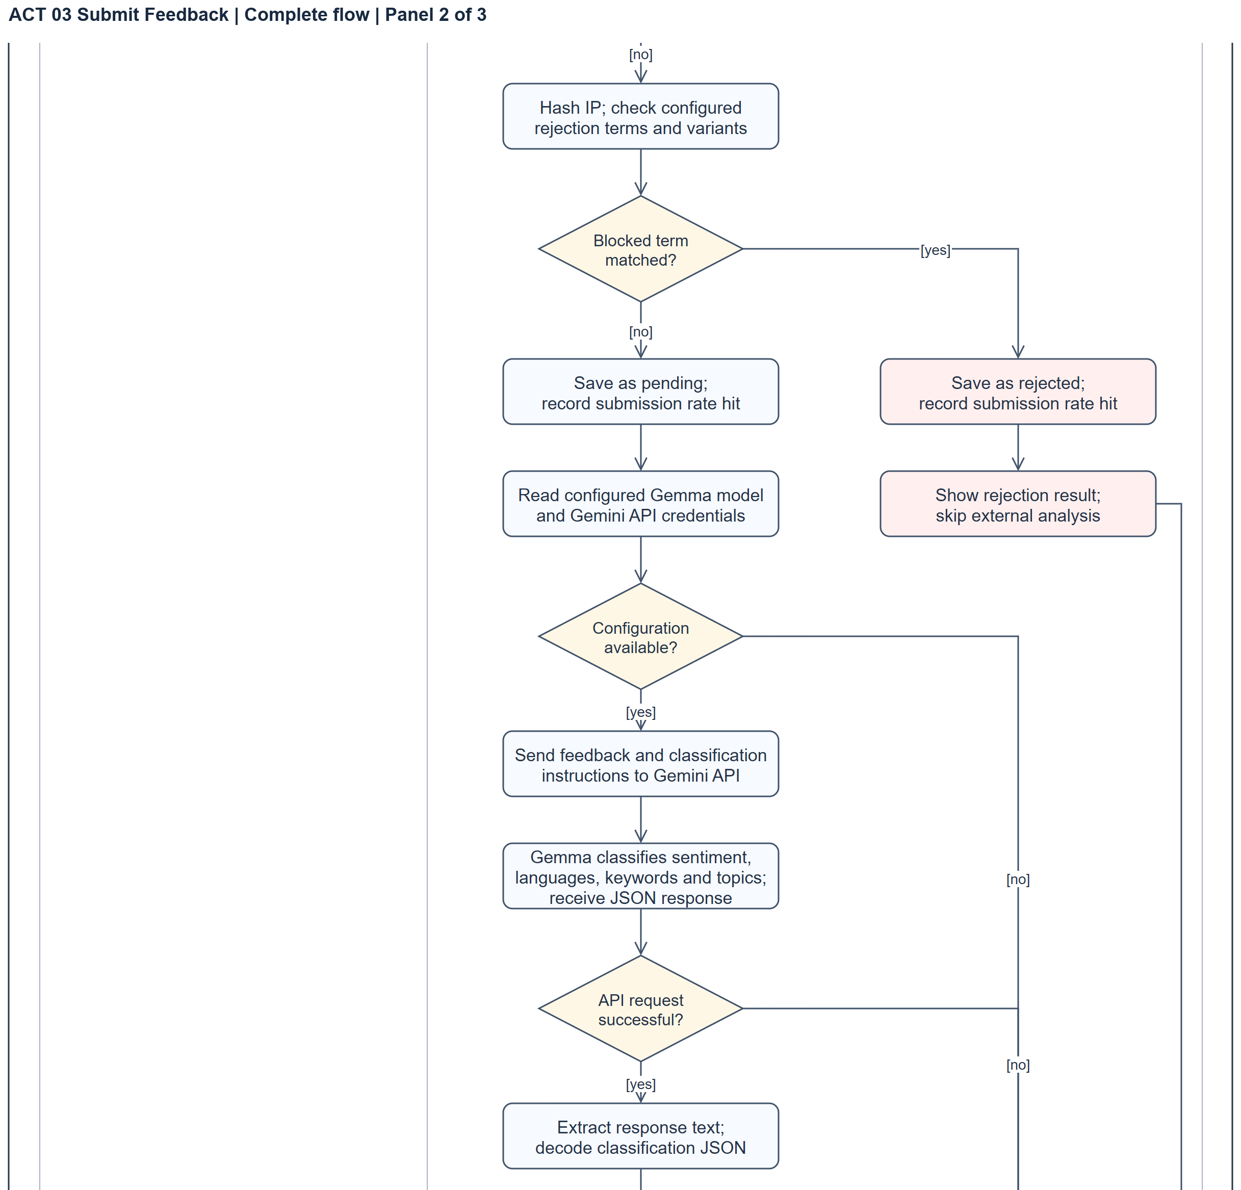
Figure 12 Activity diagram for submit feedback complete flow panel 2 of 3
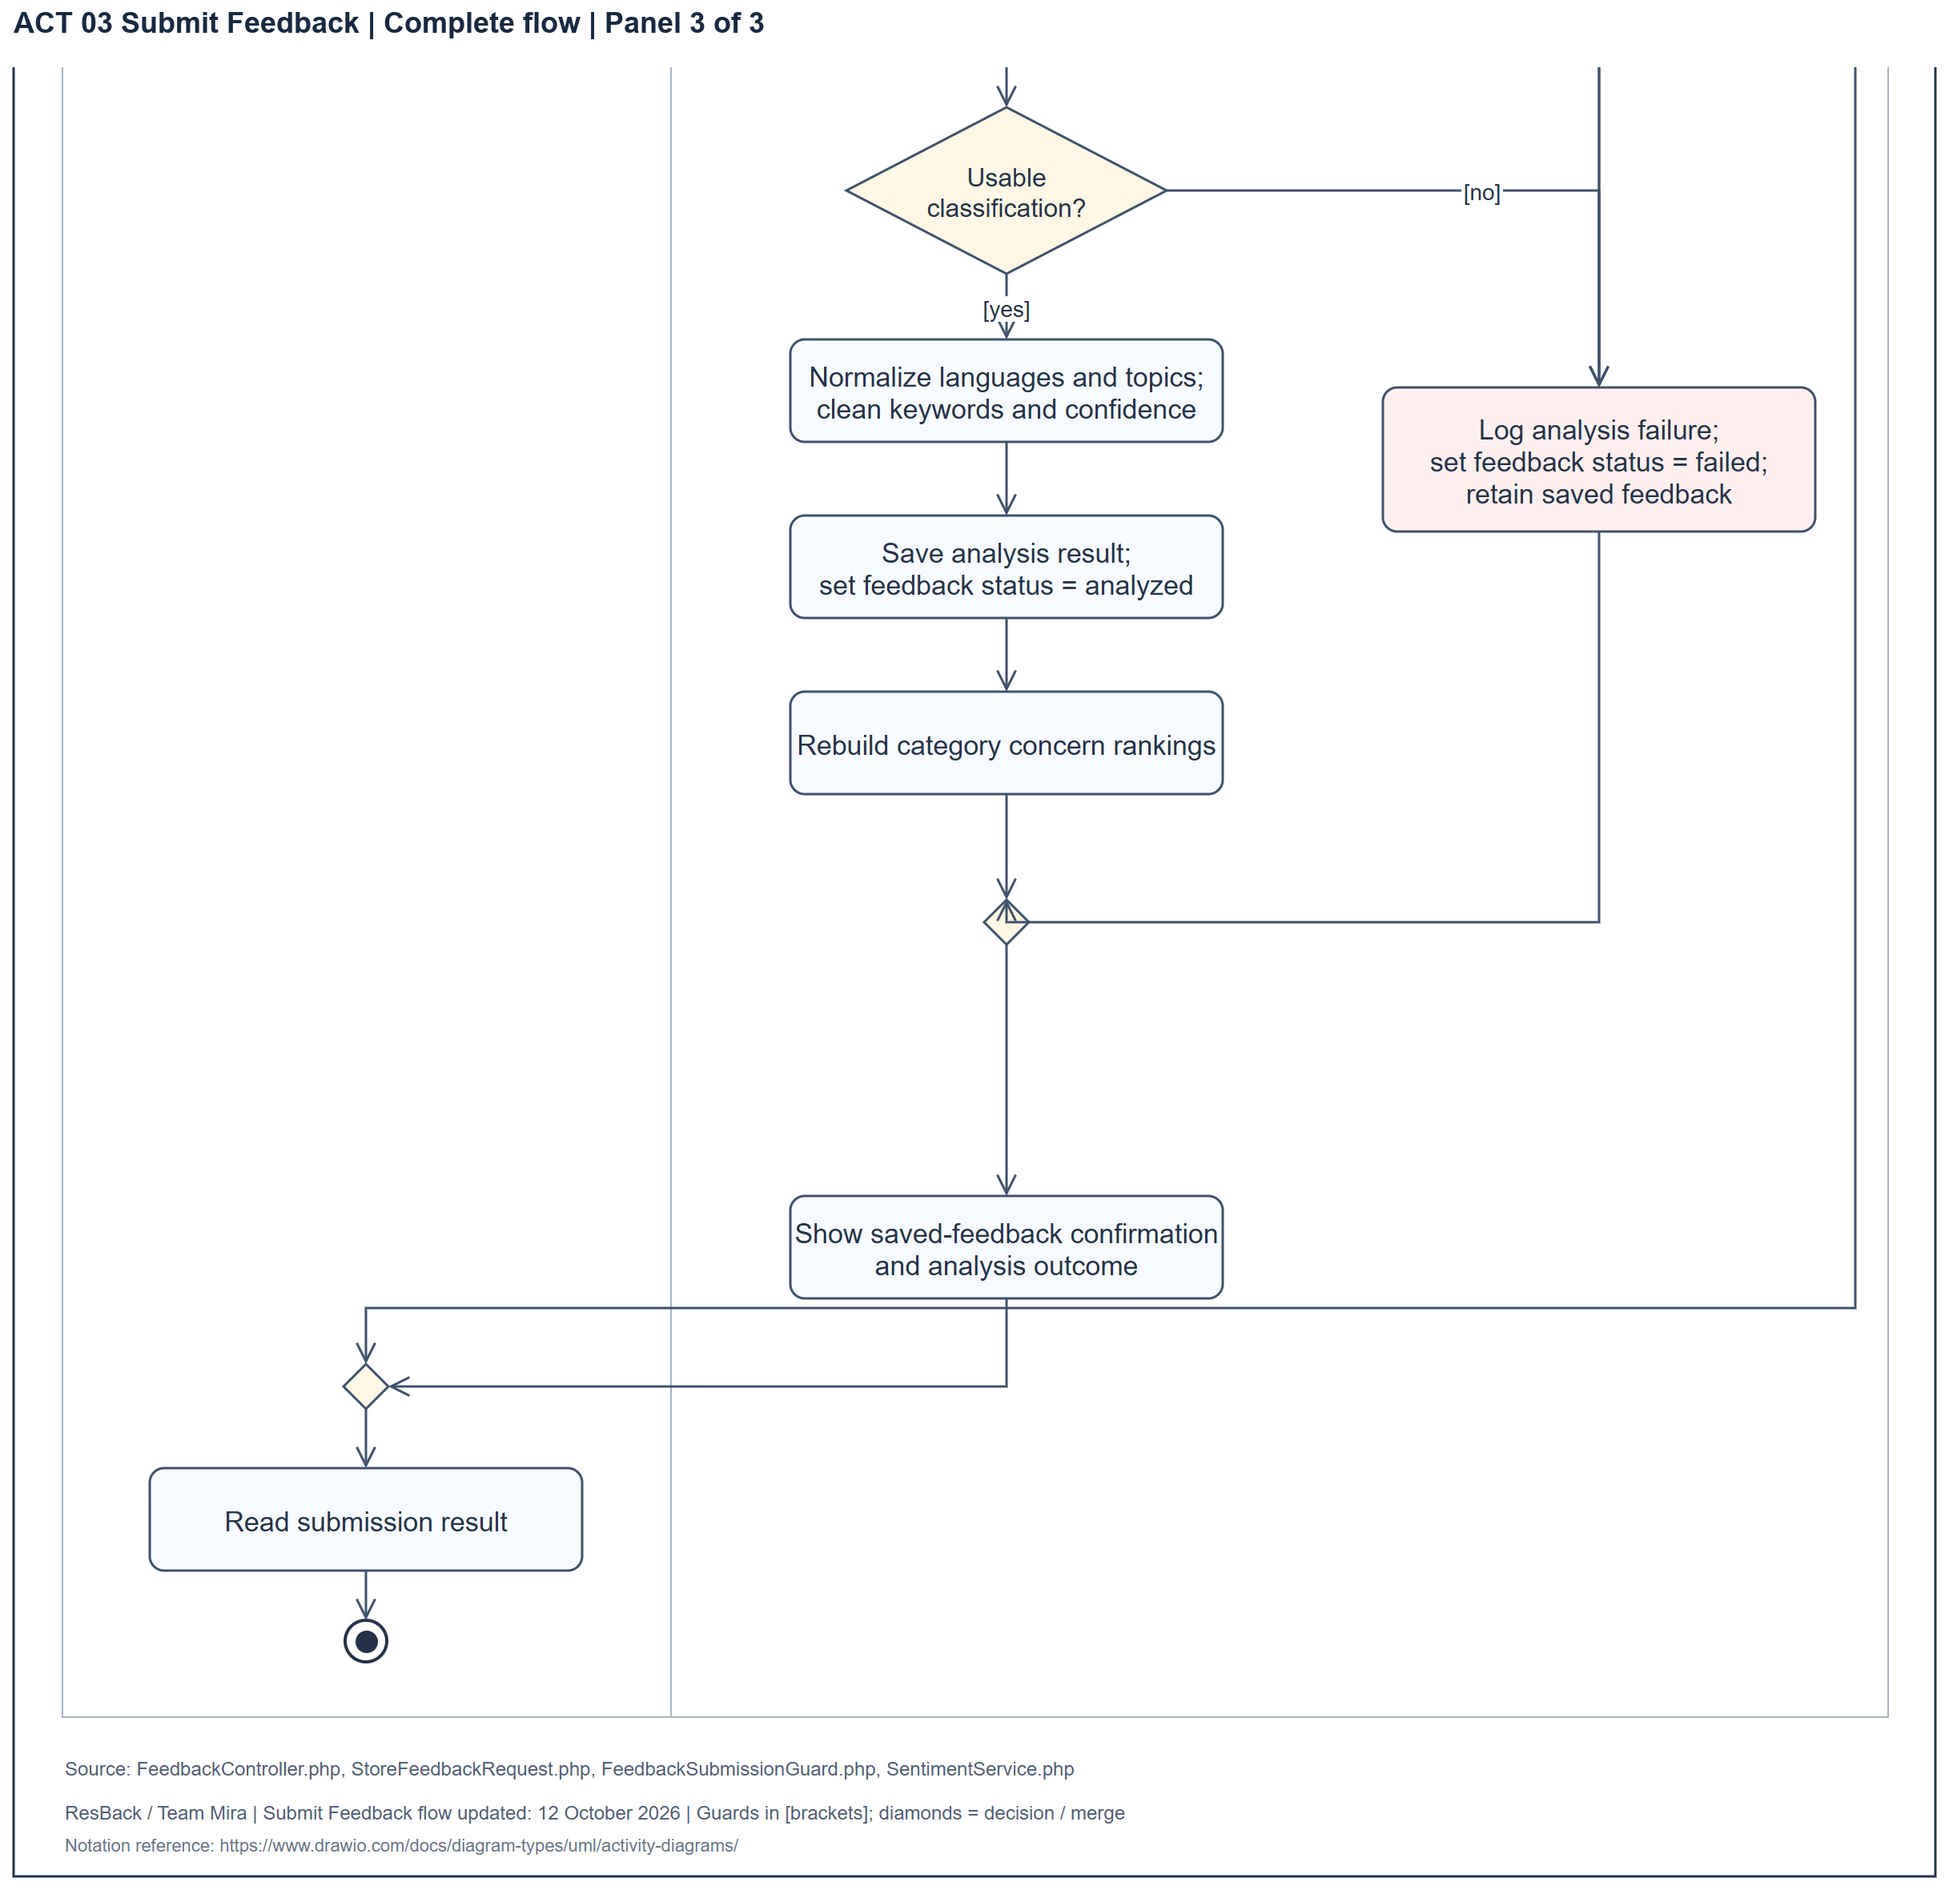
Figure 12 Activity diagram for submit feedback complete flow panel 3 of 3
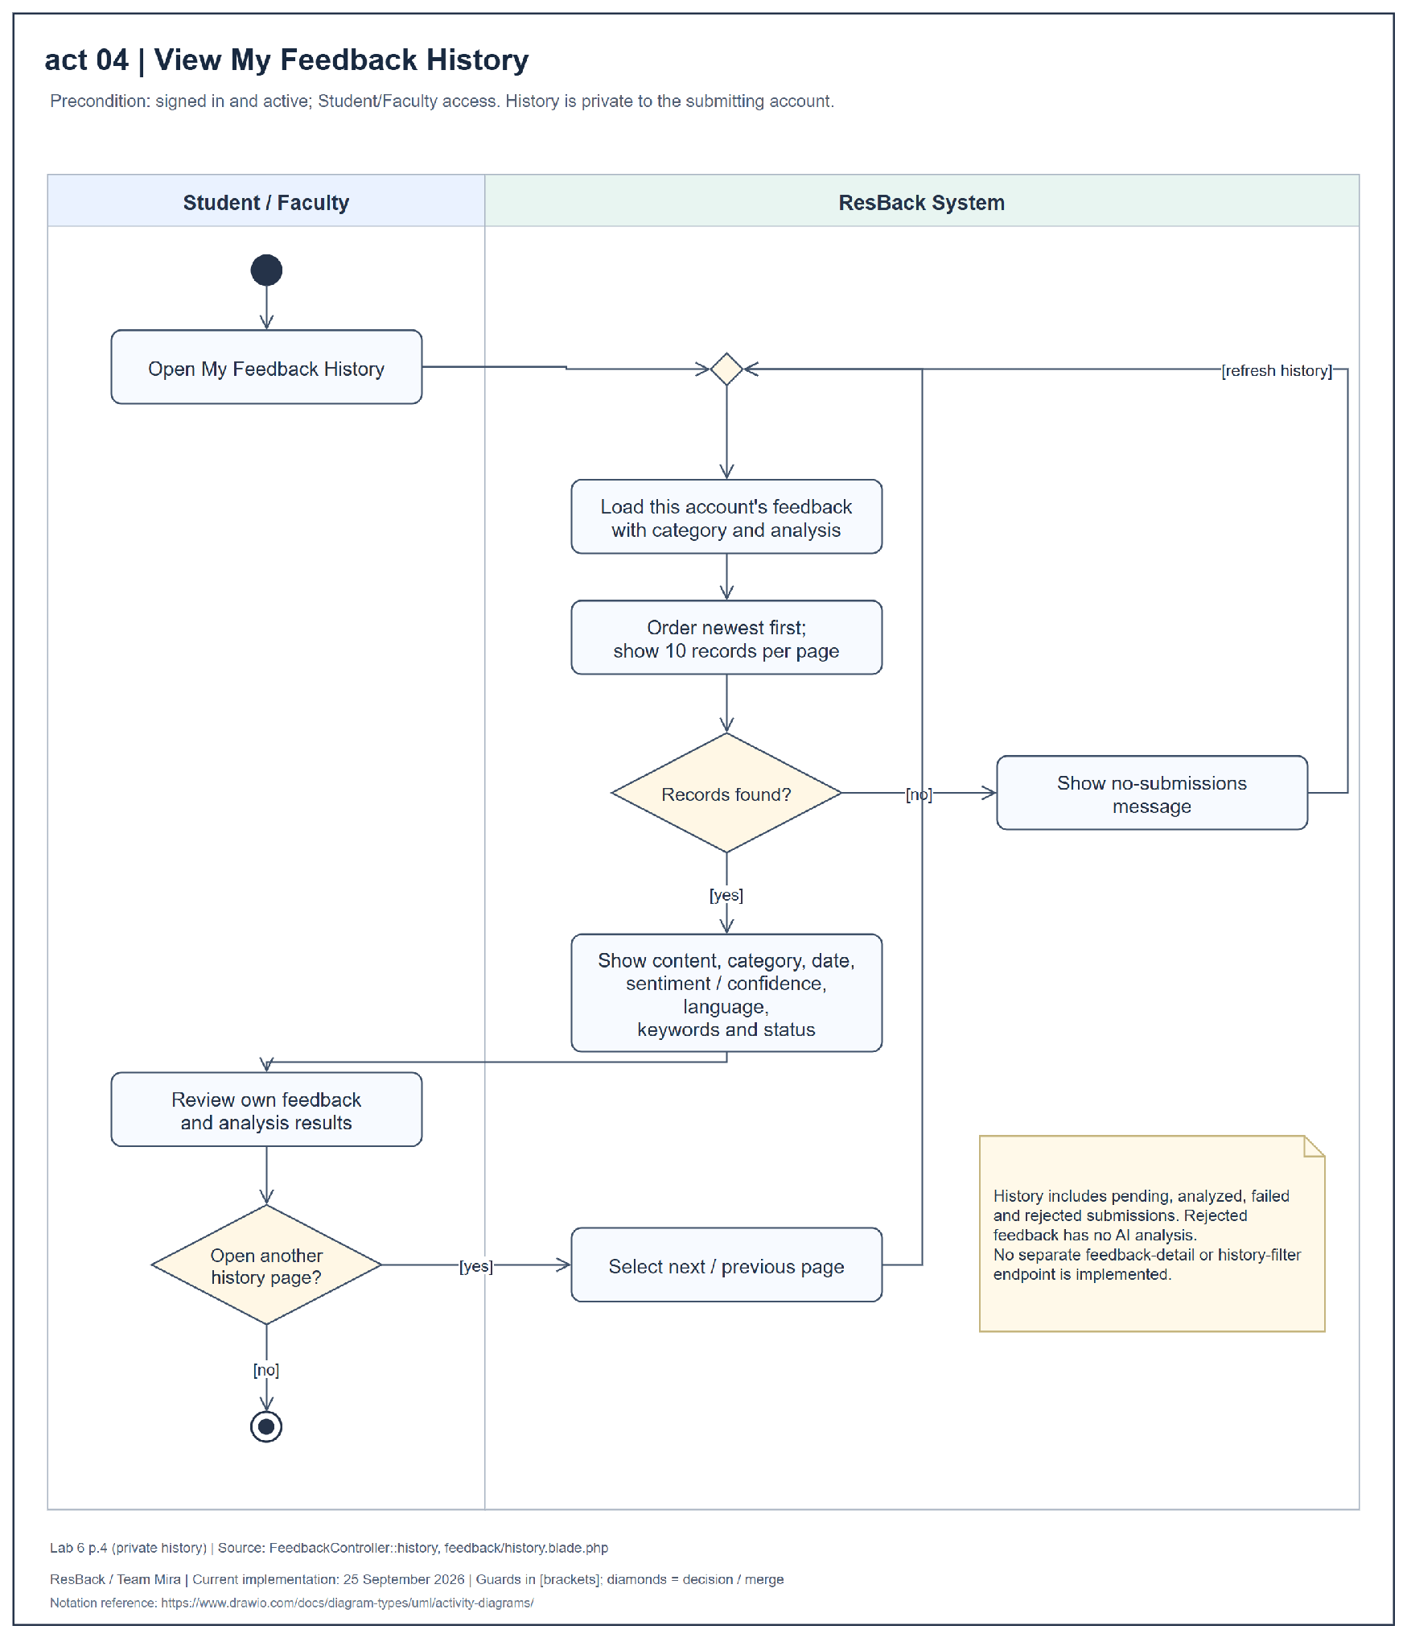
Figure 13 Activity diagram for view my feedback history
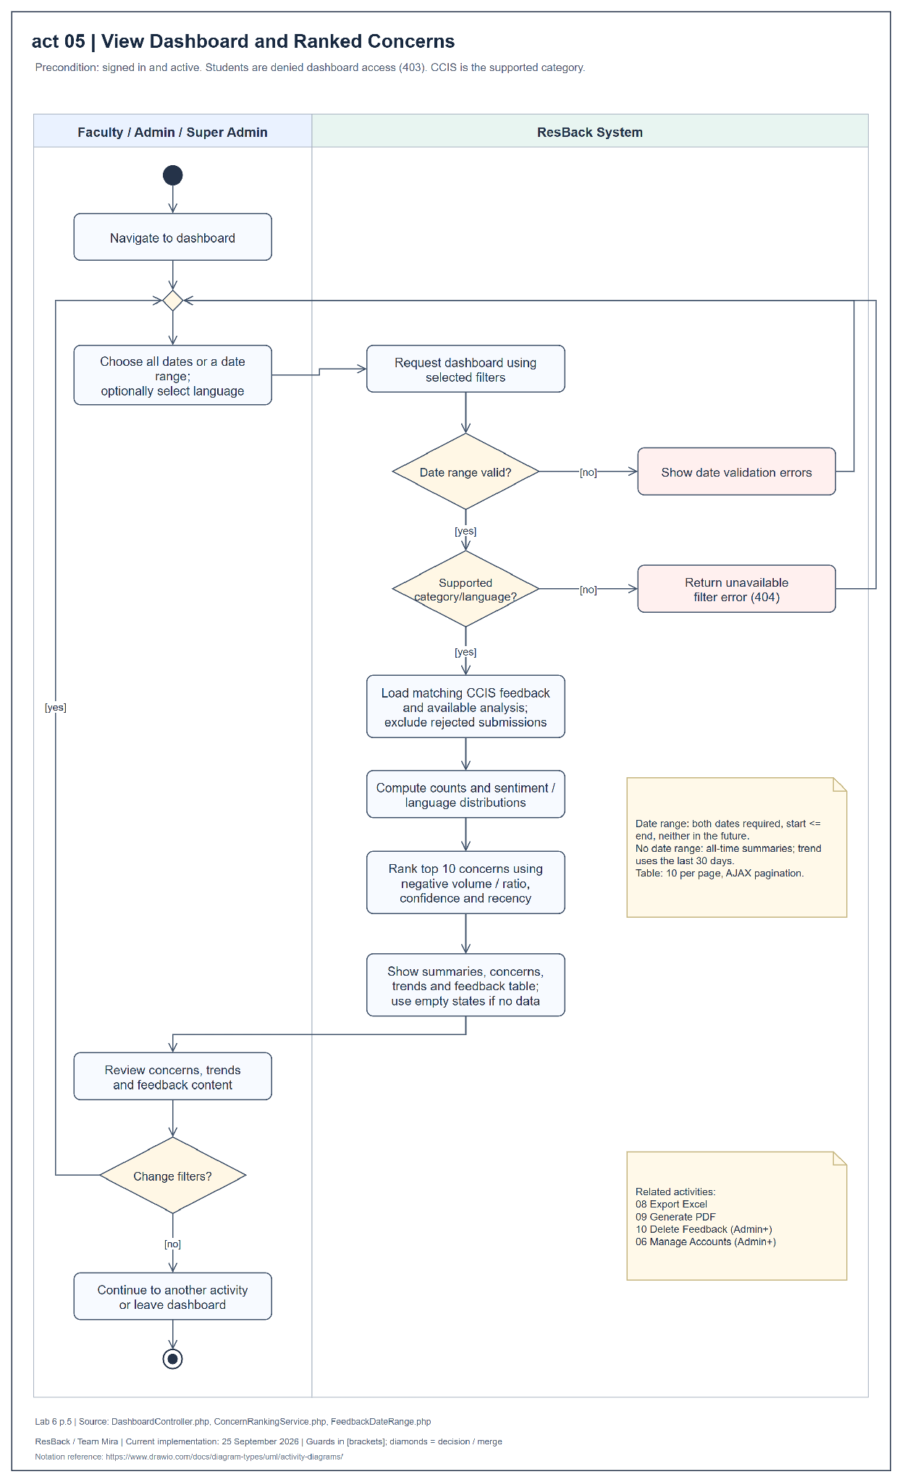
Figure 14 Activity diagram for view dashboard and ranked concerns
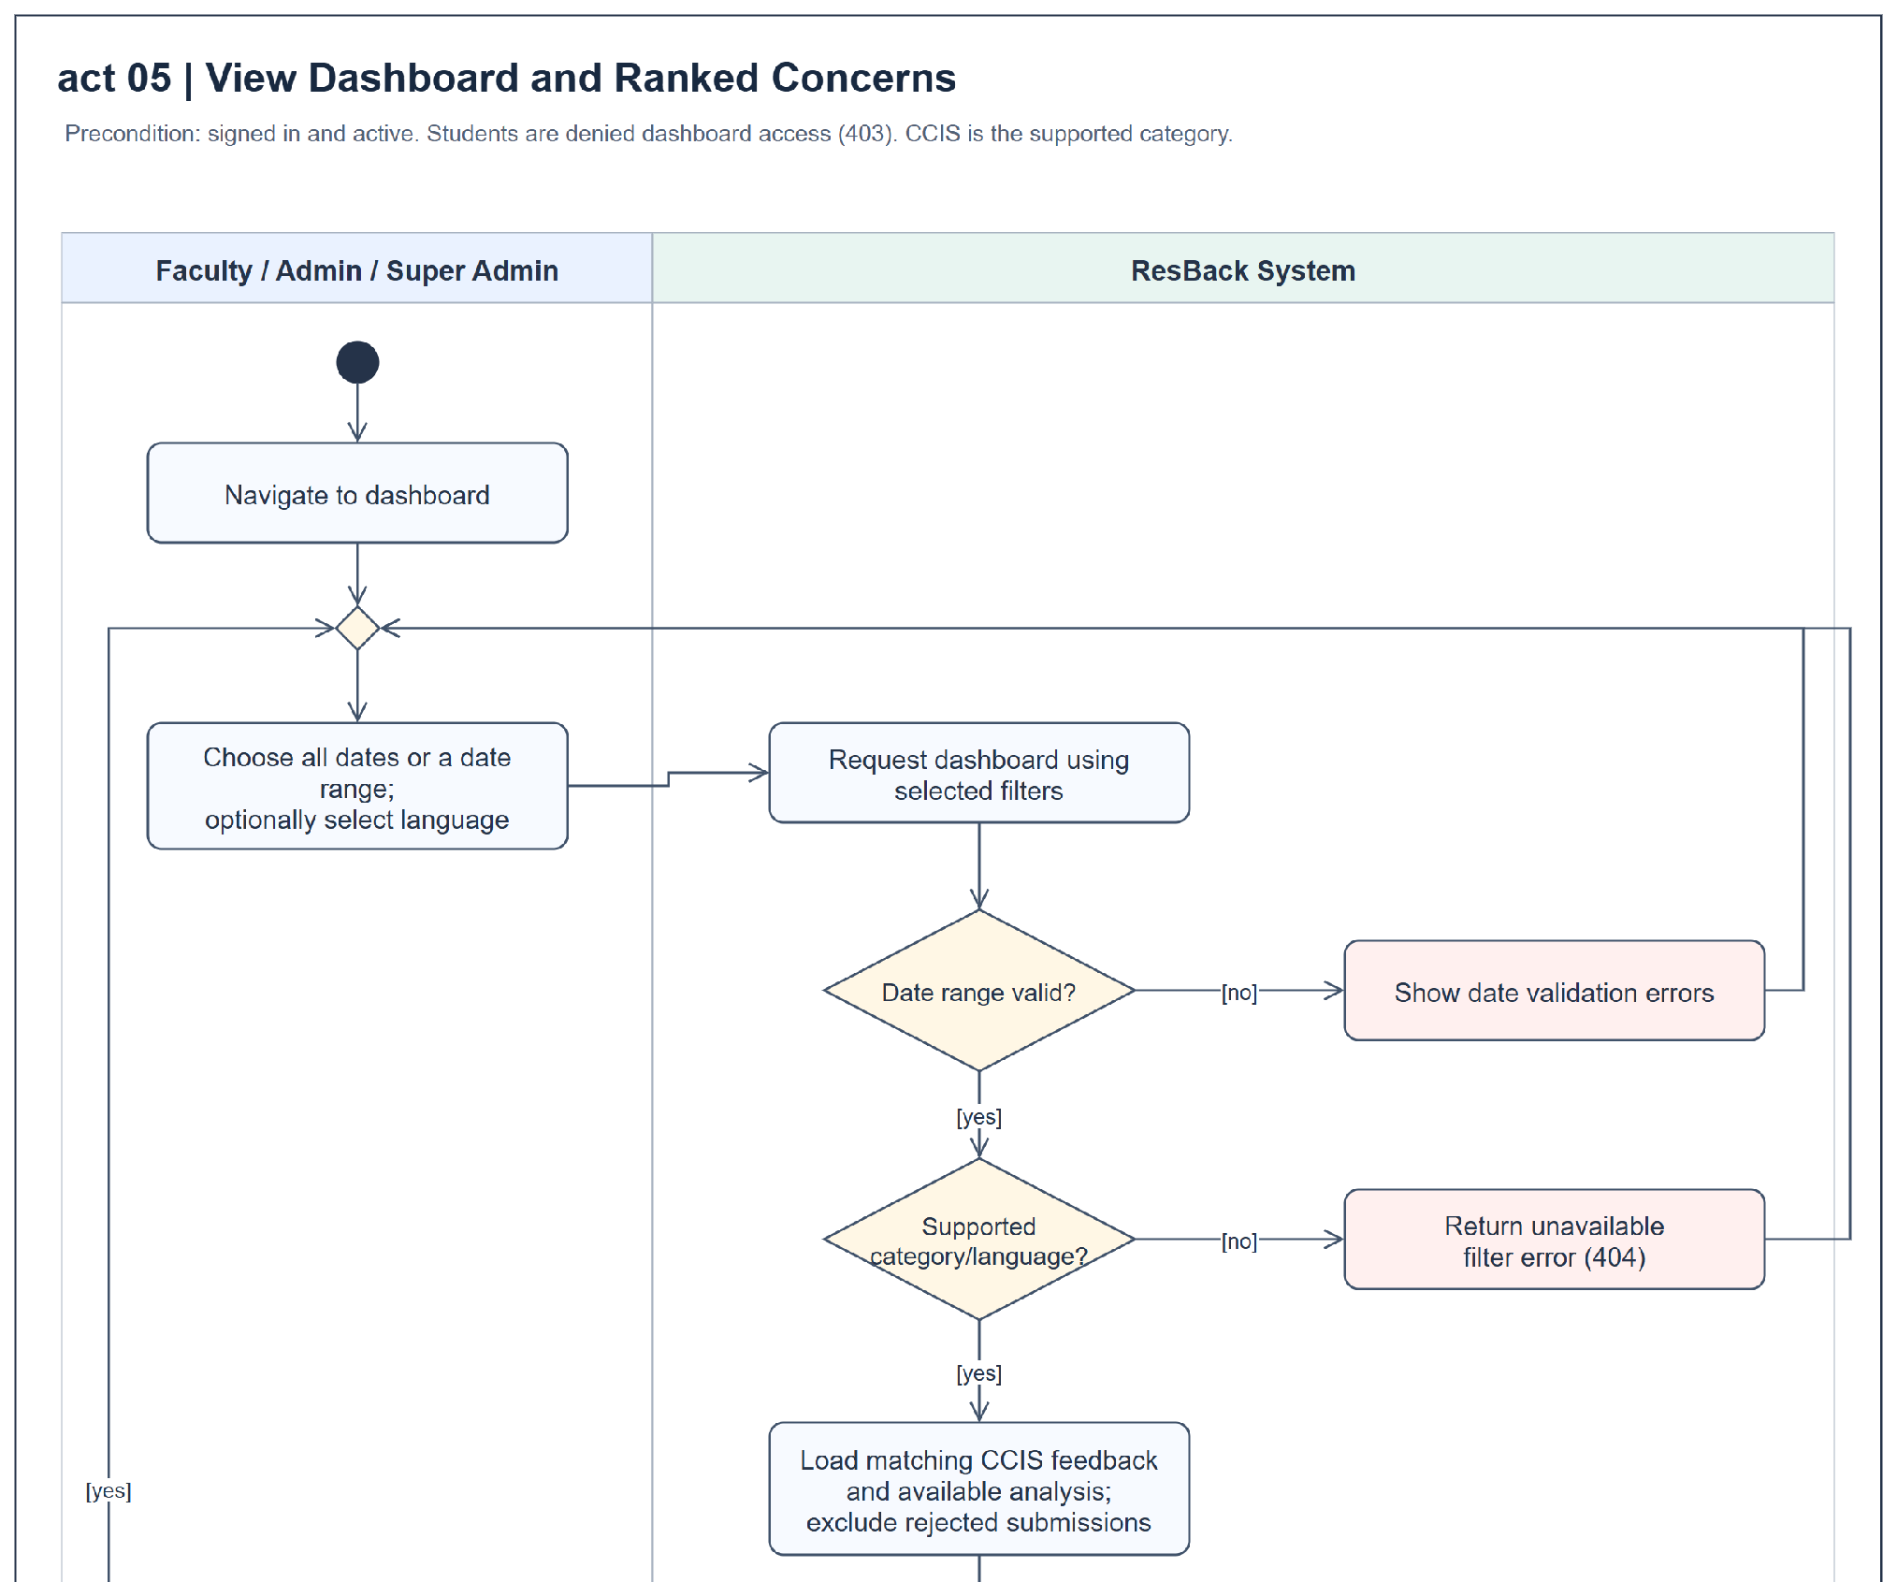
Figure 14 Activity diagram for view dashboard and ranked concerns enlarged continuation panel 1 of 2
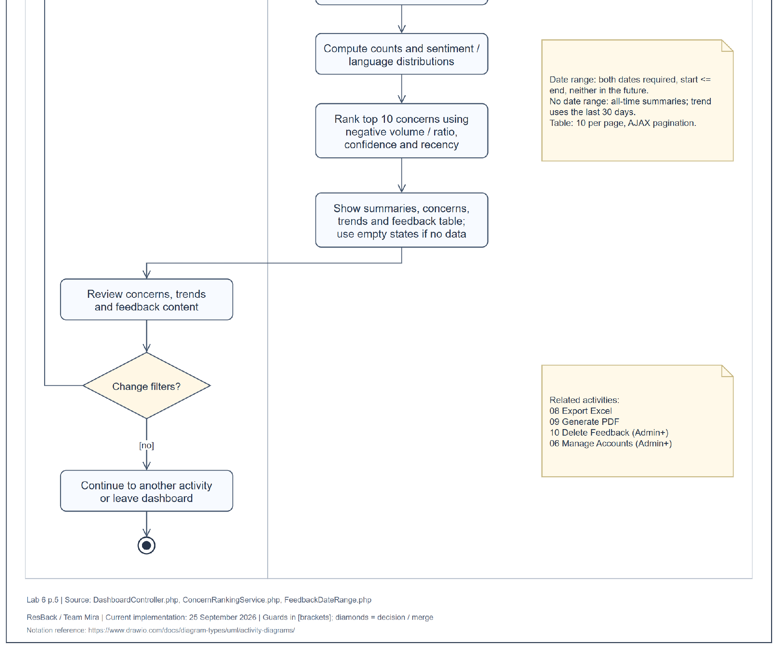
Figure 14 Activity diagram for view dashboard and ranked concerns enlarged continuation panel 2 of 2
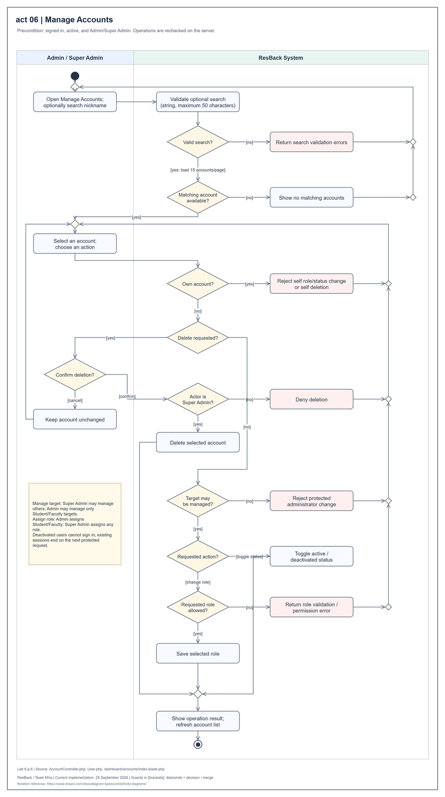
Figure 15 Activity diagram for manage accounts
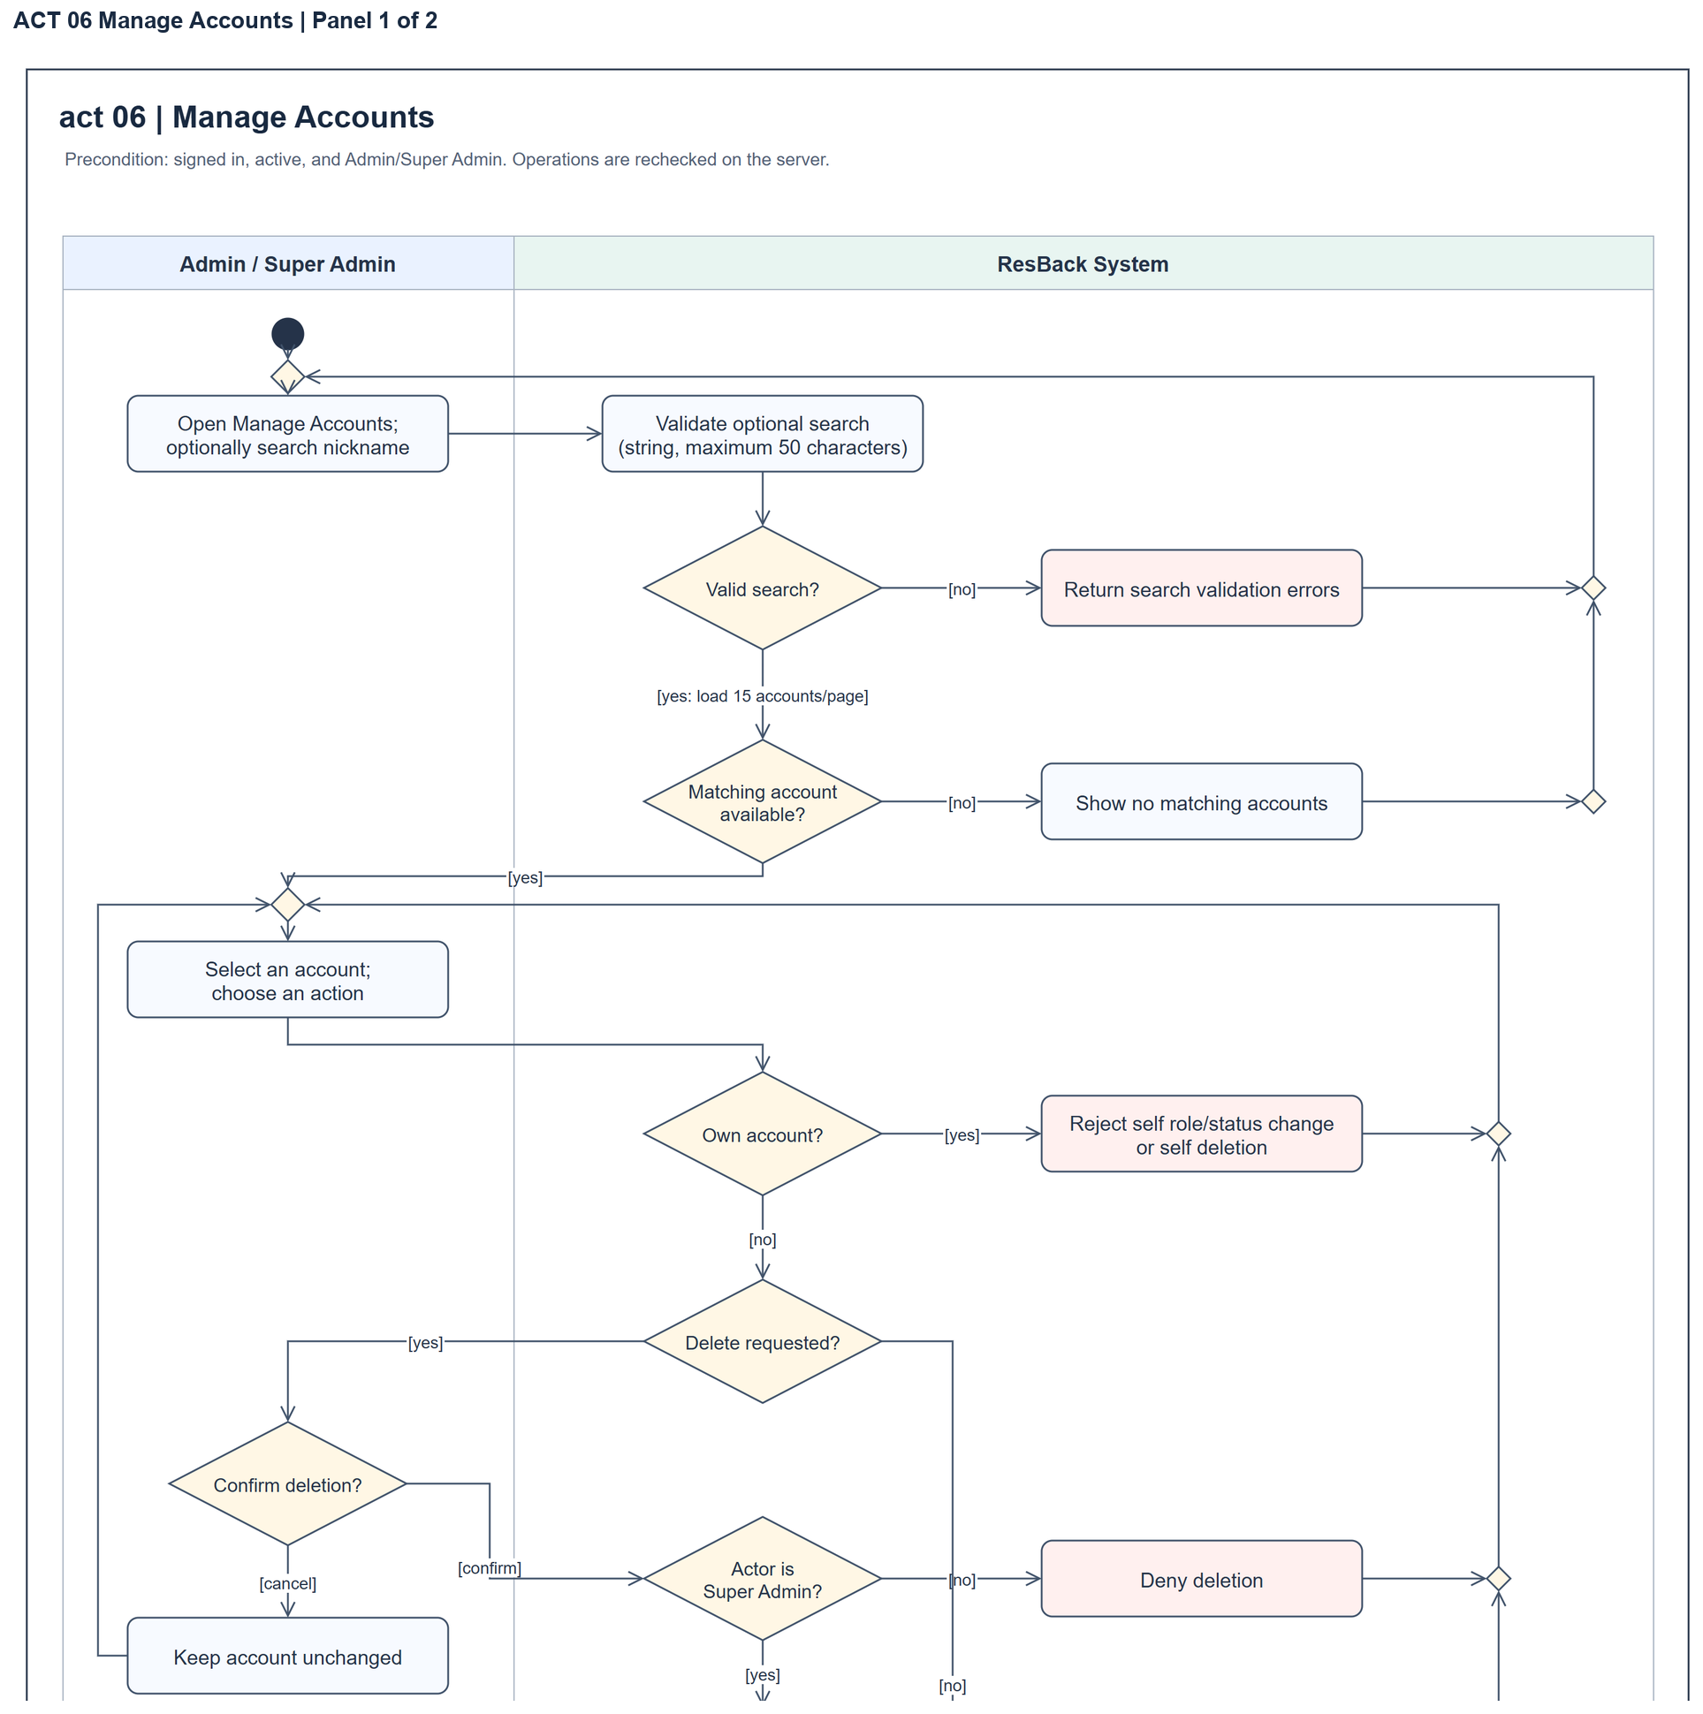
Figure 15 Activity diagram for manage accounts enlarged continuation panel 1 of 2
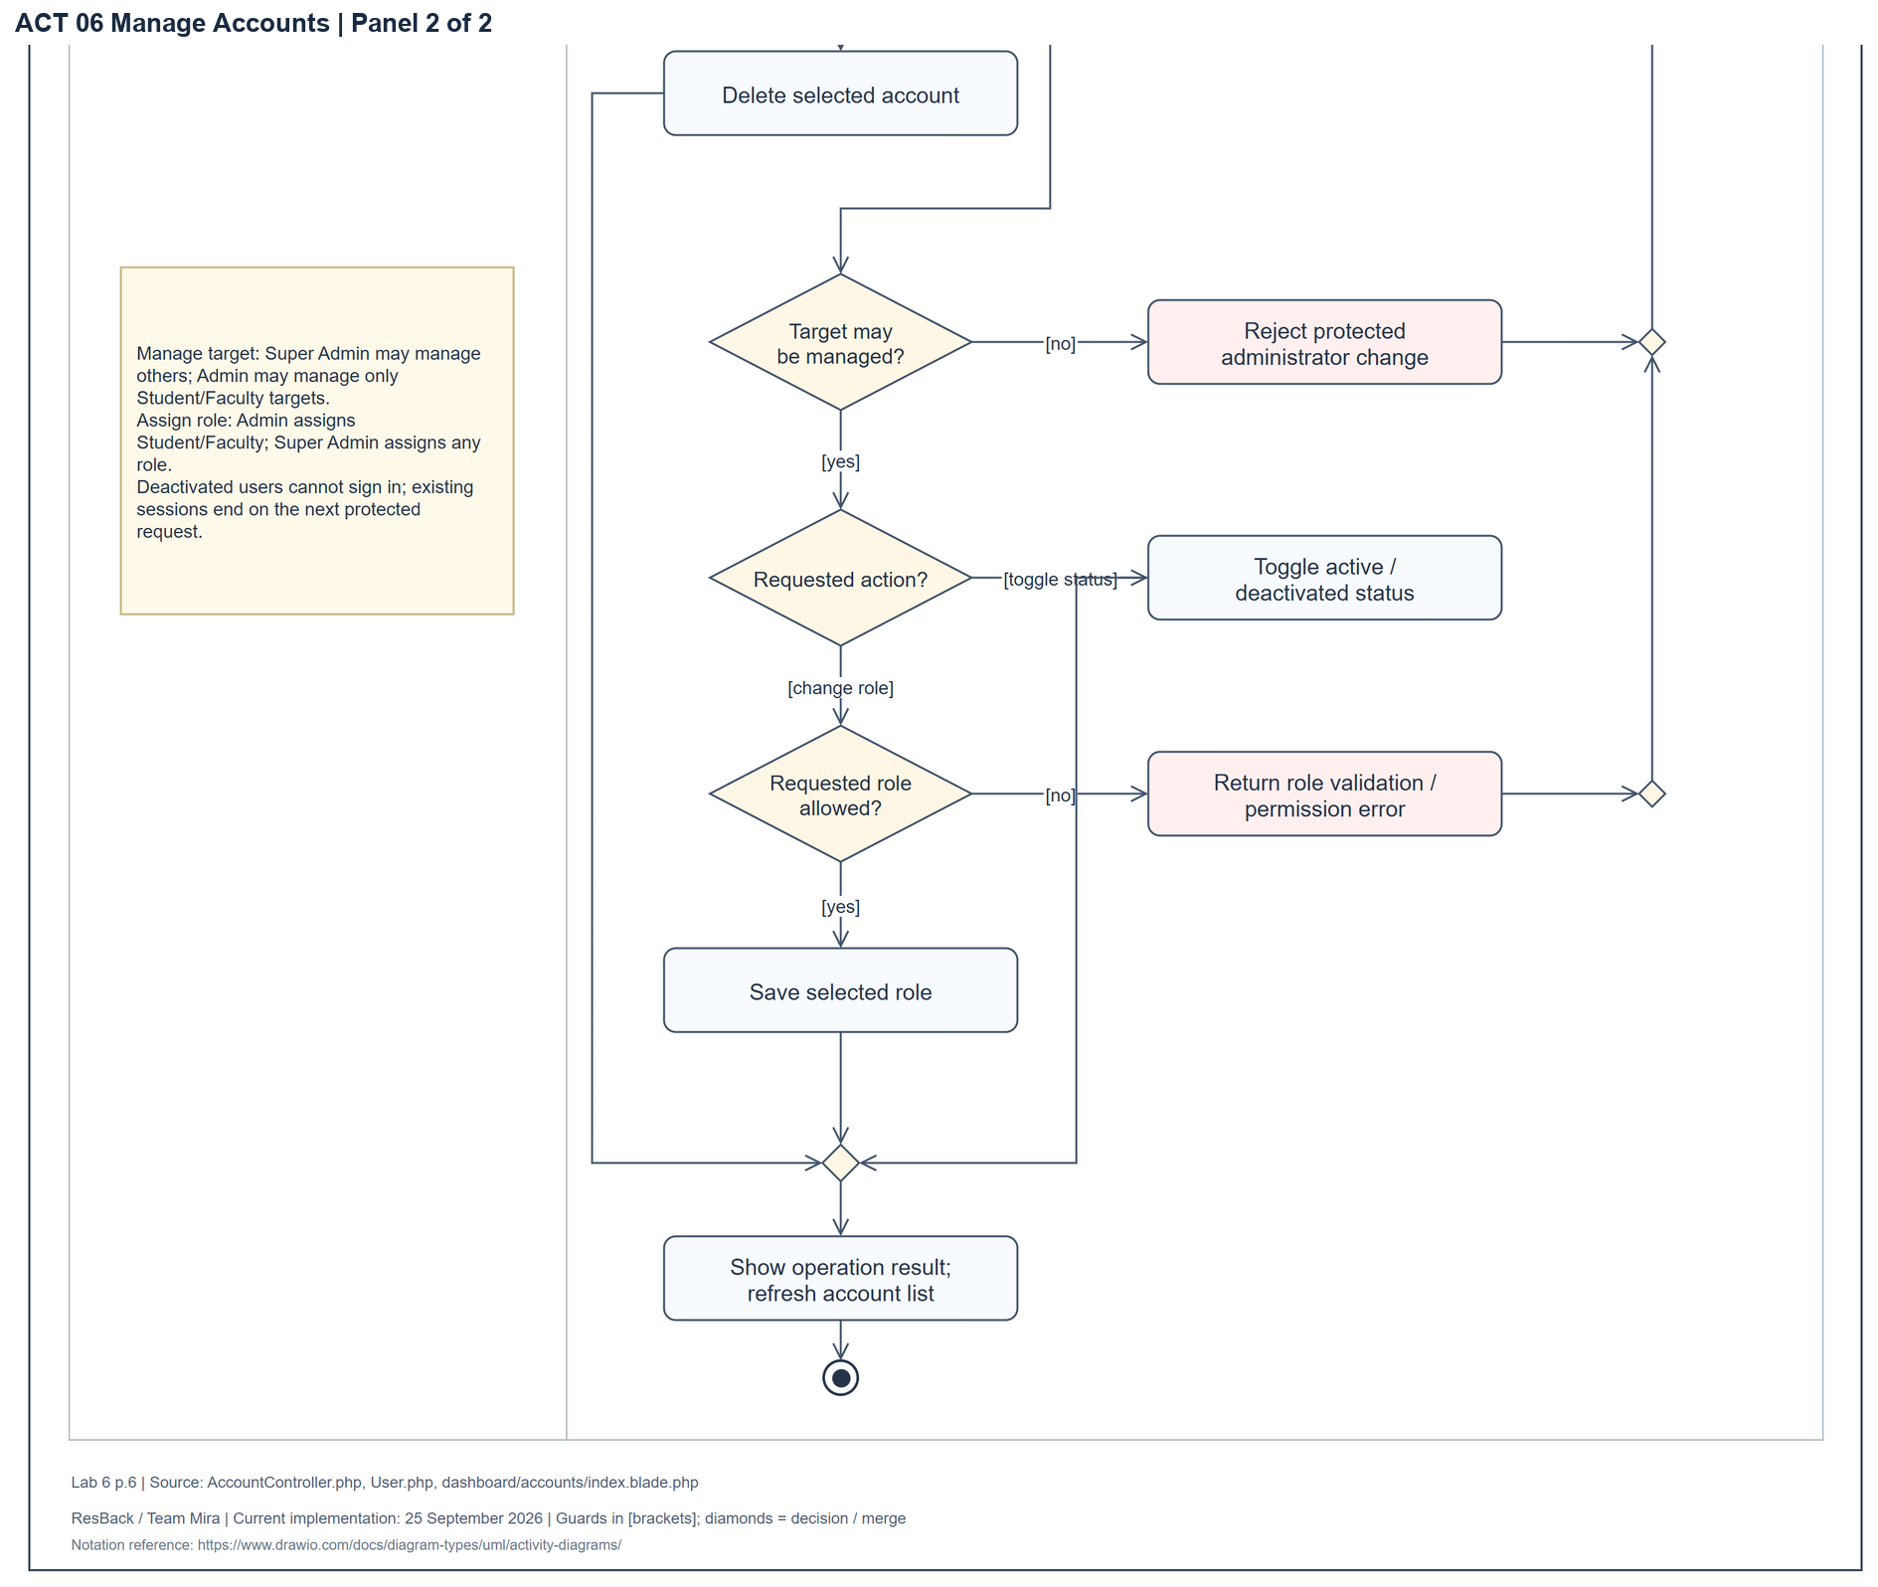
Figure 15 Activity diagram for manage accounts enlarged continuation panel 2 of 2
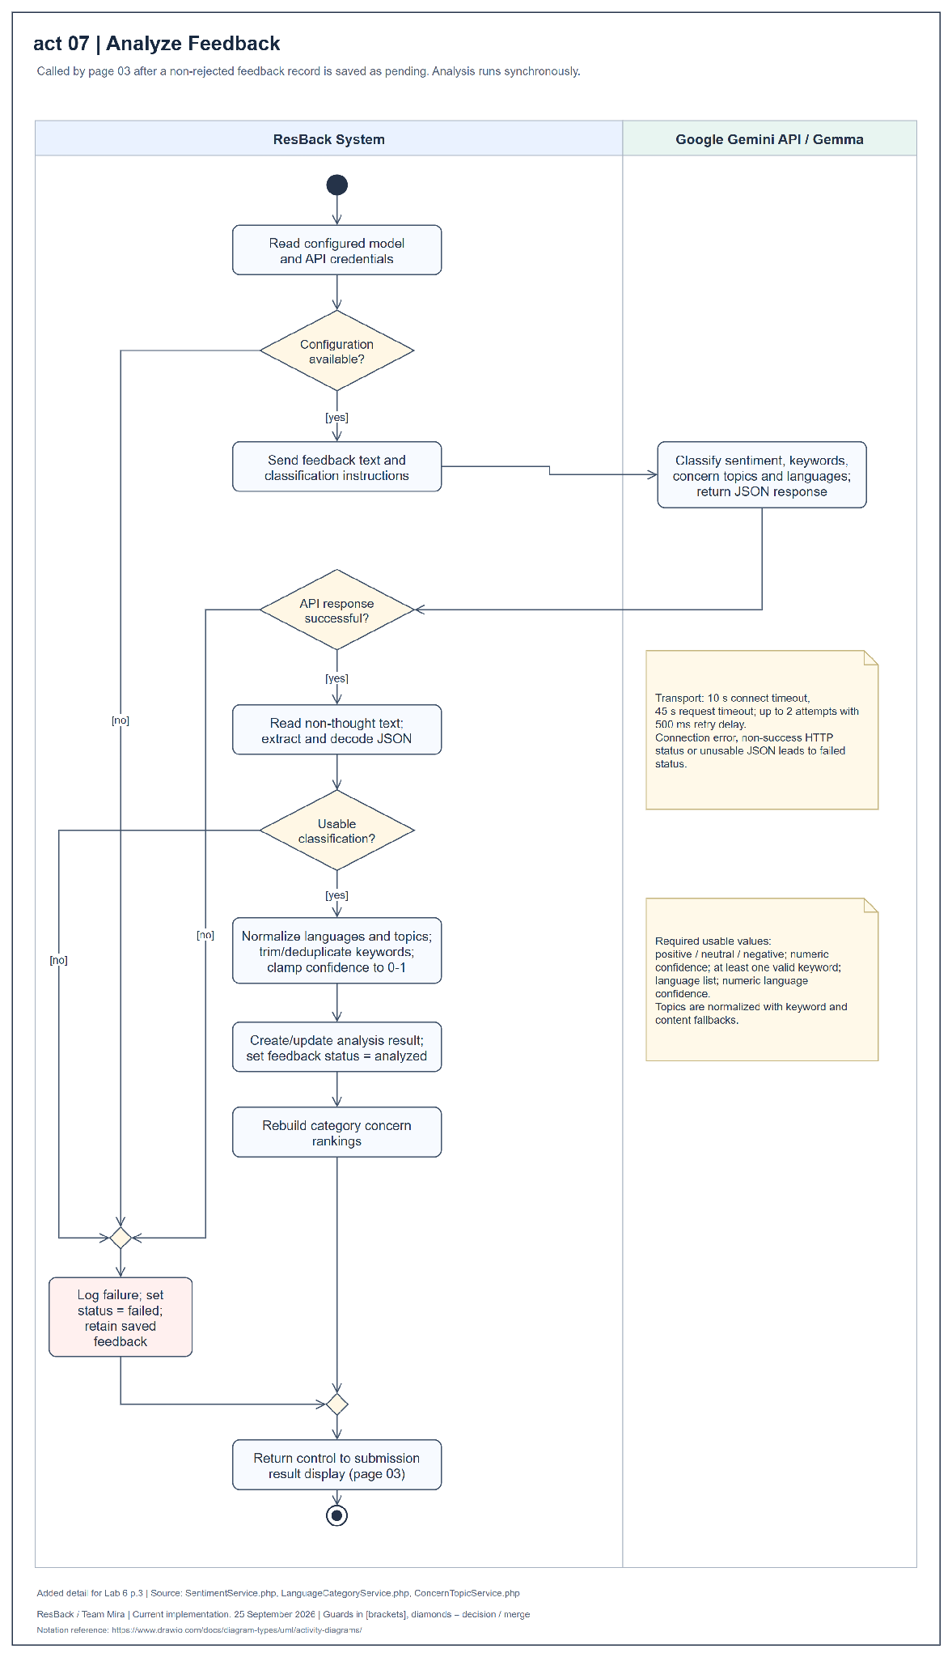
Figure 16 Activity diagram for analyze feedback
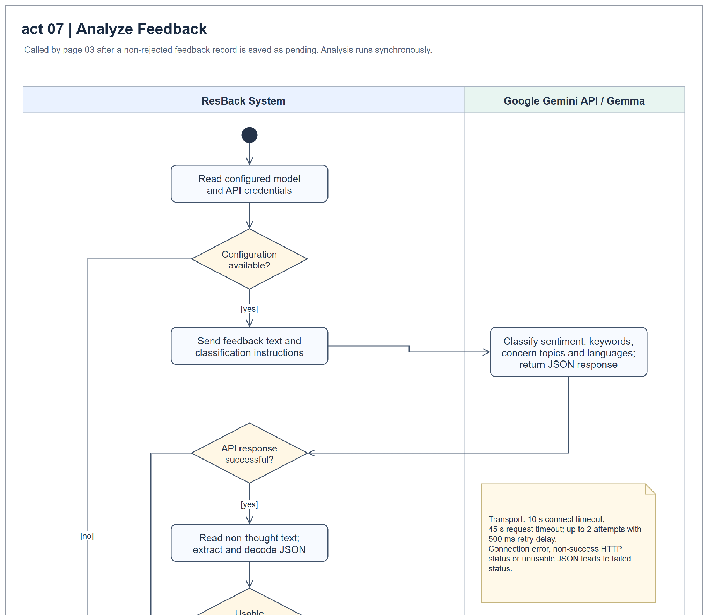
Figure 16 Activity diagram for analyze feedback enlarged continuation panel 1 of 2
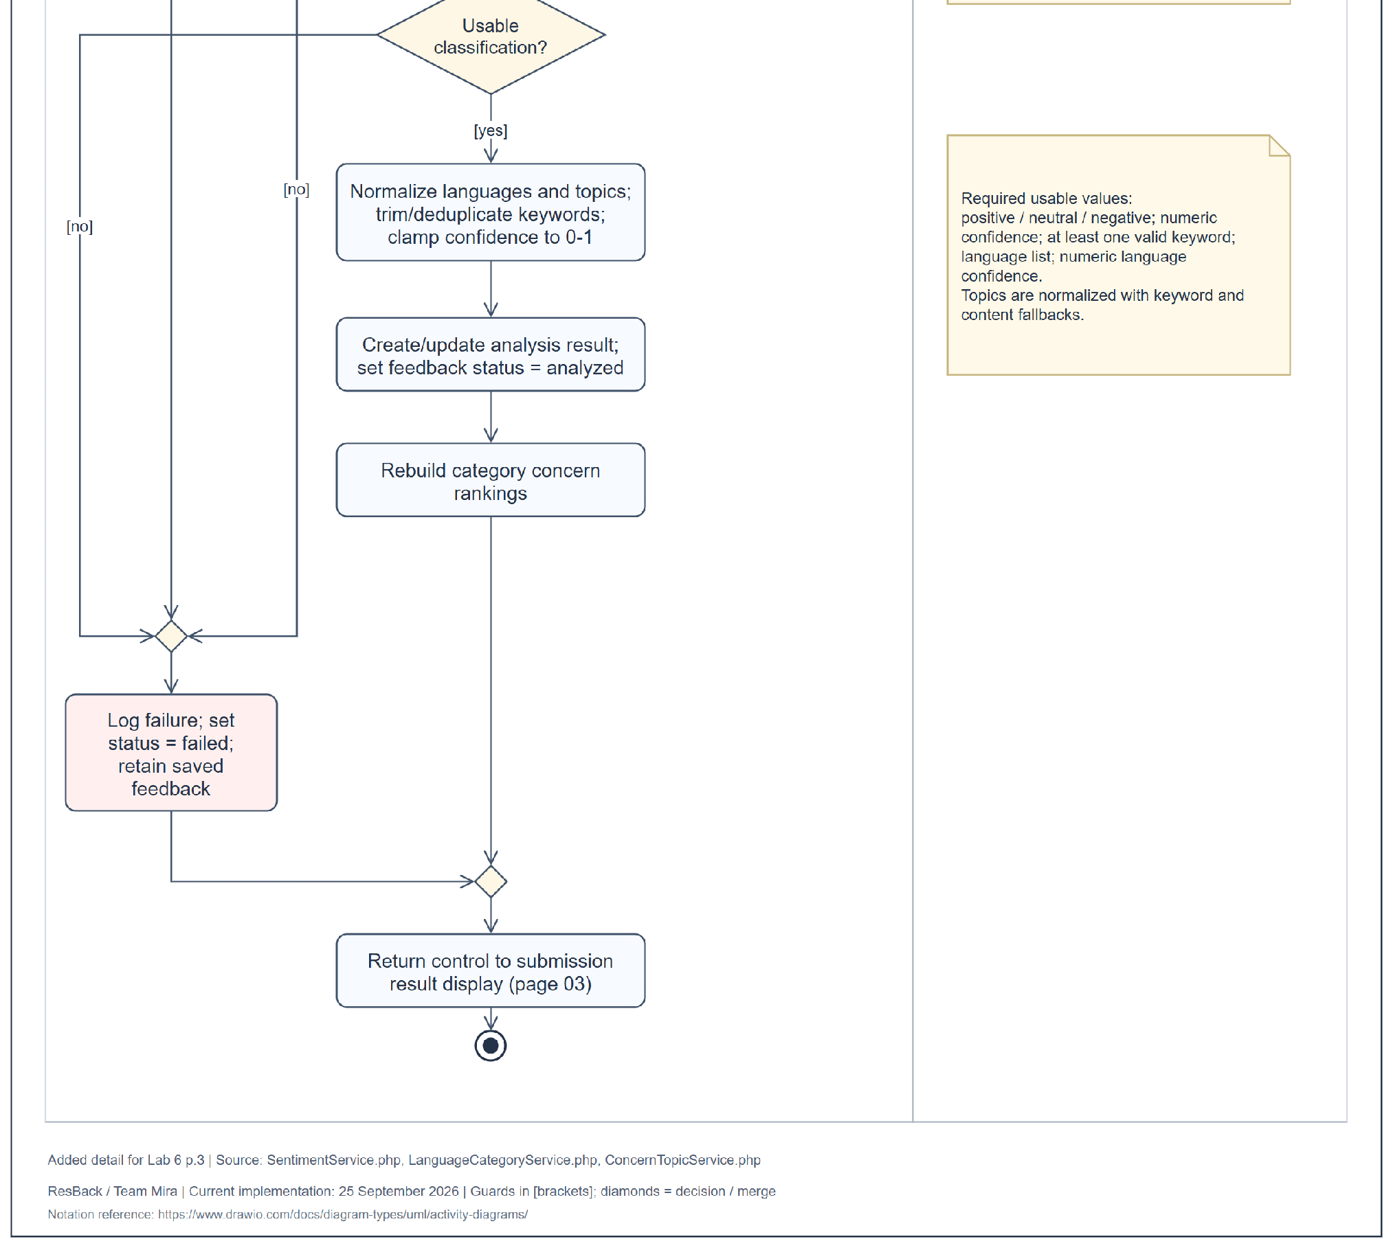
Figure 16 Activity diagram for analyze feedback enlarged continuation panel 2 of 2
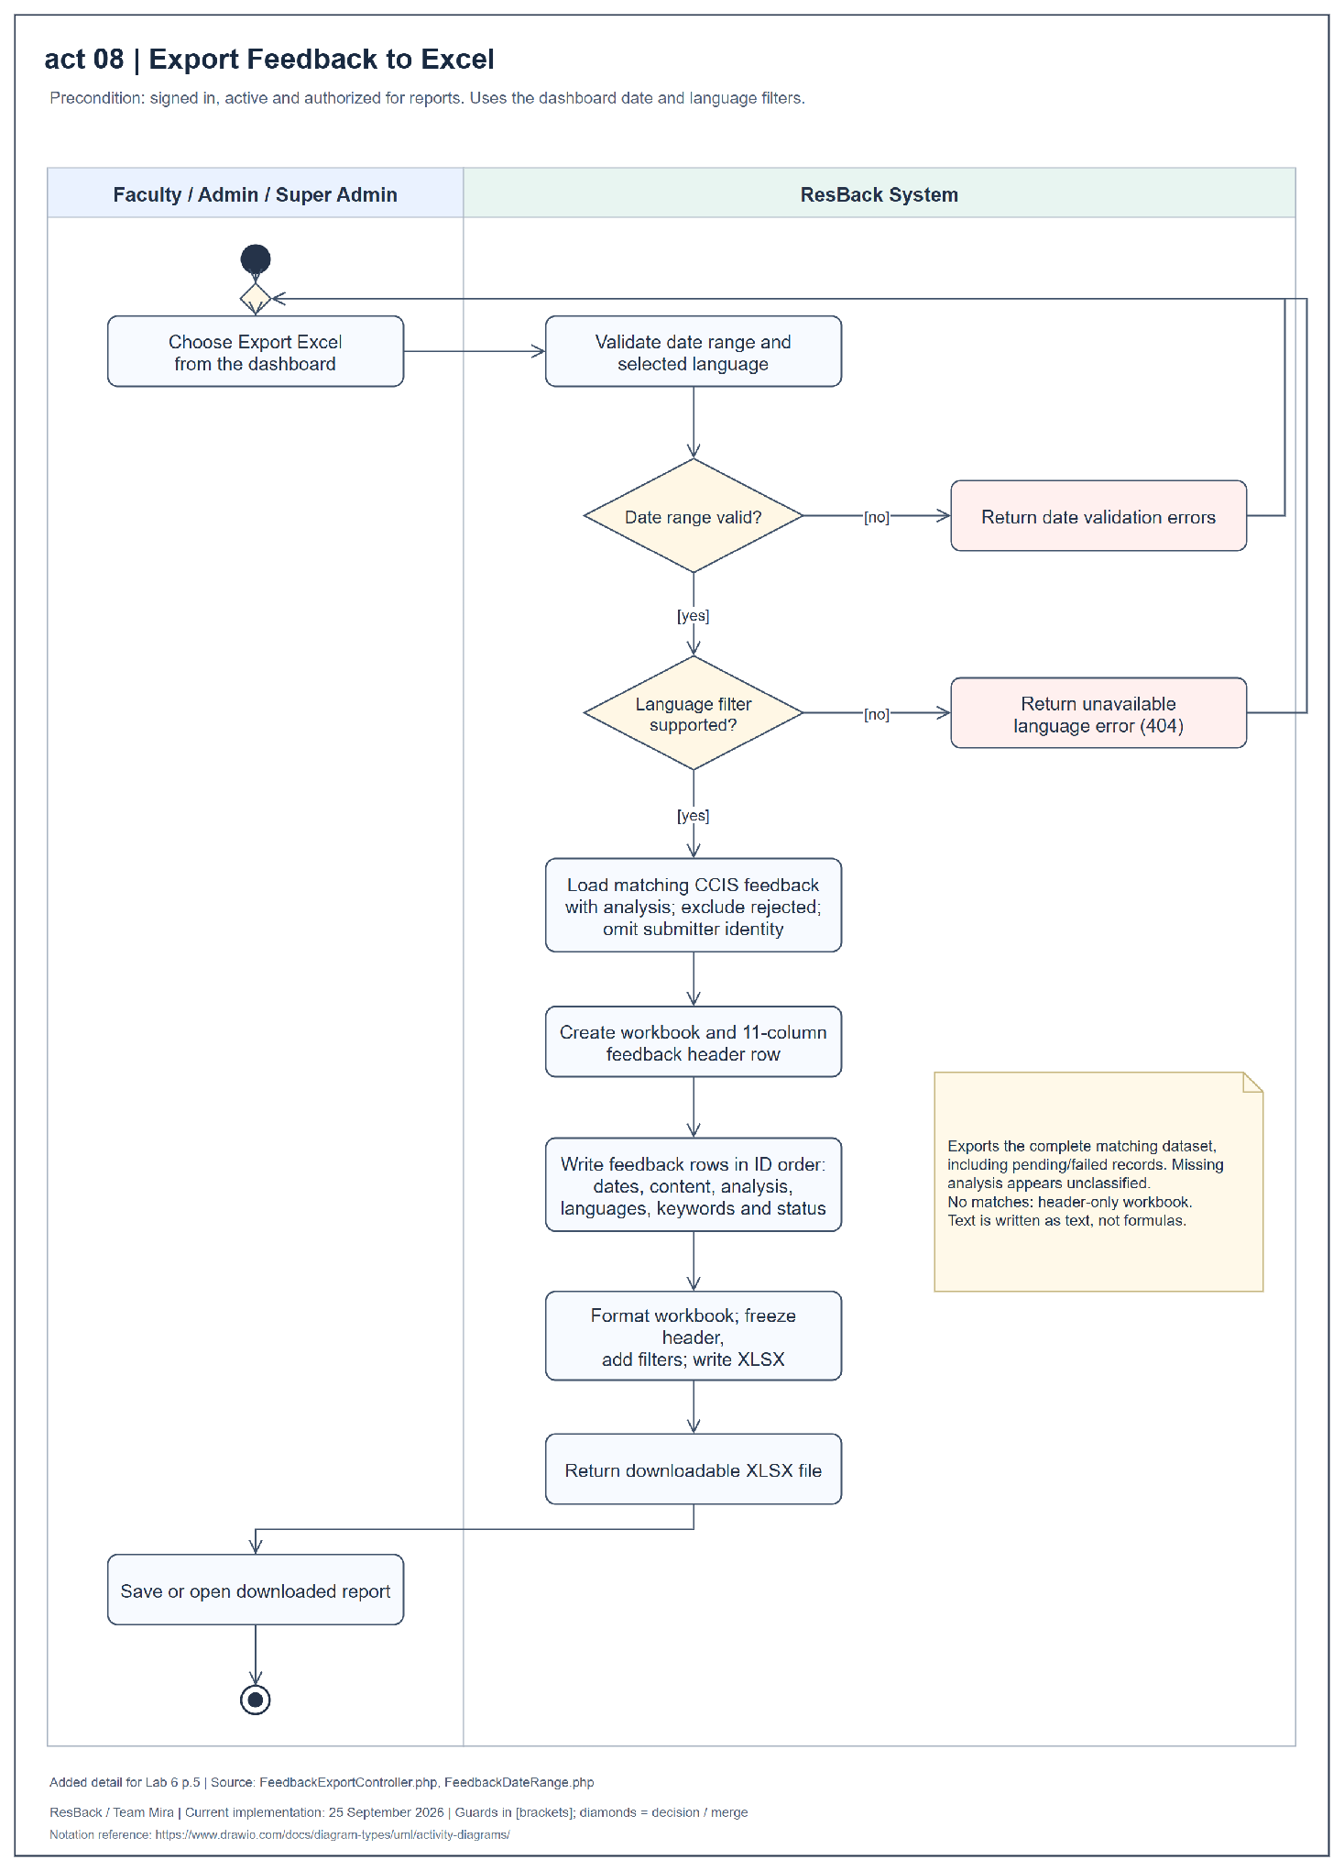
Figure 17 Activity diagram for export feedback to Excel
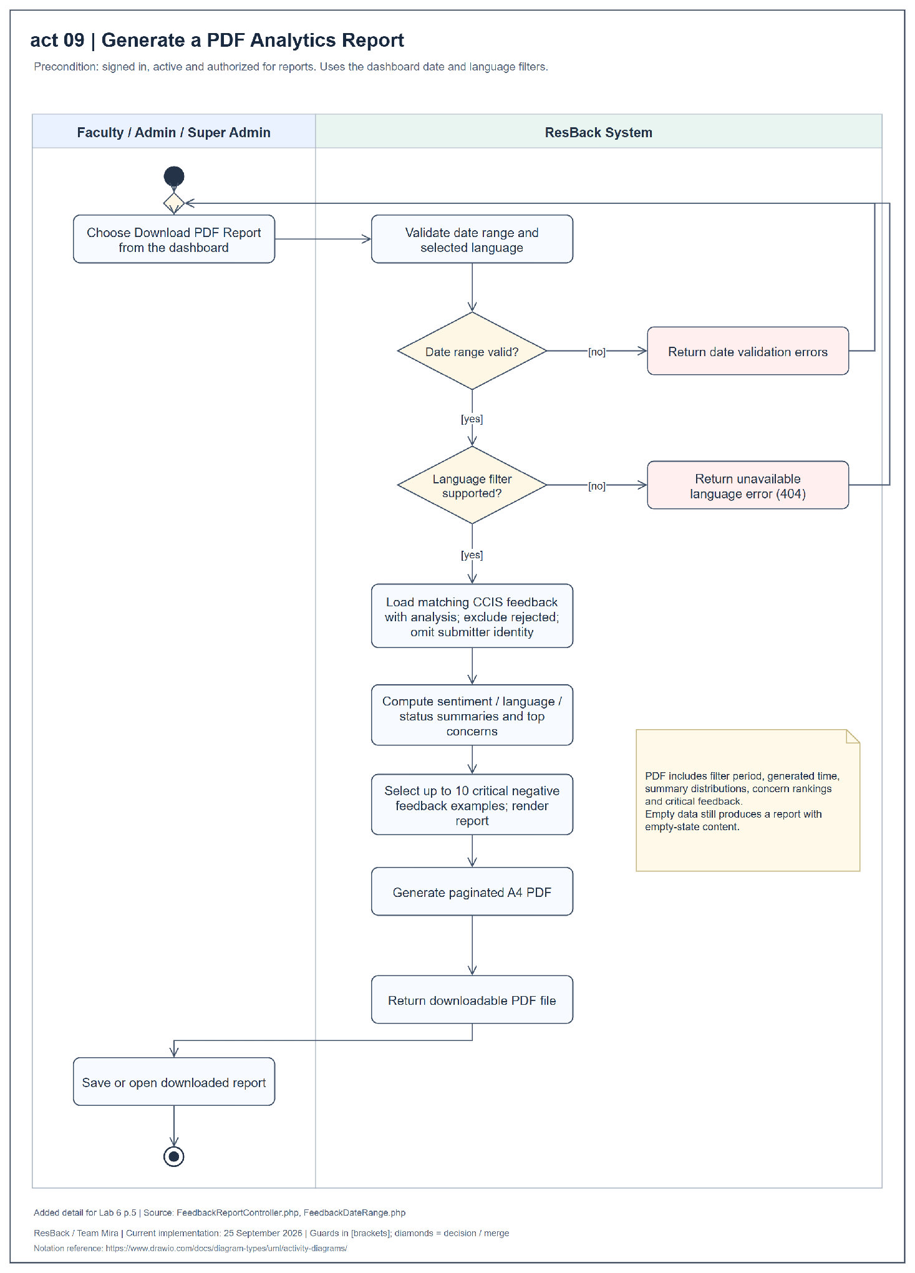
Figure 18 Activity diagram for generate a PDF analytics report
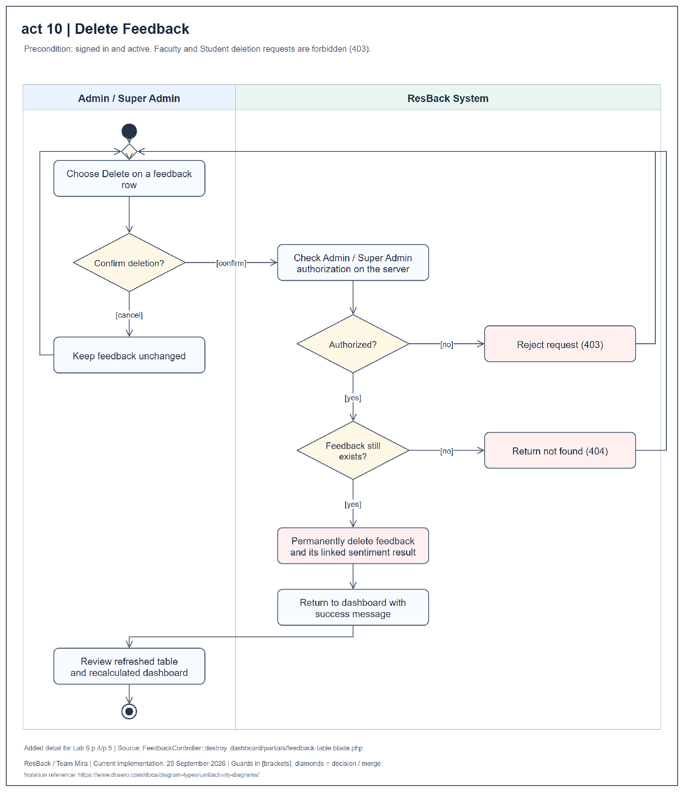
Figure 19 Activity diagram for delete feedback
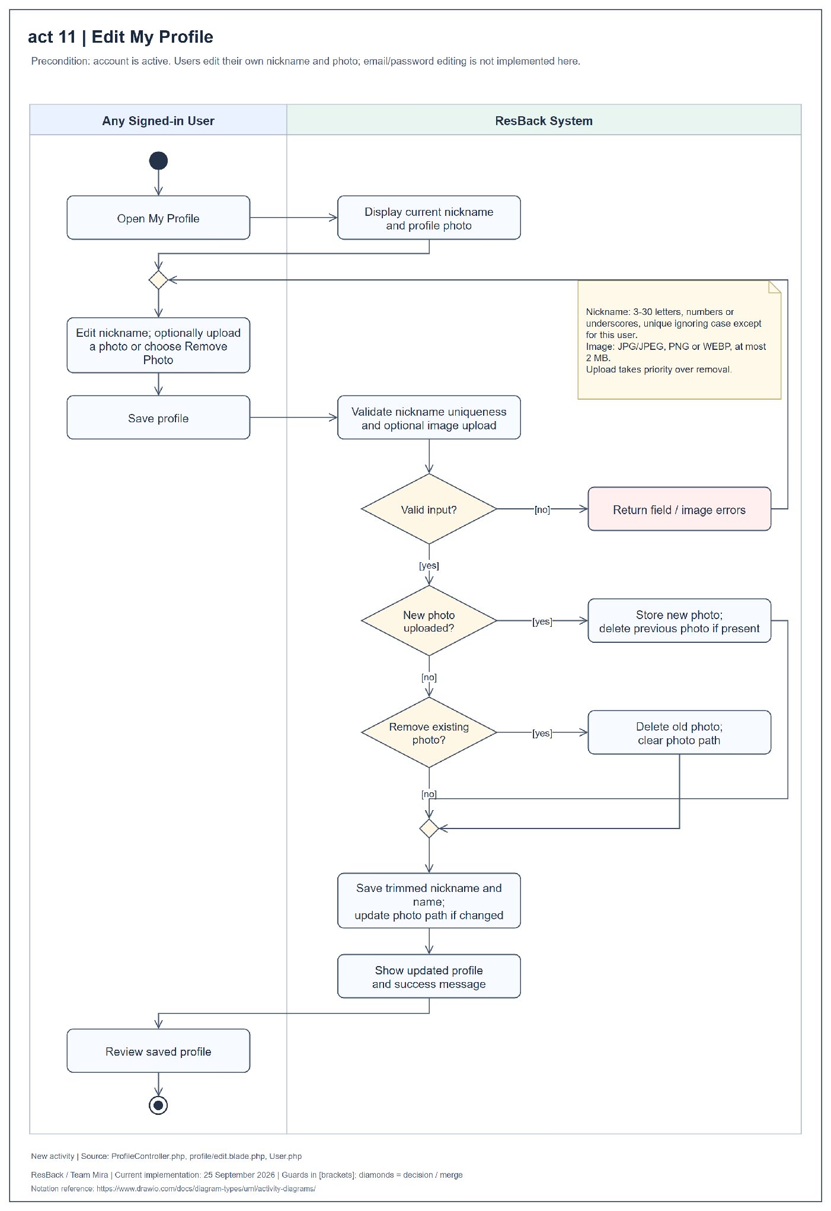
Figure 20 Activity diagram for edit my profile
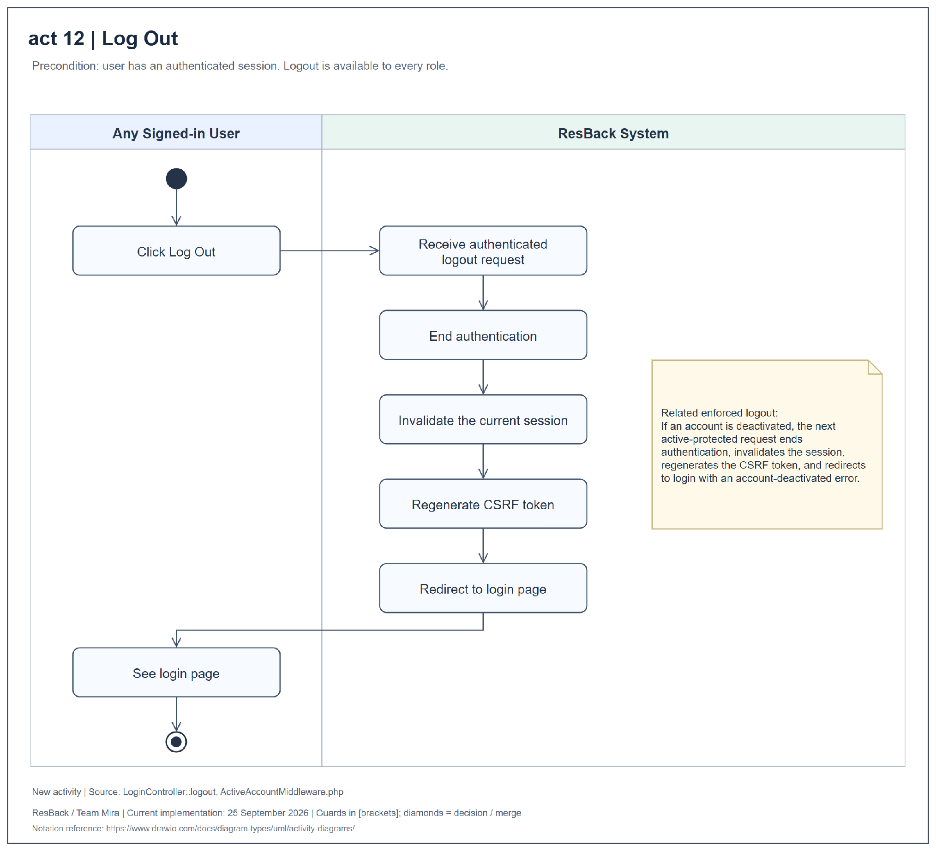
Figure 21 Activity diagram for log out

APPENDIX F CLASS DIAGRAMS
Figures 22–27 present six class views. Plus, hash, and minus symbols identify public, protected, and private members. The source sheets retain their original 01–06 labels.
Figure 22. The core domain model shows record attributes, operations, ownership, analysis relationships, and deletion behavior. User roles are stored values rather than subclasses.
Figure 23. Authentication, accounts, and profiles connect registration, login, routing, account administration, and profile editing to the User model.
Figure 24. Feedback submission and protection connect validation, rate limiting, duplicate detection, screening, and analysis. Screening occurs before external inference.
Figure 25. Sentiment analysis and concern ranking connect model-output normalization, language and topic categories, optional date boundaries, and ranking reconstruction.
Figure 26. Dashboard and report generation share filters, ranked concerns, models, and export utilities. Review outputs omit submitter identification and rejected feedback.
Figure 27. Account-access middleware checks authentication, active status, and roles. Controller authorization adds account-management restrictions.
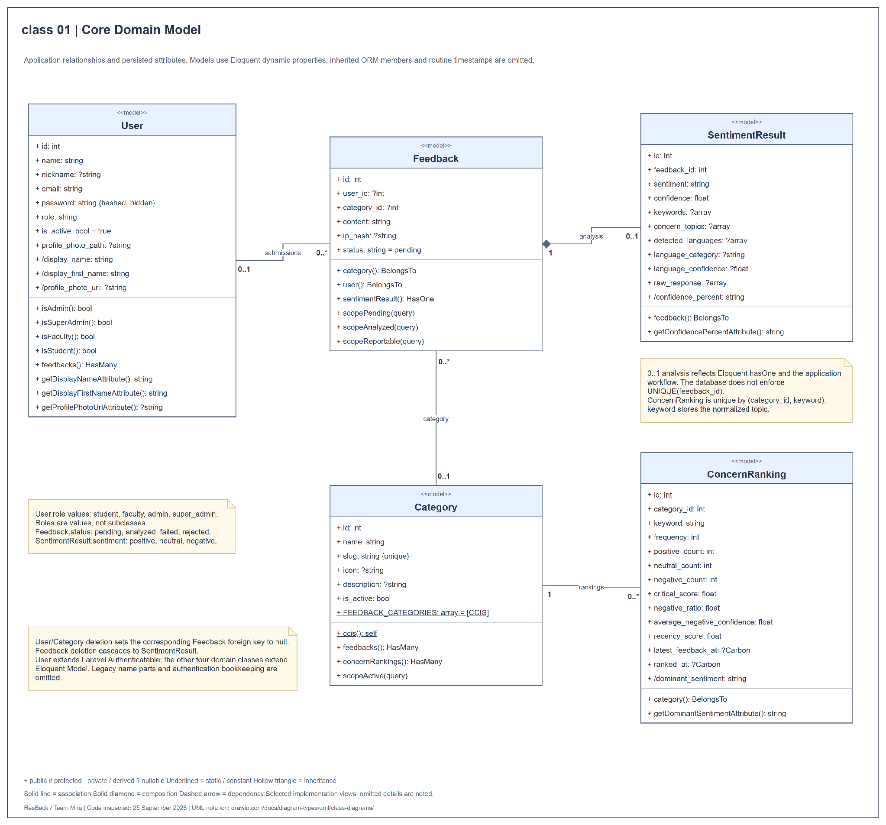
Figure 22 Class diagram for core domain model
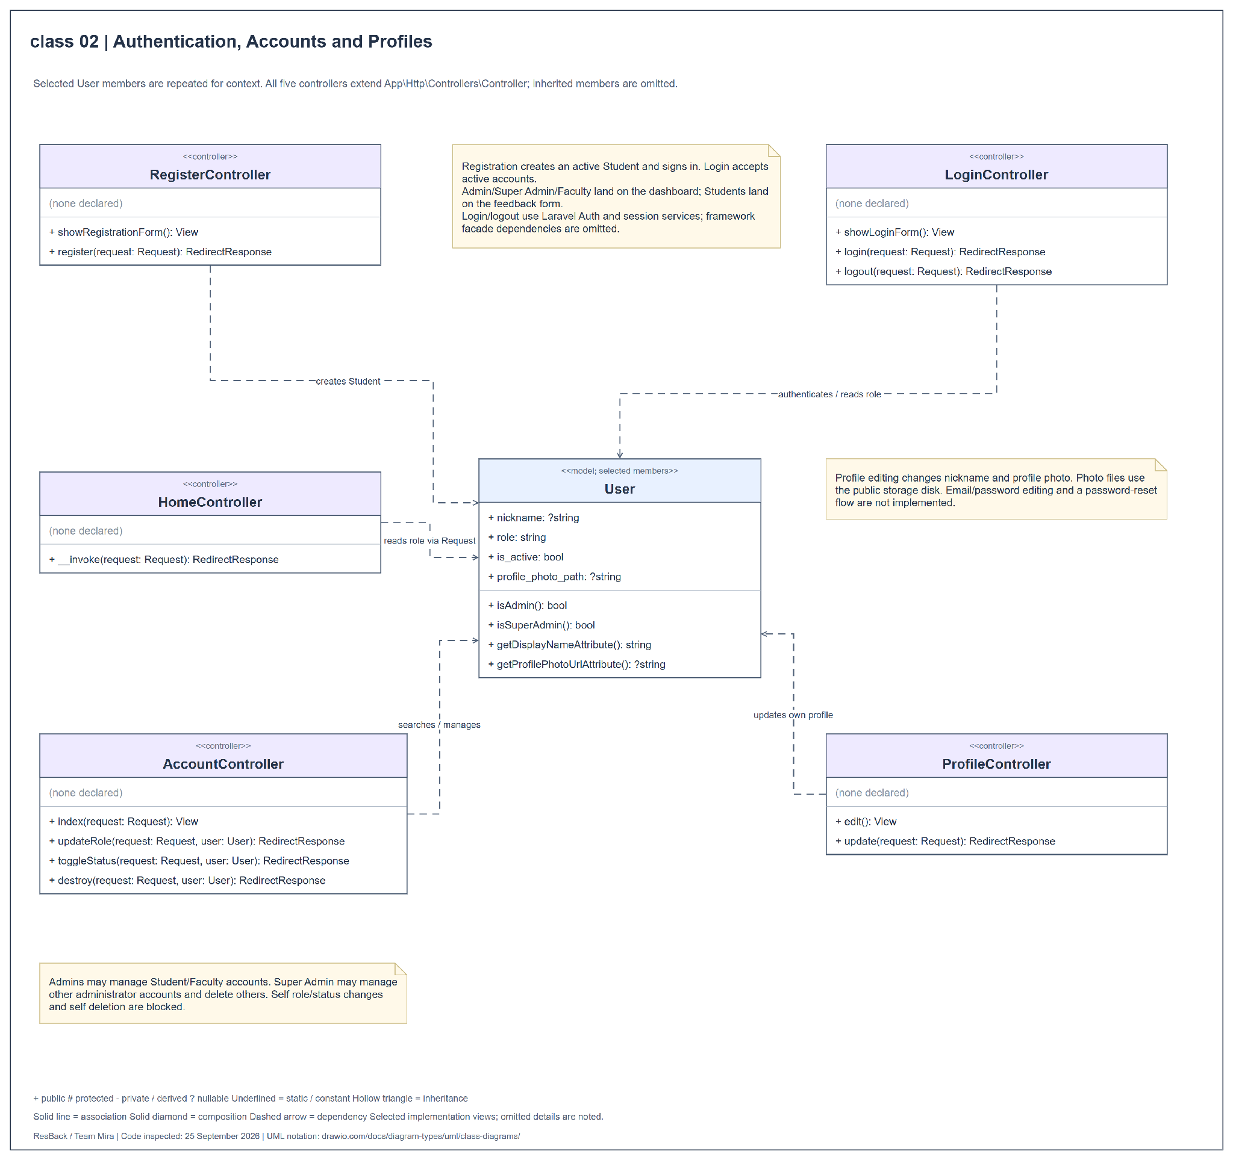
Figure 23 Class diagram for authentication accounts and profiles
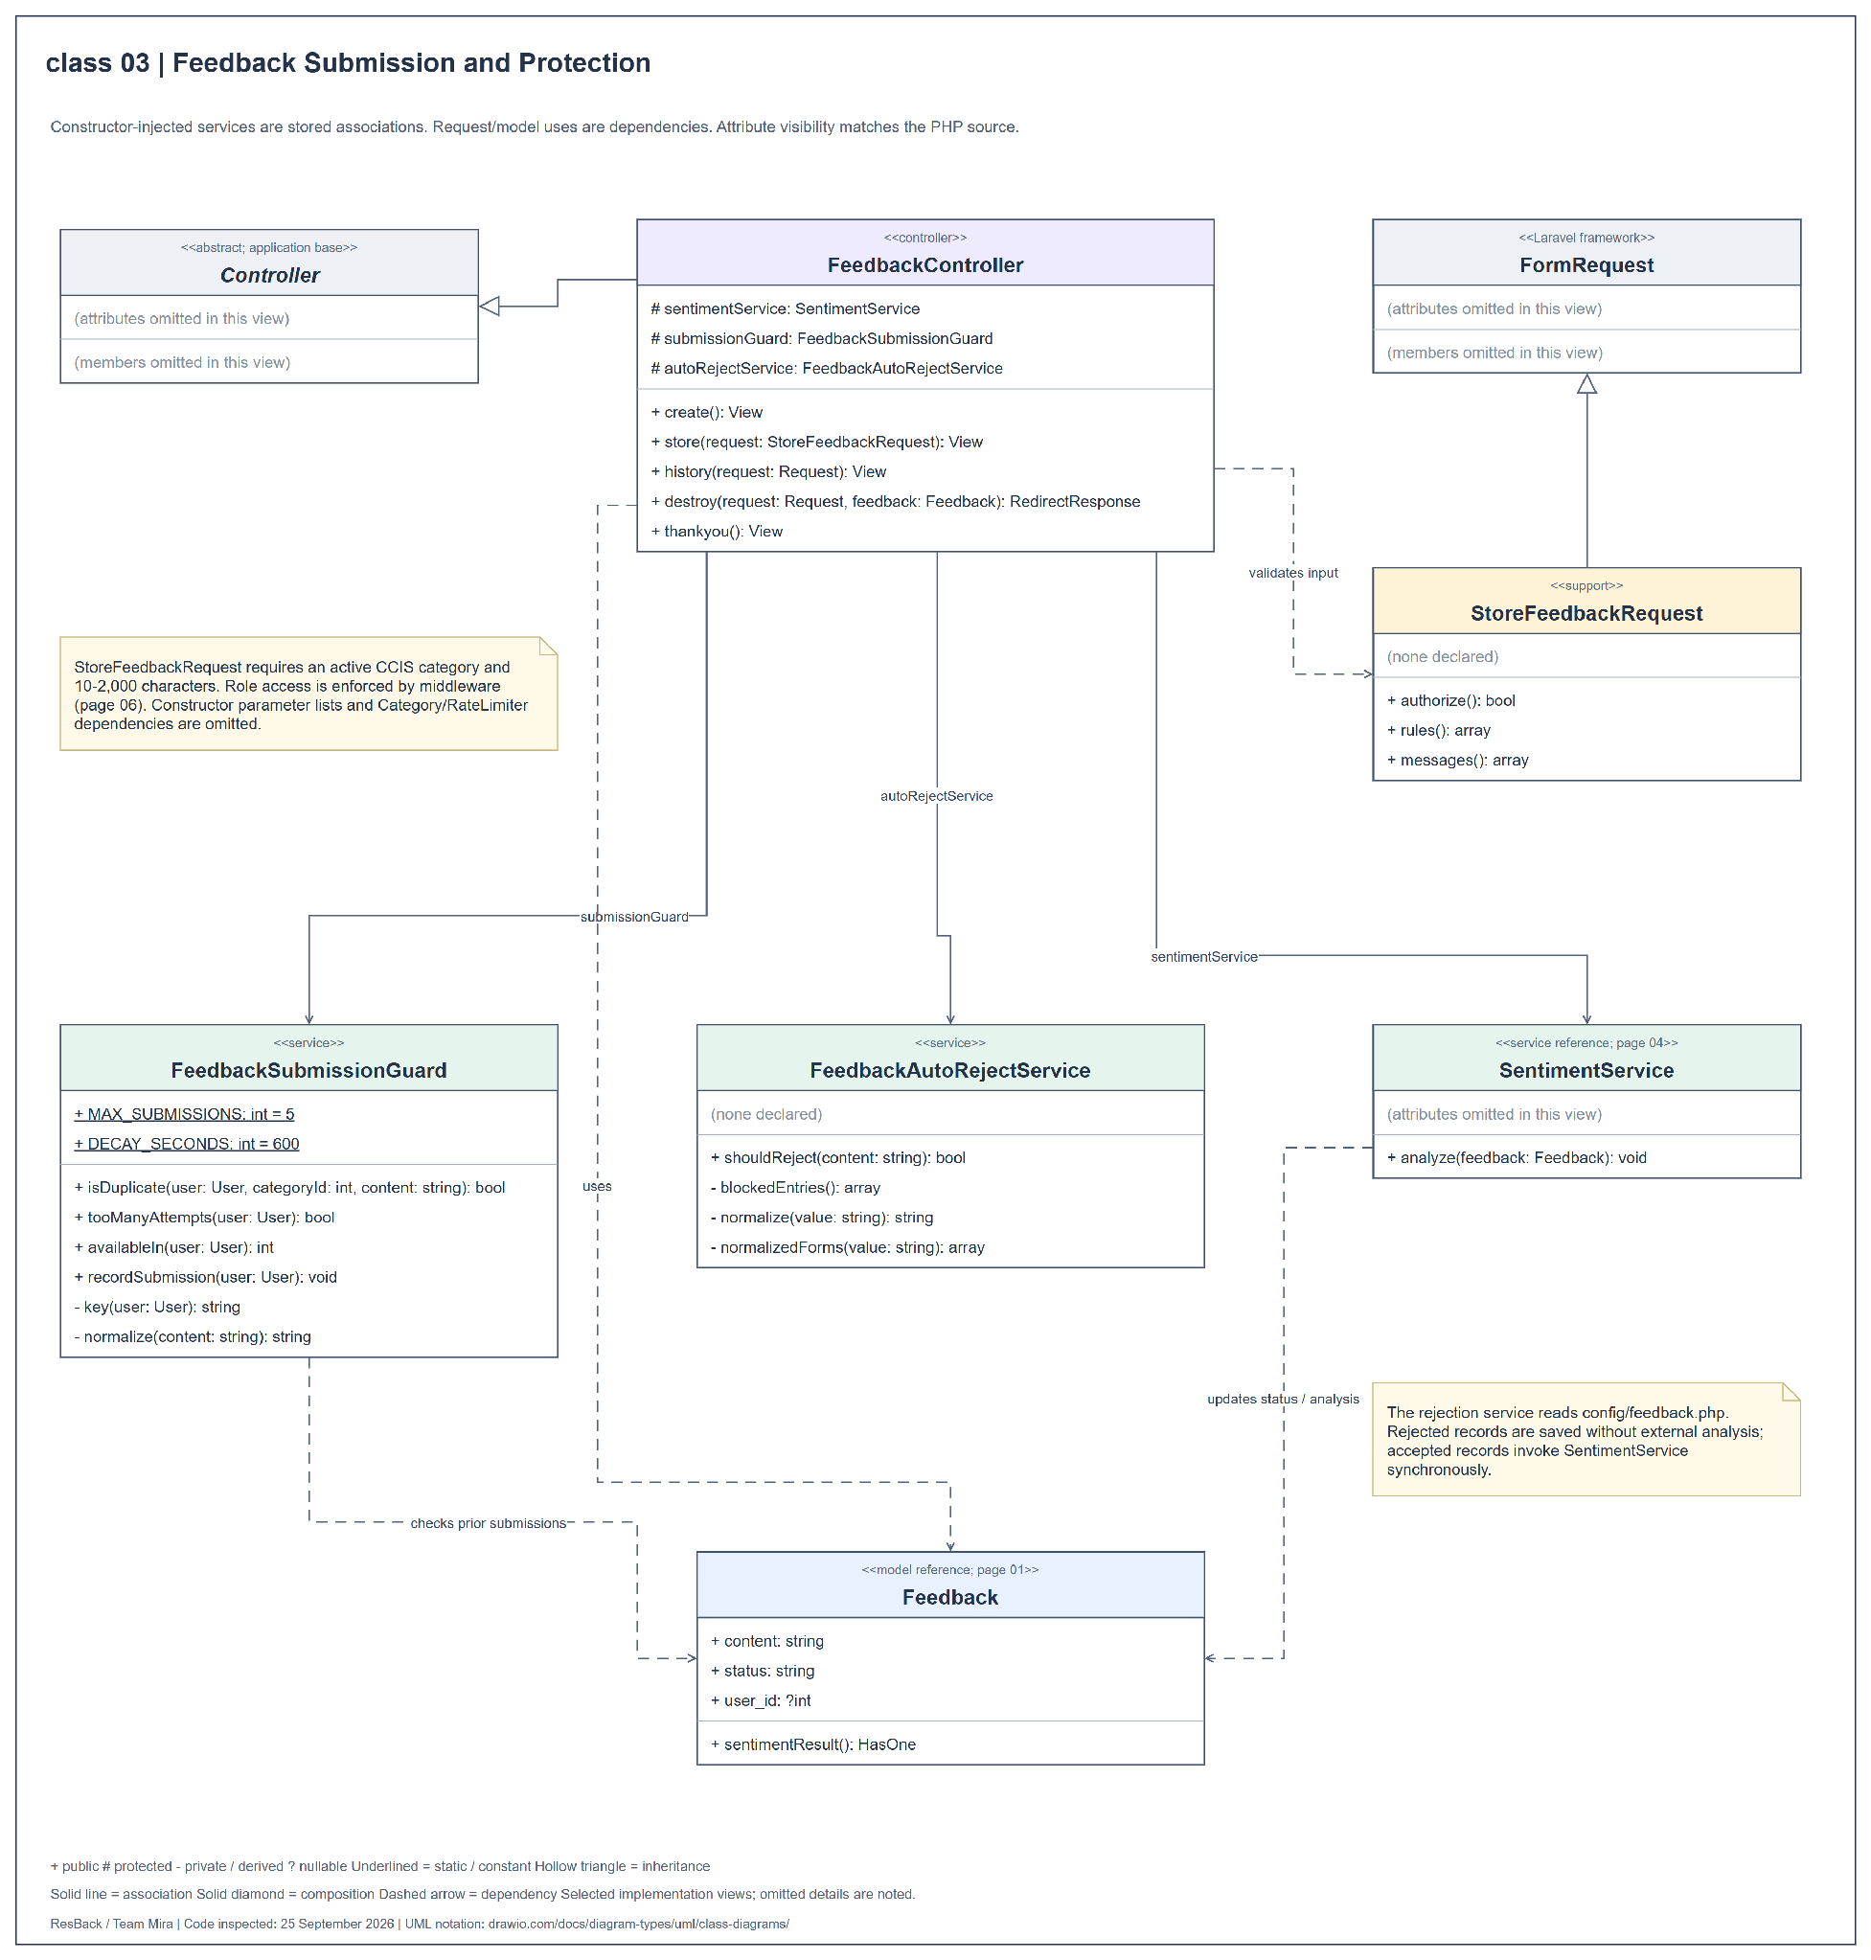
Figure 24 Class diagram for feedback submission and protection
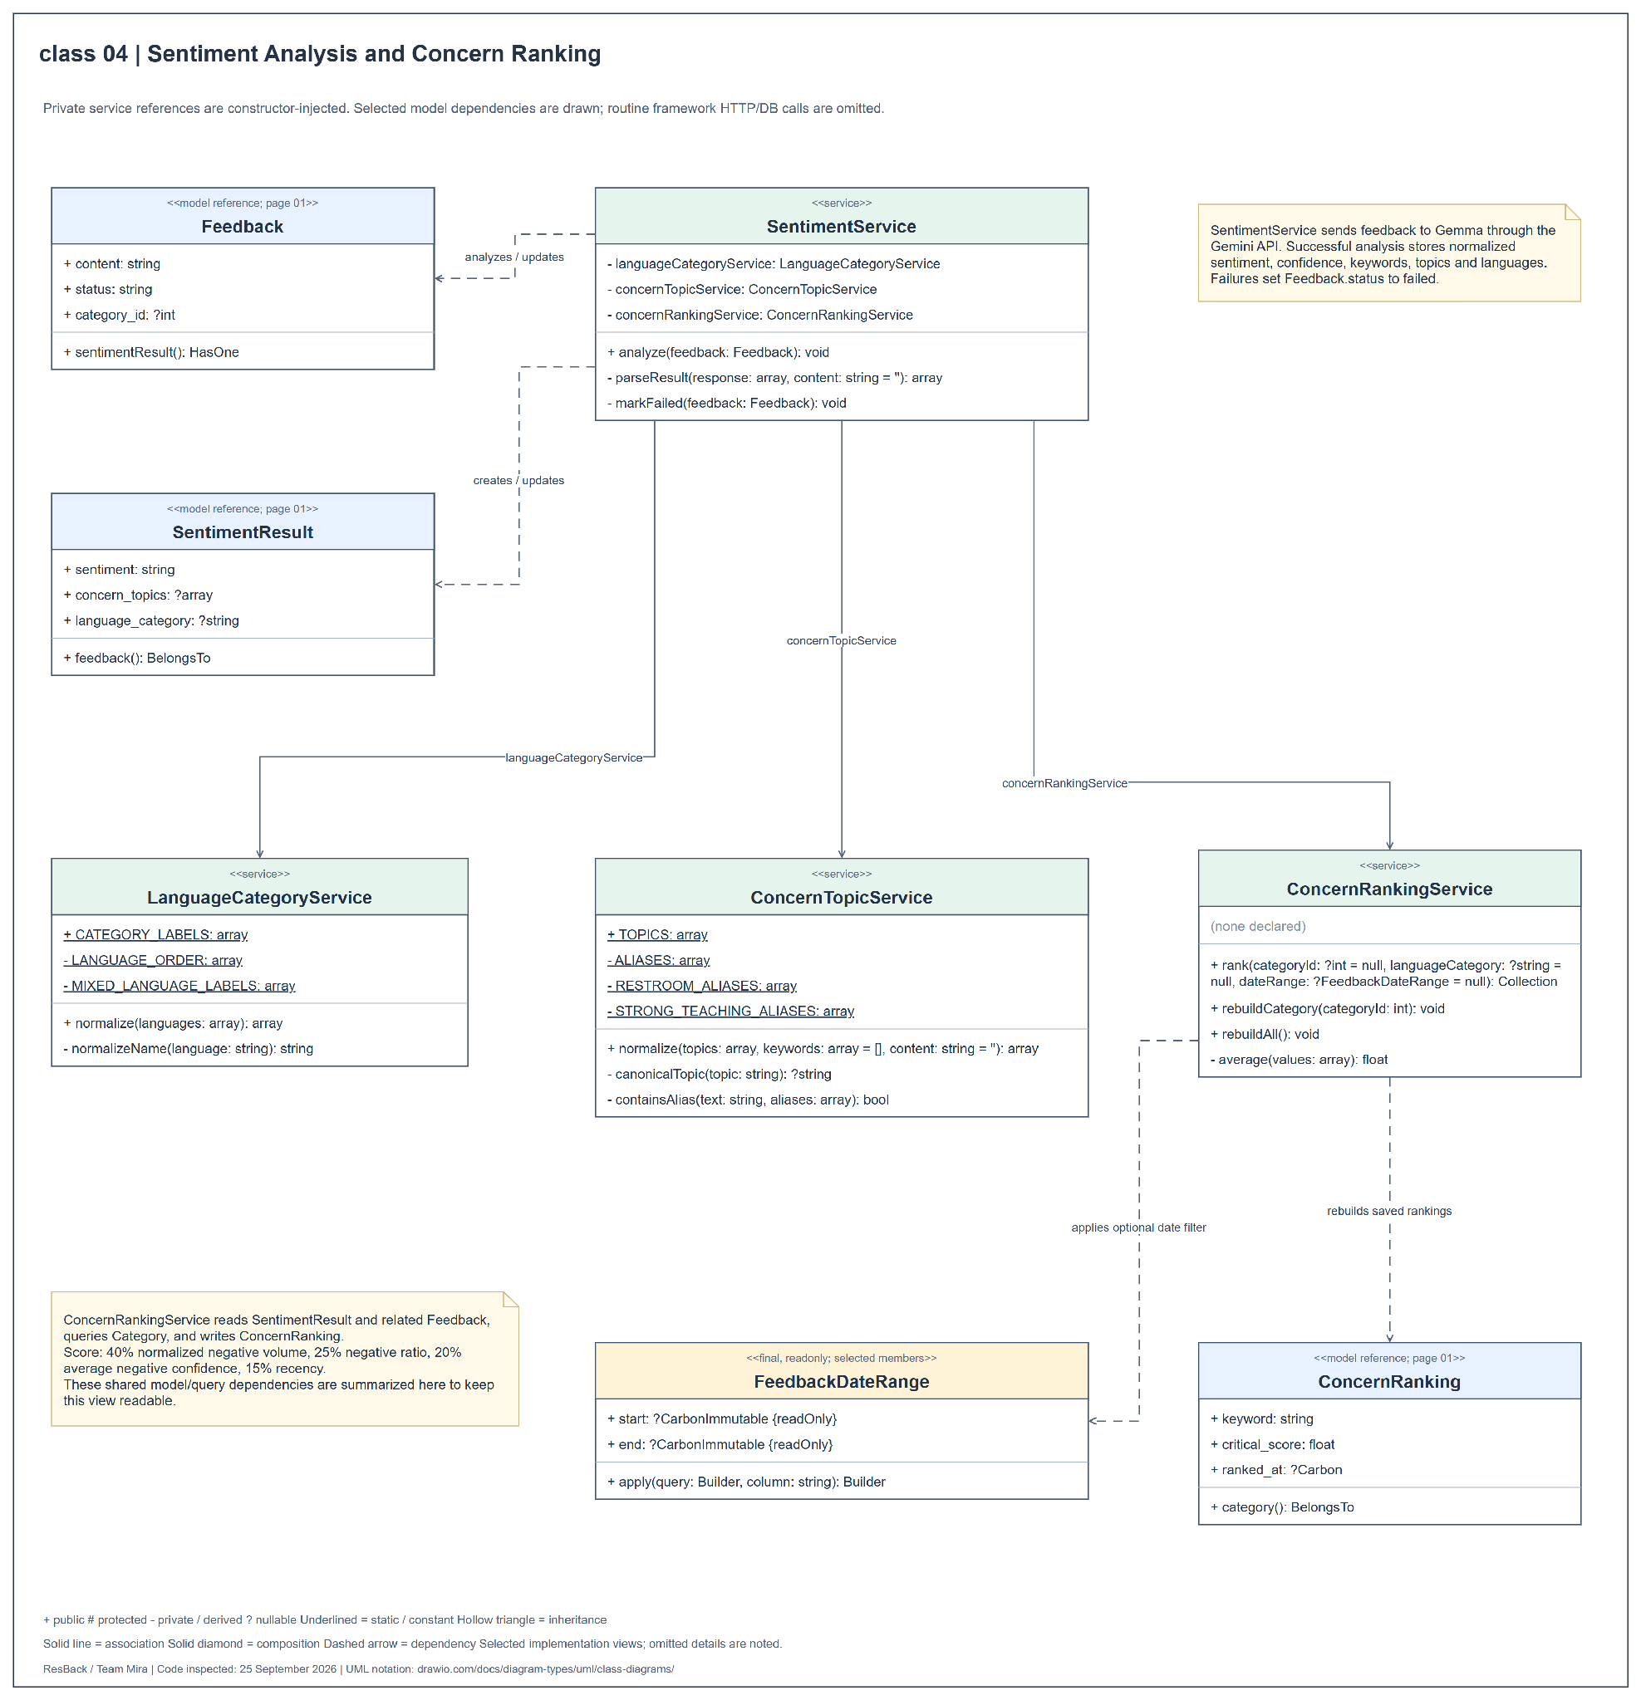
Figure 25 Class diagram for sentiment analysis and concern ranking
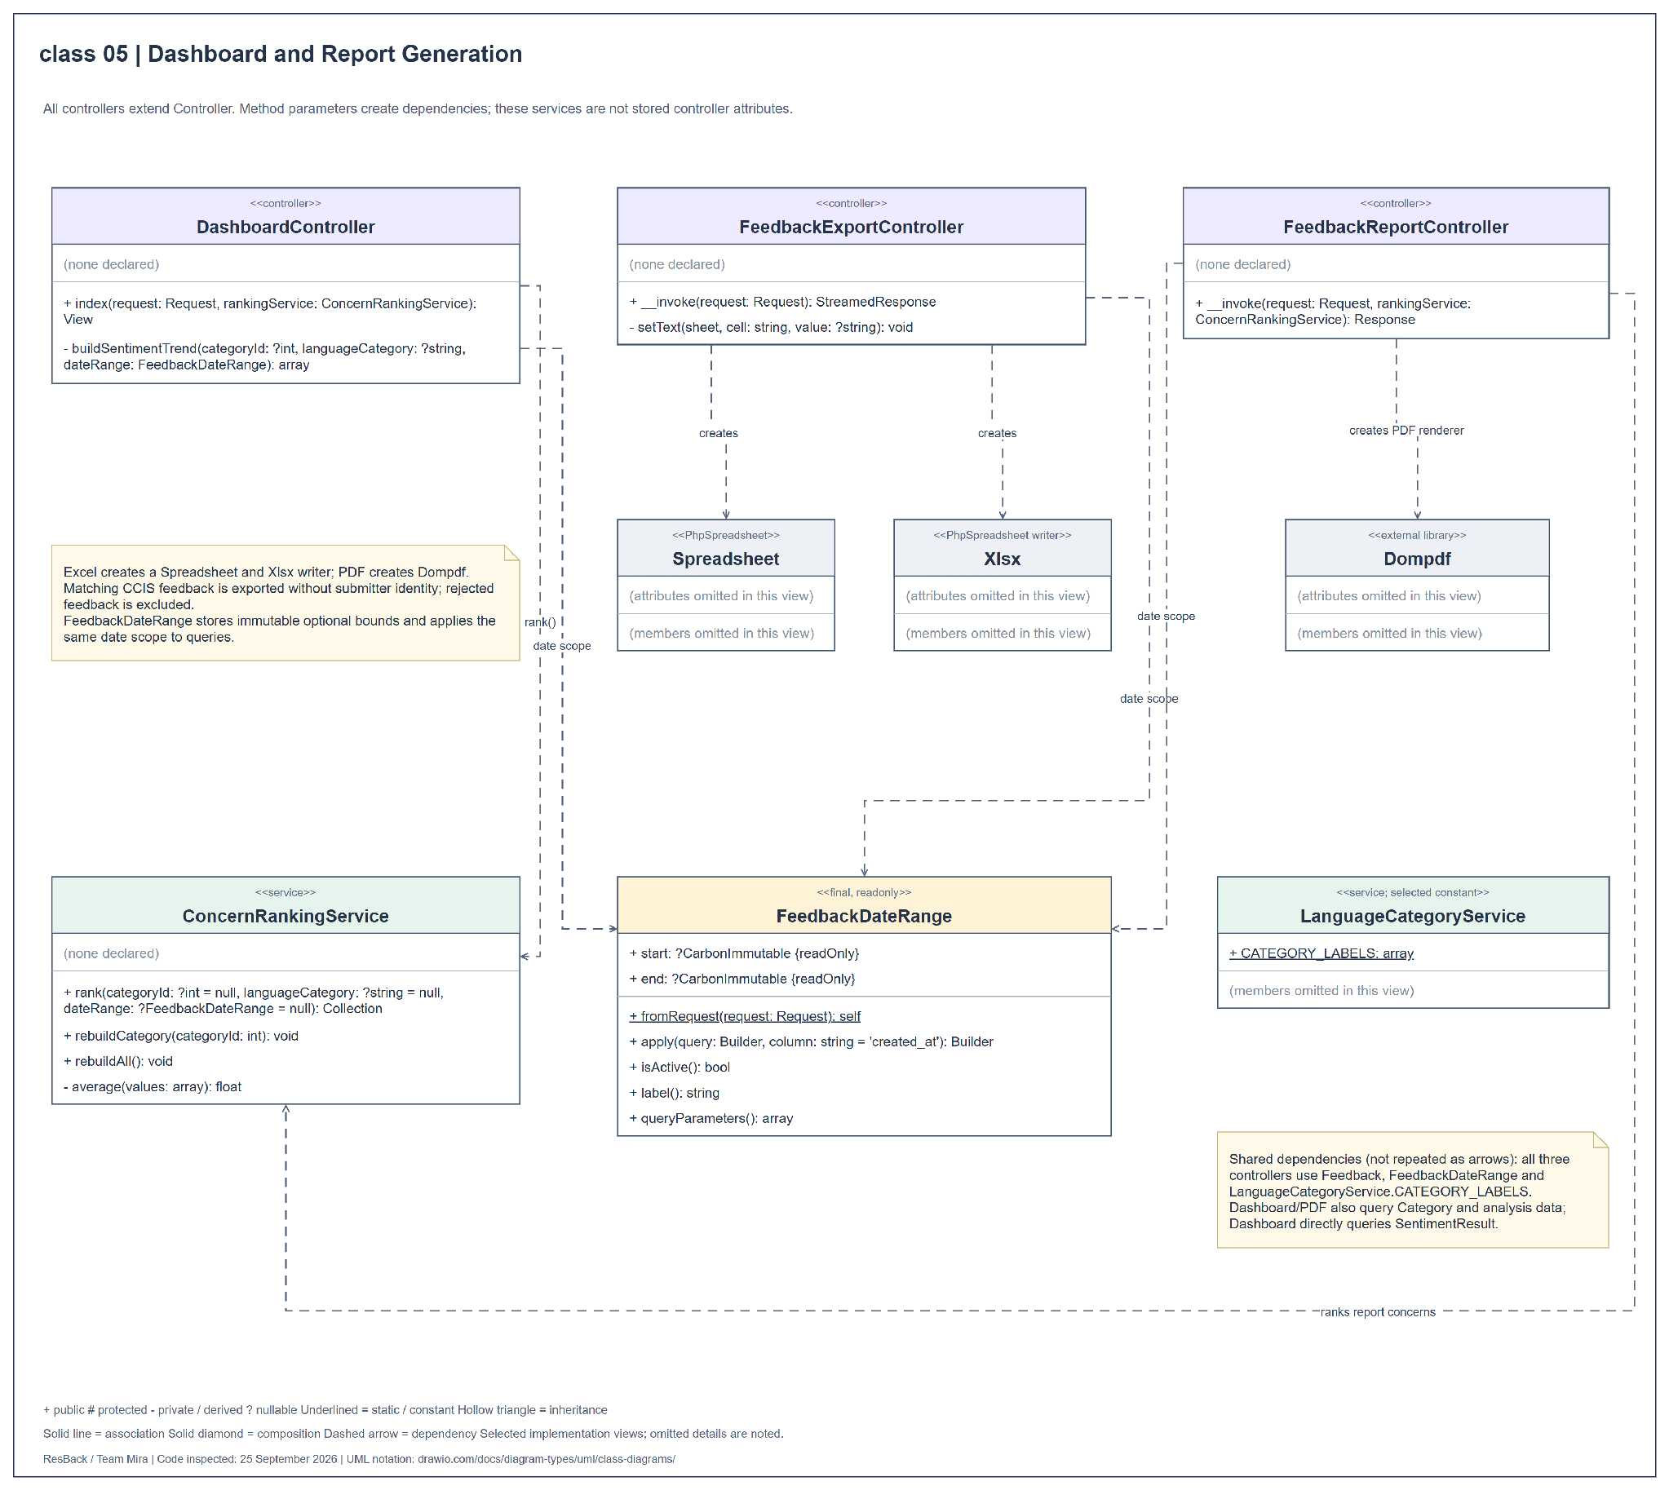
Figure 26 Class diagram for dashboard and report generation
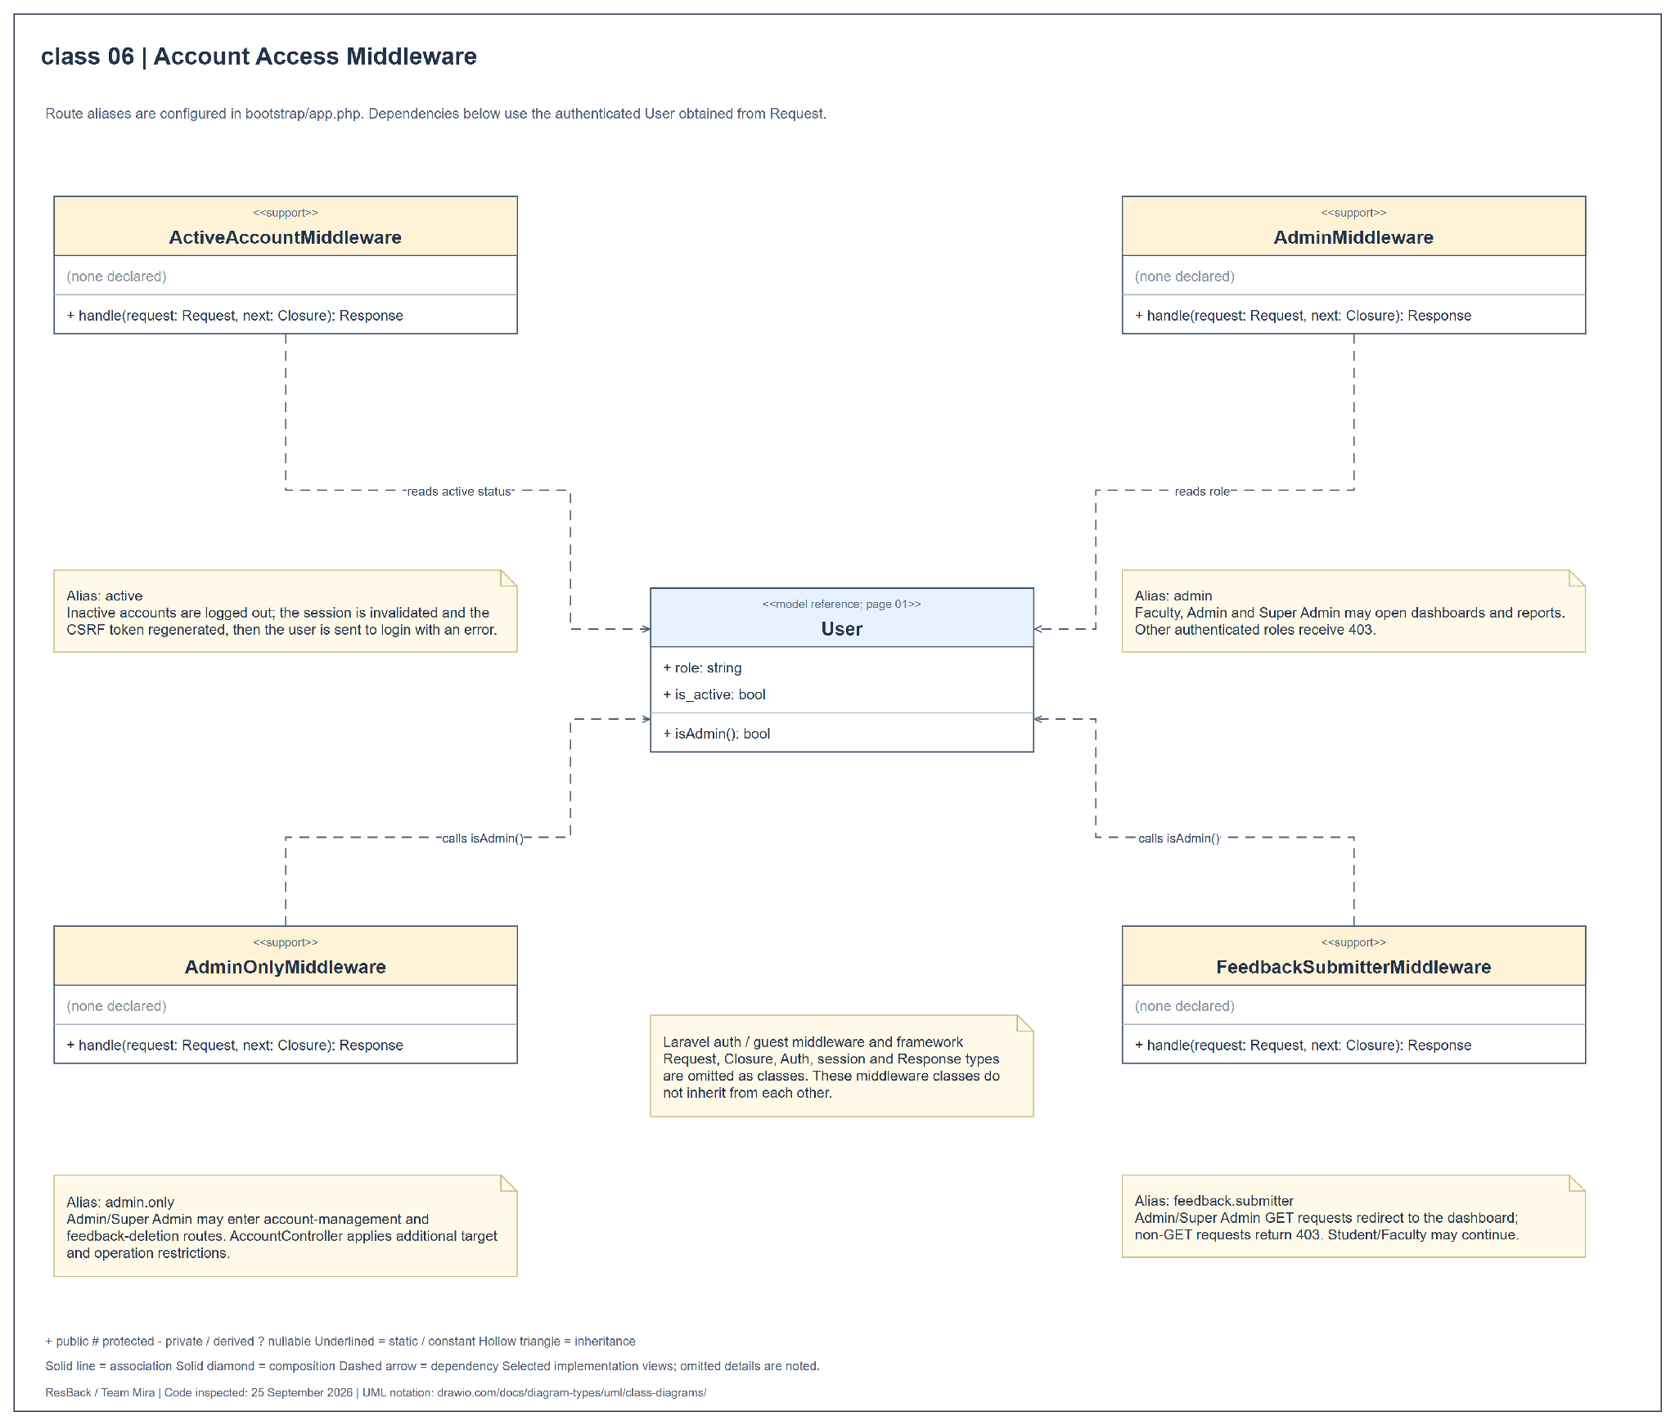
Figure 27 Class diagram for account access middleware

APPENDIX G COMPONENT DIAGRAM
Figure 28 shows the logical modules inside the Laravel application: Web Presentation, Identity and Accounts, Feedback Management, Sentiment Analysis, Concern Ranking, and Dashboard and Reporting. These are logical components of the existing application rather than separately deployed services.
Provided and required interfaces identify service contracts. Delegation connectors link application boundaries to internal components. The diagram also includes external inference, relational storage, profile-photo storage, and report libraries.
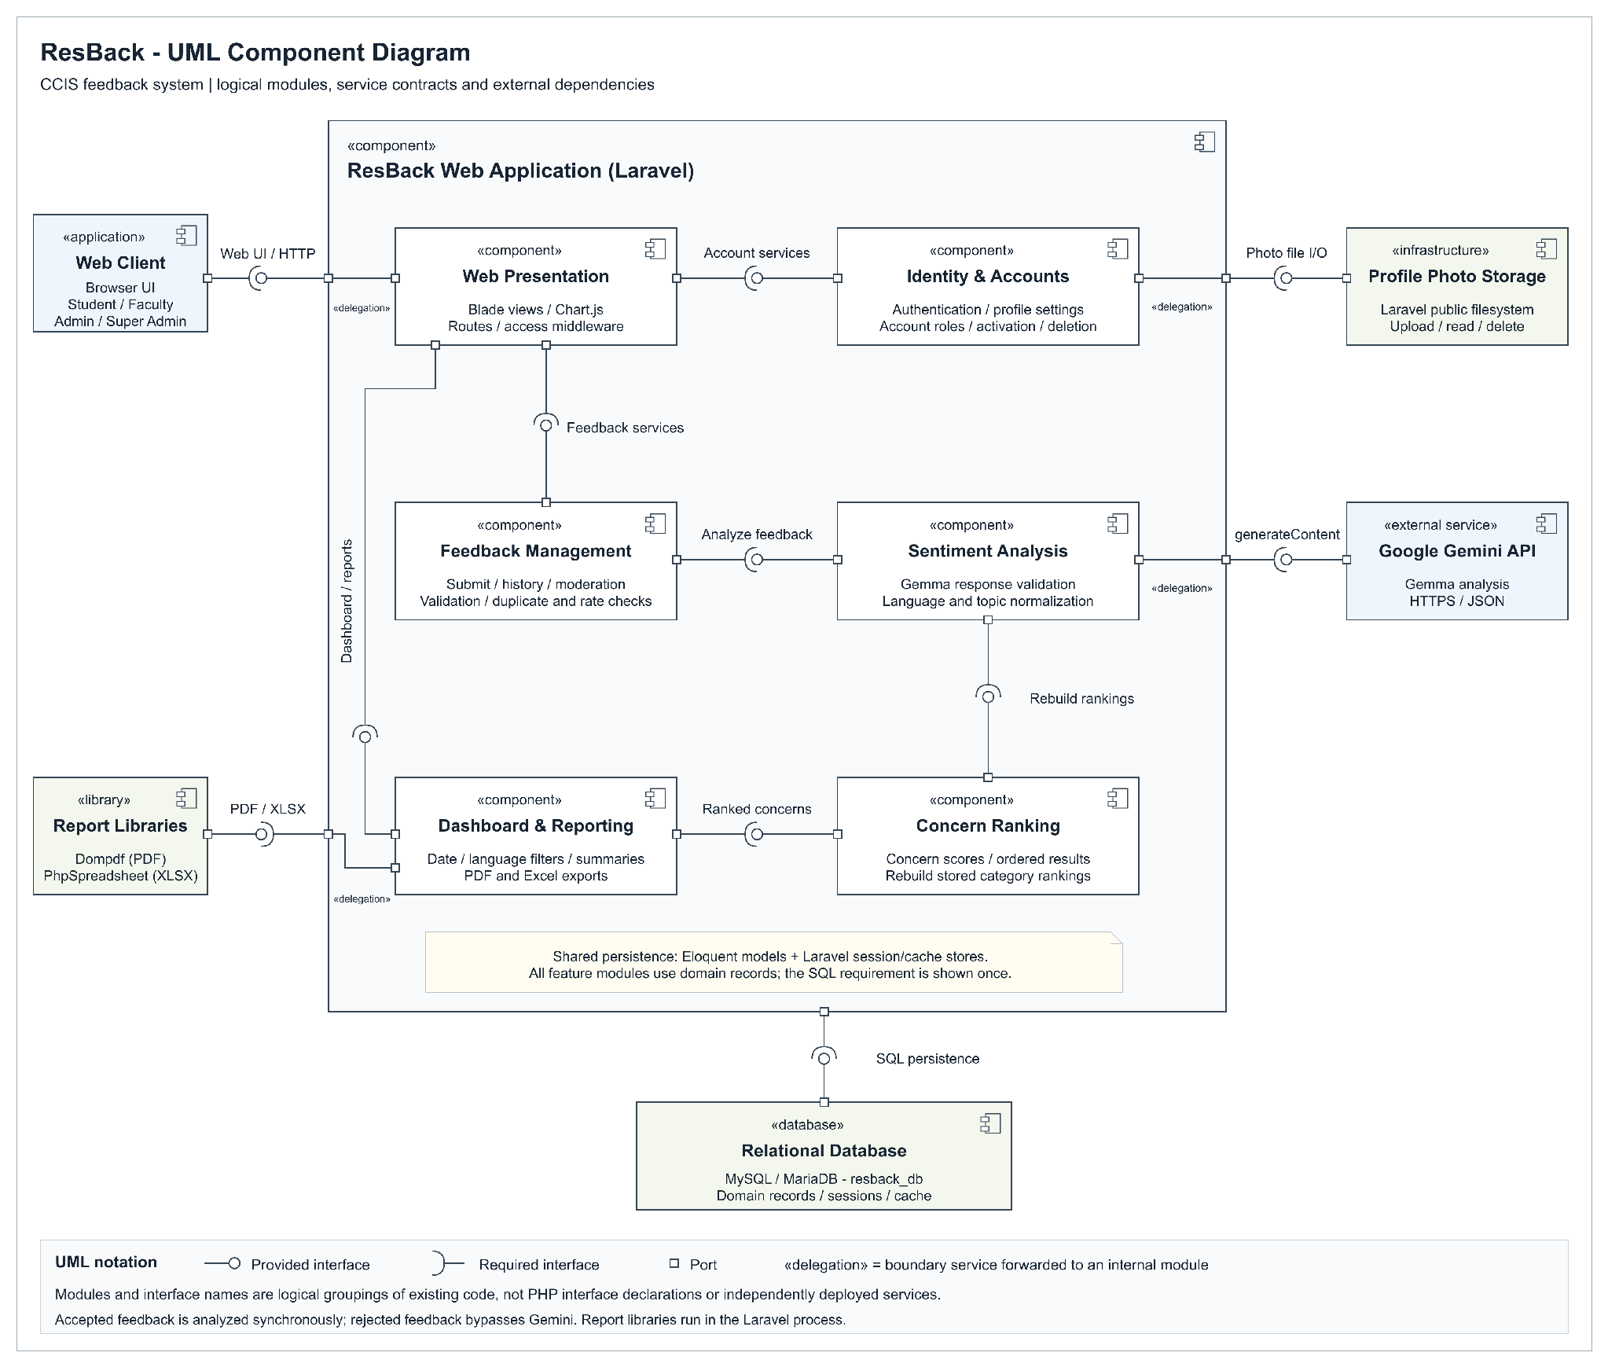
Figure 28 ResBack UML component diagram

APPENDIX H PACKAGE DIAGRAM
Figure 29 groups the application into packages for presentation, account access, feedback handling, analysis, reporting, and persistence. Dashed dependency arrows point toward the package being used. The Google API remains an external dependency.
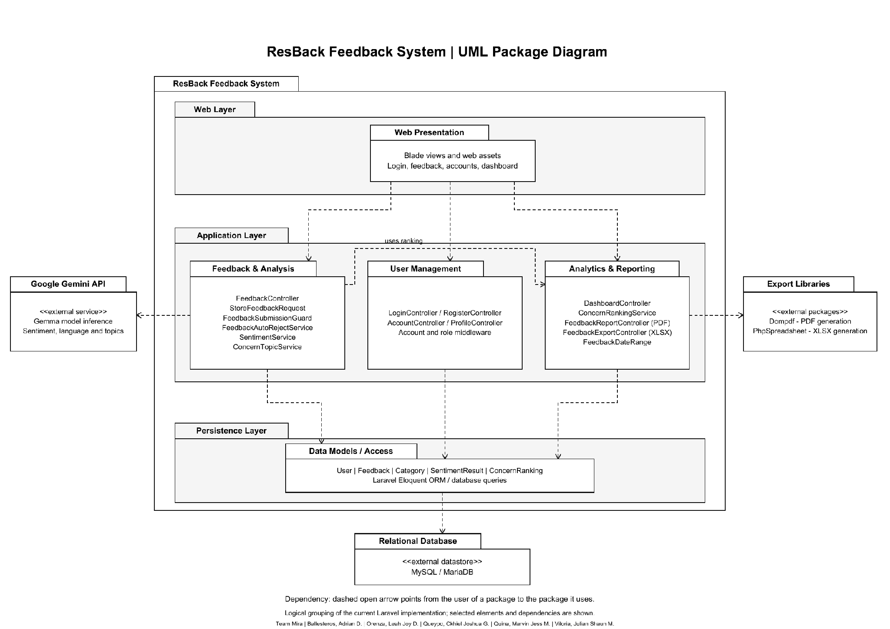
Figure 29 ResBack UML package diagram

APPENDIX I DEPLOYMENT DIAGRAMS LOCAL AND ONLINE
Figure 30 shows the local development deployment: the web browser, PHP development server, XAMPP MySQL or MariaDB, application files, and external Google Gemini API. Web and database services run locally, while Gemma inference requires internet access.
Figure 31 shows the proposed online deployment on Render with Supabase PostgreSQL and profile-photo storage. This remains a target architecture and requires database compatibility, persistent-storage integration, deployment configuration, and operational verification.
The local and online diagrams are separate views. Solid communication paths identify the protocols between execution environments and services.
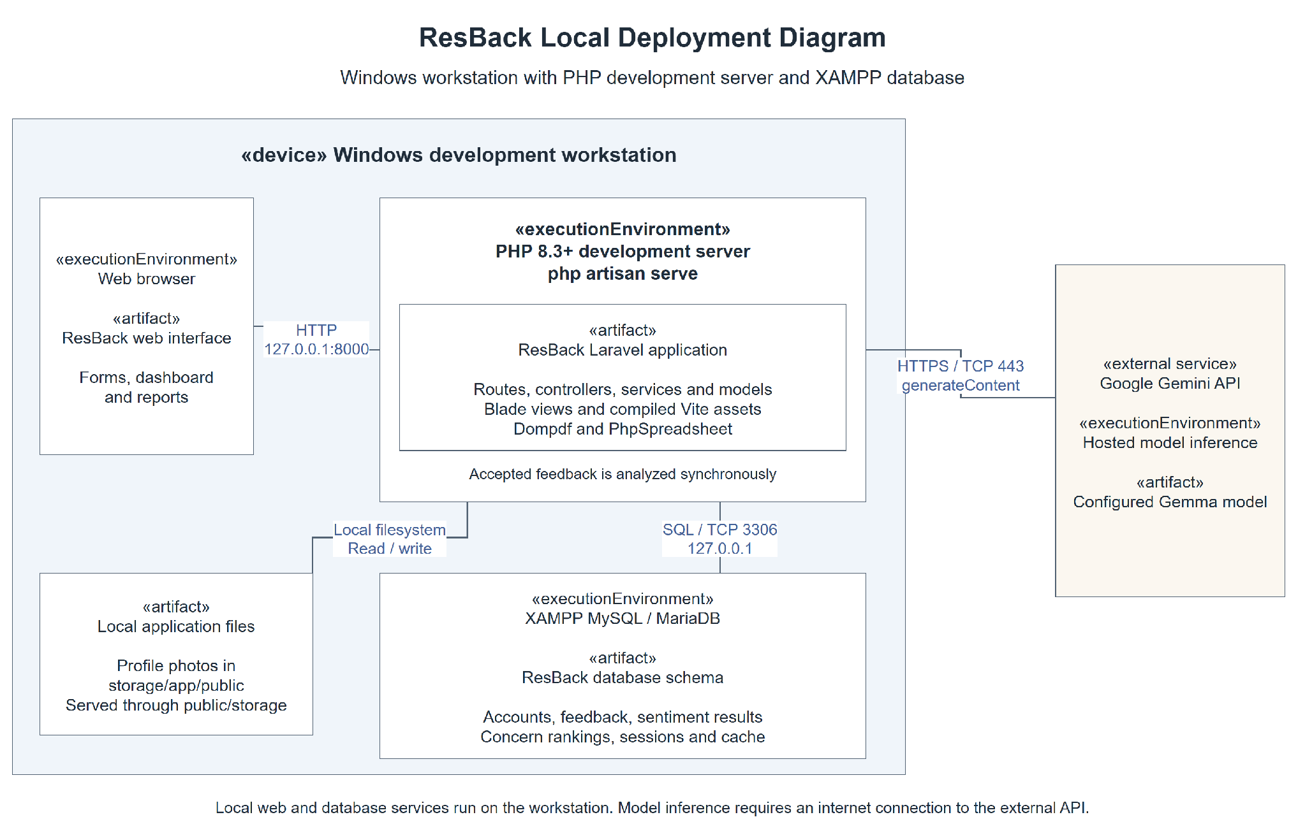
Figure 30 ResBack UML local deployment diagram
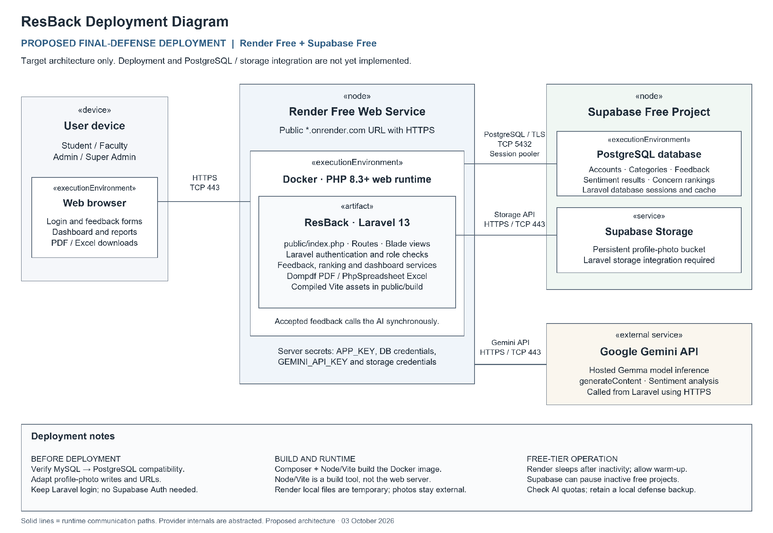
Figure 31 Proposed online deployment diagram

